**TABLE OF CONTENTS**

|  |  |
| --- | --- |
| **Contents**  Acronyms    **Chapter 1: Introduction**  1-1 Purpose and Applicability  1-2 Selected Authorities    **Chapter 2: Processing Complaints**  2-1 Complaint Intake  2-2 Processing Complaints    **Chapter 3: Investigative Process**   * 1. Scope of the Investigation   2. Developing an Investigative Plan   3. Investigative Log   4. Request for Information and Cover Letter   5. Interviews   6. Failure by the Respondent to Provide Access to Information   7. On-Site Visits   8. Analyzing Evidence   3-9 Exit Interview  3-10 Preparing the Investigative Report (IR)/Report of Investigation (ROI)  **Chapter 4: Investigative Case File**   * 1. Creating the Investigative Case File   4-2 Distribution of the Investigative Case File  **Appendices: List of Appendices** | **Page**  **3**  **4**  4  4  **7**  7  10  **15**  15  15  16  16  16  18  19  20  22  23  **24**  24  24    **25** |

**ACRONYMS**

**ADA** Americans with Disabilities Act of 1990

**ADAAG** Americans with Disabilities Act Accessibility Guidelines

**ADR** Alternative Dispute Resolution

**CFR** Code of Federal Regulations

**DOCR** Departmental Office of Civil Rights

**FHWA** Federal Highway Administration

**FOIA** Freedom of Information Act

**HCR** Headquarters Office of Civil Rights

**IP** Investigative Plan

**IR** Investigative Report

**LOF** Letter of Finding

**LEP** Limited English Proficiency

**OA** Operating Administration

**ROI** Report of Investigation

**ROW** Right-of-Way

**STA** State Transportation Agency

**U.S.C.** United States Code

**USDOJ** U.S. Department of Justice

**USDOT** U.S. Department of Transportation

**CHAPTER 1**

**INTRODUCTION**

* 1. **Purpose and Applicability**

This manual outlines the Federal Highway Administration’s (FHWA) procedures for processing external complaints of discrimination filed under Title VI of the Civil Rights Act of 1964 (and related statutes as identified in Section 1-2) and Title II of the Americans with Disabilities Act of 1990 and/or Section 504 of the Rehabilitation Act of 1973. The procedures are designed to provide due process for complainants and respondents.

The procedures apply to the FHWA, and may be used by the, State Transportation Agencies (STA) and other primary recipients and sub-recipients for the investigation of external complaints of discrimination. The procedures do not preclude the responsible staff of any agency from attempting to informally and independently resolve complaints.

* 1. **Selected Authorities**

**A. Nondiscrimination Statutes**

* **Title VI of the Civil Rights Act of 1964,** 42 U.S.C. 2000d, provides: No person in the United States shall, on the ground of race, color, or national origin, be excluded from participation in, be denied the benefits of, or be subjected to discrimination under any program or activity receiving Federal financial assistance.
* **Section 504 of the Rehabilitation Act of 1973,** 42 U.S.C. 794, et seq.,

provides: No qualified handicapped person shall, solely by reason of his handicap, be excluded from participation in, be denied the benefits of, be subjected to discrimination under any program or activity that receives or benefits from Federal financial assistance.

* **Age Discrimination Act of 1975,** 42 U.S.C. 6101, provides: No person in the United States shall, on the basis of age, be excluded from participation in, be denied the benefits of, or be subjected to discrimination under any program or activity receiving Federal financial assistance.
* **Federal Aid Highway Act of 1973,** 23 U.S.C. 324**,** provides: No person shall, on the ground of sex, be excluded from participation in, be denied the benefits of, or be subjected to discrimination under any program or activity receiving Federal assistance under this Title or carried on under this Title.
* **The Civil Rights Restoration Act of 1987,** P.L. 100-209, provides:

Clarification of the original intent of Congress in Title VI of the Civil Rights Act of 1964, Title IX of the Education Amendments of 1972, the Age Discrimination Act of 1975, and Section 504 of the Rehabilitation Act of 1973. The Act restores the broad, institution-wide scope and coverage of the nondiscrimination statutes to include all programs and activities of Federal-aid recipients, sub-recipients, and contractors, whether such programs and activities are federally assisted or not.

* **Title II of the Americans with Disabilities Act of 1990,** 42 U.S.C.

12131, et seq., provides: No qualified individual with a disability shall, by reason of such disability, be excluded from the participation in, be denied the benefits of, or be subjected to discrimination by a department, agency, special purpose district, or other instrumentality of a State or local government.

**B. Regulations**

* 23 Code of Federal Regulations (CFR) 1.36, Compliance with Federal Laws and Regulations
* 23 CFR 200, Title VI Program and Related Statutes-Implementation and Review Procedures
* 28 CFR 35, Nondiscrimination on the Basis of Disability in State and Local Government Services
  + - 28 CFR 36, Nondiscrimination on the Basis of Disability in Public Accommodations and in Commercial Facilities
    - 28 CFR 42, Subpart C, Implementing Title VI of the Civil Rights Act of 1964
    - 28 CFR 50.3, USDOJ’s Guidelines Enforcement of Title VI of the Civil Rights Act of 1964
    - 49 CFR 21, Nondiscrimination in Federally-Assisted Programs of the Department of Transportation-Effectuation of Title VI of the Civil Rights Act of 1964
    - 49 CFR 27, Nondiscrimination on the Basis of Disability in Programs or Activities Receiving Federal Financial Assistance
    - 49 CFR 28, Enforcement of Nondiscrimination on the Basis of Handicap in Programs or Activities Conducted by the Department of Transportation (DOT)

**C. Executive Orders (E.O.)**

* E.O. 12250,Leadership and Coordination of Nondiscrimination Laws
* E.O. 12898,Federal Actions to Address Environmental Justice in

Minority Populations and Low-Income Populations

* E.O. 13166, Improving Access to Services for Persons with Limited English Proficiency

**D.** **Directives**

* DOT Order 1000.18,Implementation of the DOT Title VI Program
* DOT Order 1050.2,Standard Title VI Assurances
* FHWA Notice 4720.6, Impacts of the Civil Rights Restoration Act (CRRA) on FHWA Programs

1. **Other References**

* USDOJ’s Title VI Legal Manual
  + - USDOJ’s Investigation Procedures Manual for the Investigation and Resolution of Complaints Alleging Violations of Title VI and Other Nondiscrimination Statutes
    - Americans with Disabilities Act Accessibility Guidelines (ADA Handbook Appendix B)
    - Revised Draft Public Rights-of-Way Accessibility Guidelines (PROWAG) (2005)
    - FHWA’s Memorandum Clarification of FHWA’s Oversight Role in Accessibility, Dated September 12, 2006 (htpp://www.fhwa.dot.gov/civilrights/memo/ada_memo_clarificationa.htm)

**CHAPTER 2**

**PROCESSING COMPLAINTS**

# 2-1 Complaint Intake

**A.** **Agencies Authorized to Receive Complaints**

Complaints may be submitted to the Federal Highway Administration (FHWA), the State Transportation Agency (STA), the United States Department of Transportation (USDOT), and the United States Department of Justice (USDOJ).

**B.** **Persons Eligible to File**

Any person or any specific class of persons, by themselves or by a representative, that believe they have been subjected to discrimination or retaliation prohibited by Title VI of the Civil Rights Act of 1964 (Title VI) and related statutes, Section 504 of the Rehabilitation Act of 1973 (Section 504), or Title II of the Americans with Disabilities Act of 1990 (ADA) may file a complaint.

**C.** **What is a Complaint?**

1. A complaint is a written or electronic statement concerning an allegation of discrimination that contains a request for the receiving office to take action. Complaints should be in writing and signed and may be filed by mail, fax, in person, or e-mail. A complaint should contain at least the following information:

a. A written explanation of what has happened;

b. A way to contact the complainant;

c. The basis of the complaint, e.g., age, sex, race, color, national origin, or disability;

d. The identification of the respondent, e.g., agency/organization alleged to have discriminated;

e. Sufficient information to understand the facts that led the complainant to believe that discrimination occurred; and,

f. The date(s) of the alleged discriminatory act(s).

2. While the above indicates a complaint should be in writing and signed, the receiving agency must accept complaints in alternate formats from persons with disabilities, upon request.

a. The complaint may be filed on a computer disk, by audio tape, or in Braille.

1. The complainant may call the agency and provide the allegations by telephone. The agency will transcribe the allegations of the complaint as provided over the telephone and send a written complaint to the complainant for signature.
2. **Timeframe for Filing Complaints**

Complaints must be filed within 180 days of the last date of the alleged discrimination, unless the time for filing is extended (49 CFR 21.11 and 27.123). The filing date of the complaint is the earlier of: (1) the postmark of the complaint, or (2) the date the complaint is received by any office authorized to receive complaints. An extension may be granted under any of the following circumstances:

1. The complainant could not reasonably be expected to know the act was discriminatory within the 180-day period, and the complaint was filed within 60 days after the complainant became aware of the alleged discrimination;
2. The complainant was unable to file a complaint because of incapacitating illness or other incapacitating circumstances during the 180-day period, and the complaint was filed within 60 days after the period of incapacitation ended;
3. The complainant filed a complaint alleging the same discriminatory conduct within the 180-day period with another Federal, State or local civil rights enforcement agency, and filed a complaint with DOT within 60 days after the other agency had completed its investigation or notified the complainant that it would take no further action;
4. The complainant filed, within the 180-day period, an internal grievance alleging the same discriminatory conduct that is the subject of the DOT complaint, and the complaint is filed no later than 60 days after the internal grievance is concluded;
5. Unique circumstances generated by DOT action have adversely affected the complainant;
6. The discriminatory act is of a continuing nature; or
7. Some complaints will be referred to DOT by other agencies. In the event the referring agency has possessed the complaint for an inordinately long period of time and the complainant filed his or her complaint with that agency within the 180-day timeframe DOT will automatically grant an informal extension. In these cases, staff does not need to notify the complainant of the extension.
8. **Agency Responsibilities**
9. **Federal Highway Administration**
10. All complaints received by the Resource Center or Division Offices will be forwarded to the Director, Investigations and Adjudications in the Headquarters Office of Civil Rights (HCR).
11. The HCR will acknowledge receipt of all complaints filed. The HCR will analyze the allegation(s) and notify the complainant and respondent of the issues accepted for investigation. **(SEE APPENDICES: D-3, D-4, D-5 and E)**
12. Complaints filed under Title VI against an STA will be investigated by HCR or a team comprised of Division Office and Resource Center personnel.

a. The Division Office personnel will not investigate Title VI complaints filed against the State for which they are responsible. The Division Office personnel may be assigned as a team member or team leader for the investigation of complaints in other States.

* + 1. The HCR will provide the appropriate Division Office with a memorandum advising that a complaint has been filed and accepted for investigation. (**SEE APPENDIX D-6)**
    2. The HCR will also provide the appropriate Division Office with a copy of the Letter of Finding (LOF) after completion of the investigation.

1. Complaints filed under Section 504/ADA with the US DOT/FHWA will be referred to the Division Office for investigation. Upon completion of the investigation, the Division Office will forward the complaint and investigative report to HCR-40 for issuance of the LOF.

1. HCR will consult the Office of Chief Counsel (HCC), the Departmental Office of Civil Rights (S-33), and the Department’s Office of the General Counsel whenever (1) a complaint or investigation presents a novel issue, (2) a complaint or investigation presents a issue with which the investigating office is unfamiliar, (3) there is media interest in the case or political sensitivity, or (4) there is a recommendation to terminate or refuse financial assistance. Novel issues are those which raise substantive legal or policy questions that are not addressed in Departmental or FHWA regulations or guidelines.

**B.** **State Transportation Agencies**

1. Complaints filed under Title VI with STAs in which the STA is named as the respondent should be forwarded to HCR for investigation.

2. Title VI complaints filed directly with the STAs against its sub-recipients should be processed by the STA in accordance with the FHWA approved complaint procedures as required under 23 CFR 200.9(b)(3). However, the HCR has delegated authority for making all final decisions which include dismissing complaints and issuing LOFs.

3. Complaints filed under the Section 504/ADA with the STA can be investigated by the STA in accordance with 49 CFR 27.13(b).

4. The STAs may use contract investigators to conduct investigations of complaints of discrimination, if the use of contract investigators will assist in preventing or eliminating a backlog of complaints. All complaints are to be investigated in accordance with approved complaint processing procedures.

**2-2 Processing Complaints**

**A.** **Recording Complaints**

Upon initial receipt, a complaint should always be date stamped by the receiving office. The date of receipt by the receiving office is crucial for determining jurisdiction and timeliness.

* 1. **Items Not Considered a Complaint**

The following are examples of items that should not be considered a complaint, unless the item contains a signed cover letter specifically asking that the agency take action concerning the allegations:

* 1. An anonymous complaint;
  2. Inquiries seeking advice or information;
  3. Courtesy copies of court pleadings;
  4. Courtesy copies of complaints addressed to other local, State, or Federal agencies;
  5. Newspaper articles; and,
  6. Courtesy copies of internal grievances.

1. **Accepting Complaints in Alternative Formats and Languages**

1. Recipients must ensure that persons with Limited English Proficiency (LEP) have meaningful access to their programs and activities, including their complaint procedures in accordance with E.O. 13166, “Improving Access to Services for Persons with Limited English Proficiency.”

2. Complaints in languages other than English should be translated and

responded to in the language in which they were sent.

3. It is important to recognize the need to modify practices to serve LEP

complainants and those with disabilities may extend beyond the complaint

intake stage. Throughout the complaint resolution process, staff should ensure

these individuals understand their rights and responsibilities, as well as the

status of their complaint.

**D. Reviewing Complaints**

1. The complaint will be reviewed within 10 calendars days of receipt to determine whether it contains all the necessary information required for acceptance.

2. If the complaint is complete and no additional information is needed, the complainant will be sent a letter of acceptance along with the Complainant Consent/Release form and the Notice About Investigatory Uses of Personal Information form. **(SEE APPENDIX D)**

3. If the complaint is incomplete, the complainant will be contacted in writing or by telephone to obtain the additional information. The complainant will be given 15 calendars days to respond to the request for additional information.

**E. FHWA Complaint Jurisdiction**

1. The HCR has delegated authority for referring complaints to other agencies

for lack of jurisdiction.

1. If it becomes clear that FHWA lacks jurisdiction over a complaint, the complaint should be referred to the appropriate agency. A referral letter will be sent to the agency along with the complaint and other documents. A letter will also be sent to the complainant stating that the complaint has been referred to another agency and that FHWA has closed the complaint. **(SEE APPENDICES: D-1, D-2, E-2, E-3, E-4 and E-5)**

**F. Notification of Acceptance of Complaints**

After determining the complaint will be accepted for investigation, a notification letter will be sent to the complainant and the respondent. **(SEE APPENDICES: D, D-3, D-4, D-5 and E)**

**G.** **If the Complainant is Represented by an Attorney**

Complainants represented by an attorney should provide a letter of representation.

**H.** **Timeframes for Investigations**

1. Although the regulations do not specify a timeframe for the investigation of Title VI complaints the HCR attempts to complete investigations within 180 days.

1. Title VI complaints received directly by the STA are bound by the timeframes outlined in 23 CFR 200.9(b)(3).

3. Although the regulations do not specify a timeframe for the investigation of Section 504/ADA complaints the HCR requests that the Division Office and STA investigate complaints within 90 days of receipts of the complaint from HCR.

**I**. **Dismissals**

The HCR has delegated authority for dismissing Title VI complaints. The HCR has delegated authority for dismissing Section 504/ADA complaints processed by the FHWA. A complaint may be dismissed for the following reasons:

1. The complaint is untimely filed;

2. The complainant fails to respond to repeated requests for additional information needed to process the complaint;

3. The complainant cannot be located after reasonable attempts;

4. There is no statutory or alleged basis for the complaint, FHWA lacks jurisdiction in the matter, or the complainant does not allege any harm with regard to current programs or statutes;

5. The complaint has been investigated by another agency and the resolution of the complaint meets USDOT/FHWA regulatory standards; e.g., all allegations were investigated, appropriate legal standards were applied, and any remedies secured meet USDOT’s standards;

6. The FHWA obtains credible information at any time indicating that the allegations raised by the complainant have been resolved, or are moot and there are no class-wide allegations or implications. In such a case, FHWA will attempt to ascertain the apparent resolution. If FHWA determines that there are no current allegations appropriate for further complaint resolution, the complaint will be closed;

7. The complainant decides to withdraw the complaint. If the complaint included class allegations, the FHWA may close out the entire complaint, pursue resolution of the class allegations, or use the information to target future compliance review activity;

8. The same complaint allegations have been filed with another Federal, State, or local agency, or through a respondent’s internal grievance procedures, including due process proceedings, and FHWA anticipates that the respondent will provide the complainant with a comparable resolution process under comparable legal standards; e.g., all allegations were investigated, appropriate legal standards were applied, and any remedies secured meet USDOT’s standards;

9. The FHWA refers a complaint over which USDOT has jurisdiction to another agency that also has jurisdiction but may be better suited to conduct the investigation;

10. A complaint, because of its scope, may require extraordinary resources. In such instances, FHWA may consider treating such a complaint as a compliance review. Similarly, a compliance review may be the most effective means of addressing multiple individual complaints against the same respondent; or,

If FHWA selects this option, it should discuss the decision with the complainant(s), close the complaint, and initiate the review as soon as possible. The FHWA should provide the complainant(s) with a copy of the resolution documents upon completion of the compliance review.

**J.** **Letters of Finding (LOFs)**

1. The HCR has delegated authority for issuing LOFs for all complaints processed by the FHWA.

1. A Title VI finding of violation, no violation, or dismissal is a Federal decision that cannot be delegated. Although an STA can conduct a Title VI investigation of its sub-recipients or contractors and make a recommended finding to the Federal decision-making authority, the FHWA has delegated authority for all final decisions, dismissals, and LOFs.
2. **Appeals**

LOFs issued by the FHWA are administratively final.

**CHAPTER 3**

**INVESTIGATIVE PROCESS**

**3-1 Scope of the Investigation**

An investigation should be confined to the issues and facts relevant to the allegations in the complaint, unless evidence shows the need to extend the issues. A future compliance review of the respondent may be appropriate when issues identified during the investigation cannot be covered within the scope of the investigation.

**3-2 Developing an Investigative Plan**

The investigator shall prepare an Investigative Plan (IP) which is a working document intended to define the issues and lay out the blueprint to complete the investigation. The IP is an internal document for use by the investigator to keep the investigation on track and focused on the issues and likely sources of evidence or corroboration. The IP should follow the outline below.

1. COMPLAINANT(S) NAME AND ADDRESS

ATTORNEY FOR THE COMPLAINANT(S)--(NAME AND ADDRESS), if applicable

1. RESPONDENT(S) NAME AND ADDRESS

ATTORNEY FOR THE RESPONDENT(S)—(NAME AND ADDRESS), if applicable

1. APPLICABLE LAW(S)
2. BASIS/(ES)
3. ALLEGATION(S)/ISSUE(S)
4. THEORY(IES) OF DISCRIMINATION (for Title VI only)
5. BACKGROUND
6. NAME OF PERSONS TO BE INTERVIEWED
   1. QUESTIONS FOR THE COMPLAINANT(S)
   2. QUESTIONS FOR THE RESPONDENT(S)
   3. QUESTIONS FOR WITNESS(ES)
7. EVIDENCE TO BE OBTAINED DURING THE INVESTIGATION

**3-3 Investigative Log**

An investigative log should be maintained which documents all activity related to the complaint. **(SEE APPENDIX: C-1)**

**3-4 Request for Information and Cover Letter**

The investigator should prepare a Request for Information (RFI) and cover letter for the respondent. The RFI is taken directly from the evidence section of the IP.

The investigator should make contact with the respondent to advise of the complaint and to determine the appropriate official(s) to interview and receive the RFI. A cover letter should be sent with the RFI explaining the complaint under investigation, and including the investigator’s name and information regarding any scheduled meetings. **(SEE APPENDICIES: D-3 and E-6)**

The respondent should be given 30 calendar days from the date of the agency’s request to submit the required information. The agency may modify the timeframe depending on the extent of the data requested or other special circumstances.

**3-5 Interviews**

Interviews should be conducted with the complainant, respondent, and appropriate witnesses during the investigative process.

**A. Conducting the Interviews**

The main objective during the interview is to obtain information from witnesses who can provide information that will either support or refute the allegations. A list of major questions should be prepared to address the issues involved in the complaint. During the interview, the investigator will generally do the following:

1. Introduce themselves, provide identification, state the purpose of the interview, and outline the interview process. Indicate that notes will be taken. Make it clear that the investigator will not use a tape recorder. Take clear and precise notes.
2. Put the individual being interviewed at ease;
3. Ask open ended questions that will get the witness’s perception – who, what, where, when, and how;
4. Listen actively and effectively during the interview;
5. Distinguish factual information from opinions; and,
6. Review the statement with the interviewee and allow time for changes or corrections.

**B. Persons to be Interviewed**

1. **Complainant(s)**

Complainants are interviewed to gain a better understanding of the situation outlined in the compliant of discrimination. Usually, complaints are received through the mail from complainants. The investigator should contact the complainant to ensure they understand the complainant’s concerns. Sometimes the complainant’s concerns may be totally different from what was written in the complaint.

It is best to interview the complainant before completing the IP. However, if this cannot be done, the investigator must be ready to make any changes as appropriate to the IP based on any new information provided by the complainant.

The investigator should also question the complainant regarding resolution opportunities.

1. **Respondent(s)**

Respondents have the right to know the allegations raised in the complaint. Respondents are interviewed to provide an opportunity to respond to the issues raised by the complainant. The interview should include obtaining an understanding of the respondent’s operation and policies relative to the allegations cited in the complaint.

Respondents should always be advised that they will be asked to submit a formal position statement addressing the complainant’s allegations.

The investigator should also question the respondent regarding resolution opportunities.

1. **Witness(es)**

The complainant or respondent may have persons they wish the investigator to contact. Individuals who have information relevant to the allegations raised in the complaint of discrimination should be interviewed. The investigator will determine whether the testimony provided by a witness is relevant.

The investigator will also determine when enough interviews have been conducted.

### **C.** **Right to Representation**

The complainant, respondent, and witnesses have the right to a representative present during interviews.

### **D.** **Record of Interview**

A written record of both telephone and in-person interviews must be created and kept in the investigative case file.

**3-6 Failure by the Respondent to Provide Access to Information**

Respondents should provide investigative access to all books, records, accounts, electronic media, audiotapes, and other sources of information or facilities necessary to determine compliance. Failure by a respondent to cooperate fully can be grounds for a determination of noncompliance on the part of the respondent.

**A. A Respondent Denies Access When It**:

1. Refuses to permit access to its employees and facilities during normal business hours to conduct interviews or obtain written or unwritten information, such as electronic storage media, microfilm, retrieval systems, and photocopies; or
2. Fails to provide information by virtue of the refusal of one of its employees to do so or to provide access to information maintained exclusively by an employee in his or her official capacity.

**B.** **If Access is Denied, the Investigator Should do the Following**:

1. If the refusal is stated verbally, either in person or over the telephone, the investigator should ascertain the basis for the respondent’s refusal and explain DOT’s authority under 49 CFR 21.13, 49 CFR 27.11, and 23 CFR 1.36.
2. Where attempts to persuade a respondent to provide information have failed, a letter should be prepared setting forth DOT’s authority to obtain access to the information and addressing any particular concerns expressed by the respondent.
3. Whenever HCR determines that compliance cannot be achieved, it will initiate compliance actions under 49 CFR 21.13, 49 CFR 27.11, or 23 CFR 1.36.

The investigator should indicate in the IR that the respondent refused to provide pertinent information and describe efforts made to obtain the information, including the identity of persons not cooperating in the investigation.

There may be instances where another agency, institution, or person, has exclusive possession of information and refuses to furnish this information to the respondent.

The respondent should certify that this has occurred in its response or report to FHWA and describe what efforts it has made to obtain the information.

**3-7 On-Site Visits**

### **A. Determining if an On-Site Visit is Needed for Title VI Investigations**

**NOTE: All ADA complaints involving the public right-of-way will require an**

**on-site review.**

A thorough investigation can often be conducted without an on-site visit to the respondent’s facility. If all the following conditions are present, an on-site visit is usually unnecessary:

1. Individuals are not the primary source of information needed (e.g., interviews are unnecessary or can be done by telephone);
2. All needed information can be specified precisely in the RFI and can be easily provided by the respondent;
3. The respondent can provide written documentation to verify its position in its response to the RFI; and,
4. There is good reason to conclude that the complainant is the only person affected by the alleged discrimination.

After analyzing the respondent’s response to the RFI, the investigator may decide that a visit to the respondent’s facility is necessary. The investigator should consider the possibility of conducting a portion of the investigation on-site if any of the following apply:

1. Personal contact with the complainant and the respondent may yield information and clarification that might not otherwise be discovered by just reviewing written documents or speaking over the telephone;
2. A more accurate impression of the physical environment and general atmosphere of the respondent and the surrounding community can be obtained, which may help in making a determination on the complaint;
3. Some documentation can only be examined on-site for reasons of convenience, cost, format, or bulk.

**B. Notifying the Respondent of an On-Site Visit**

After the investigator has received and reviewed the documents contained in the RFI from the respondent, a determination should be made as to whether an on-site visit is needed. An on-site notification letter should be sent to the respondent advising it of the planned visit.

At this point of the investigative process, the respondent is already aware of the existence of the complaint, FHWA’s jurisdiction, and the basis of the complaint. However, the letter notifying the respondentof the scheduled on-site visit may:

1. Restate the allegations made by the complainant, the basis, and the legal authority under which the complaint is being investigated;
2. State the section of the appropriate regulation that prohibits the discrimination;
3. Request additional information or data needed before the on-site visit, including a deadline for submission;
4. Identify any additional data that should be made available during the on-site visit; and,
5. Request that the respondent’s staff to be interviewed and those responsible for the release of additional records be available during the on-site visit.

**C. Impartiality of the Investigator**

The investigator should conduct an unbiased investigation. In addition, the investigator should not express opinions or conclusions to the public/complainant/respondent concerning matters under investigation unless specifically authorized to do so.

### **D.** **Exit Conference During On-Site Visit**

Upon completion of the on-site visit, but before returning to the home office, the investigator should review the information and cross-check it with the IP and RFI to ensure that all needed information has been collected. Missing information should be gathered during an exit conference, which provides an opportunity for the investigator to clarify any questions that may have arisen and request any additional information.

**3-8 Analyzing Evidence – Title VI Only**

**A. Standard of Proof**

“The standard of proof applied in making a determination of noncompliance should be one of preponderance of evidence. The preponderance of evidence as a standard of proof in civil cases is evidence which is of greater weight or more convincing than the evidence which is offered in opposition to it . . . .**”** (Black’s Law Dictionary)

A formal noncompliance finding may be challenged at an administrative hearing. The evidentiary standard that will be applied by the hearing examiner will be a preponderance of the evidence. Thus, formal findings of noncompliance should not be issued unless the preponderance standard is met.

**B. Evidence Collected**

The information and data collected depend upon the issues involved in the case. Properly collected and analyzed information is central to compliance investigations. The importance of developing a thorough and complete IP of the information you need in order to determine compliance cannot be overemphasized.

Evidence standing alone does not prove a violation. It must be related to the policies and procedures of the respondent and issues under investigation. To ensure the value of the collected and analyzed evidence, the investigator should:

* Note when the document was received and from whom;
* Keep the original copy of the document clean and free from marks, tears, etc;
* Photocopies of the documents should be made for work sheets;
* Keep the documents filed in a safe place so that they will not get lost or inadvertently removed by co-workers; and,
* Document the circumstances under which the evidence was collected. Remember why the evidence was collected; what questions elicited the evidence; whether any statistical techniques were applied to the evidence, and if so, what they were.

**C. Reviewing Evidence**

Determining compliance can be done by the analysis of non-numerical evidence as well as numerical evidence, or both. When reviewing non-numerical data the investigator should remember to do the following:

**1. Read and Interpret**

* Be sure to have a clear and thorough understanding of what the document says.
* Seek clarification where needed to understand the written language, e.g., obtain definitions for abbreviations; identify words and phrases that are key to proper interpretation of the message; where words used within a given context do not take on an obvious meaning, ask interpretive questions; do not make assumptions about the author's thinking.
* Never read meanings into the evidence. Accept the evidence at face value.

**2. Determine Relevance**

* Read with a purpose.
* Know what information or answers you are looking for.
* Recognize the presence or absence of needed information.
* Where the evidence: (1) does not provide the answers needed, (2) does not provide any direction to a source for the answers needed, or (3) does not raise additional questions (issue-related), the evidence, at least for the moment, is not relevant. However, the fact that evidence is not relevant at this time does not mean that it could not become relevant at a later stage of the investigation.
* Categorize the evidence by issue allegation. This is another test of the relevance of evidence.

**3. Verify the Evidence**

* Develop a system for cross-checking.
* Identify conflicting information and resolve the conflict to the extent possible. Conflicts should be resolved in order to establish validity of the evidence.

**4. Assemble the Evidence**

* Develop an information flow pattern. Put the evidence together so that it illustrates a logical continuity of dependent or related independent occurrences leading to a conclusion.
* Be sure to "plug up the gaps" in any information you have gathered.

**5. Draw Conclusions**

* Allow the evidence to speak for itself.
* Test conclusions by considering all possible rebuttal arguments from the respondent and the complainant.
* Both the respondent and the complainant should be given an opportunity to confirm or rebut the assertions of the other party.

**3-9 Exit Interview**

The exit interview is conducted separately for the complainant and the respondent. The exit interview provides an opportunity for the investigator, as well as the respondent and the complainant, to clarify any questions that may have arisen and to provide any additional information. The investigator should explain that this exit interview may not be an end to the investigation. The investigator should also explain the process HCR will follow, if a violation is found.

The investigator may have already reached a conclusion as to whether the respondent is in compliance or noncompliance with the FHWA's requirements. Should this happen, it is important that the investigator do not communicate that opinion during the exit interview.

**3-10 Preparing the Investigative Report (IR)/Report of Investigation (ROI)**

The investigator should prepare an IR/ROI setting forth all the relevant facts obtained during the investigation. The IR/ROI should include a finding for each issue and recommendations where necessary. A copy of the IR/ROI should never be given to the respondent or complainant. **(SEE** **APPENDICES: D-21, D-22, E-22 and E-23)**

References should be used throughout the IR/ROI to direct the reader to the appropriate supporting documentation in the investigative case file. For large case files, it is suggested that the IR/ROI include an index of documents and a key referencing by tab the evidence in the file relied upon in making any determination.

Upon HCR’s review of the IR/ROI, a determination may be made that additional evidence is necessary prior to issuing the LOF.

**CHAPTER 4**

**INVESTIGATIVE CASE FILE**

**4-1 Creating the Investigative Case File**

The investigative case file is a structured compilation of all documents and information, within your agency's possession, pertaining to the case. An investigative case file should be established for each complaint which your agency accepts for investigation.

Complaints that are administratively closed for lack of jurisdiction, because they are untimely filed or, for failure to exhaust local remedies, or for failure to state a claim over which the agency has jurisdiction do not require an investigative case file.

The purpose of the investigative case file is to establish a methodology for the systematic compilation and structured storage of all documents, records, and information associated with the case. This is done in such a manner that the investigative case file: (a) provides the basis and supporting documentation for the IR/ROI, and (b) allows a reader of the IR/ROI to easily verify the facts upon which they are based. **(SEE APPENDIX: C)**

**4-2 Distribution of the Investigative Case Files**

HCR is responsible for all investigative case files regardless of the agency possessing the physical documents. HCR will provide copies of investigative case files in accordance with the FOIA. Closed investigative case files will be maintained for 4 years, after which they will be archived or destroyed in accordance with the FHWA document retention policy.

**LIST OF** **APPENDICES**

**Appendix**

A........................................…….........HCR’s Memorandum Processing Complaints

Filed Under Title VI of the Civil Rights Act of 1964

(Title VI) and the Americans with Disabilities Act of 1990 (ADA) Dated January 18, 2008 to Division

Administrators/Assistant Division Administrators

with Attached Letter Dated March 22, 2006

Processing Complaints Filed Under Title VI and

ADA

B..............................................……...Complaint Form

**Appendix C - Samples for Title VI and Section 504/ADA Complaints**

C………………………………….....Investigative Case File

C-1…………………………………..Sample Investigator’s Log

C-2…………………………………..Informal Settlement Agreement

**Appendix D - Sample Letters for Title VI Complaints**

D...............................................……..Acknowledgement Letter to Complainant

with Attachments

D-1…………………………………..No Jurisdiction - Referral to Federal Agency

D-2…………………………………..No Jurisdiction - Referral to Complainant

D-3…………………………………..Acceptance Letter and RFI to the Respondent

D-4…………………………………..Acceptance Letter to Complainant/Multiple

Allegations (If an Acknowledgement of Receipt

Letter was Provided)

D-5…………………………………..Acknowledgement of Receipt and Acceptance

Letter to the Complainant

D-6…………………………………. Notification of Complaint Memorandum to

Division Office

D-7…………………………………..Referral Letter to STA for Investigation

D-8………………………………….Acknowledgement Letter to Complainant For STA

Investigation Referral

D-9…………………………………. Letter of Finding (LOF) based on STA

Investigation - No Violation (Letter to the

Complainant)

D-10…………………………………LOF based on a STA Investigation - No

Violation (Letter to the Respondent)

D-11…………………………………LOF based on a STA Investigation - No

Violation w/Recommendation (Letter to the

Respondent)

D-12…………………………………FHWA Investigation - Violation LOF (Letter to

the Complainant)

D-13…………………………………FHWA Investigation - Violation LOF (Letter to

the Respondent)

D-14…………………………………FHWA Investigation - Violation LOF/Compliance

Achieved (Letter to the Respondent)

D-15…………………………………FHWA Investigation - No Violation LOF (Letter

to the Respondent)

D-16…………………………………FHWA Investigation - No Violation LOF (Letter

to the Complainant)

D-17…………………………………Letter Confirming On-Site Visit

D-18………………………………... Closure Letter to Complainant (Withdrawal of

Complaint and/or Issues Resolved)

D-19…………………………………FHWA Investigation (Failure to Provide

Documents)

D-20…………………………………Sample Investigative Plan

D-21…………………………………Writing the Investigative Report (IR)

D-22…………………………………Sample IR

**Appendix E - Sample Letters for Section 504/ADA Complaints**

E…………………………………….Acknowledgment Letter to Complainant

E-1…………………………………..Transmittal Memorandum to Division

Office - Forwarding ADA Complaint For

Investigation

E-2…………………………………..No Jurisdiction - Referral to USDOJ

(Letter to Complainant)

E-3...............................................….. No Jurisdiction - Referral to USDOJ

(Letter to USDOJ)

E-4.............................................…….No Jurisdiction - Referral to Federal

Agency (Letter to Complainant)

E-5…………………………………..No Jurisdiction - Referral to Federal

Agency (Memorandum to the Federal Agency)

E-6..............................................……Request For Information (RFI) to Respondent and

On-Site Visit Schedule (Sample RFI)

E-7………………………………….Transmittal Memorandum to Division Office

LOF Violations

E-8......................................................LOF to Complainant - Violations

E-9…………………………………..LOF to Respondent - Violations

E-10....................................................Transmittal Memorandum to Division

Office - No Violations

E-11…………………………………LOF to Complainant - No Violations

E-12…………………………………LOF to Respondent - No Violations

E-13…………………………………Transmittal Memorandum to Division

Office - Violations/Compliance Achieved

E-14…………………………………Updated Letter to Complainant

Violations/Compliance Achieved

E-15…………………………………Updated Letter to Respondent

Violations/Compliance Achieved

E-16…………………………………Transmittal Memorandum to Division

Office - Closure Letter to Complainant Attached

(Withdrawal of Complaint and/or Allegations

Resolved)

E-17…………………………………Closure Letter to Complainant (Withdrawal

of Complaint and/or Allegations Resolved)

E-18…………………………………Transmittal Memorandum to Division

Office - Respondent’s Failure to Cooperate and

Provide Requested Information (Complaint

Referred to USDOJ for Enforcement)

E-19…………………………………Letter to Complainant - Respondent’s Failure

to Cooperate and Provide Requested Information

(Complaint Referred to USDOJ for Enforcement)

E-20…………………………………Letter to DOJ - Respondent’s Failure to

Cooperate and Provide Requested Information

(Complaint Referred to USDOJ for Enforcement)

E-21…………………………………Sample Investigative Plan

E-22…………………………………Writing the Report of Investigation (ROI)

E-23………………………................Sample ROI

**APPENDIX A**

**HCR’s Memorandum**

**Processing Complaints Filed Under Title VI of**

**the Civil Rights Act of 1964 (Title VI) and the**

**Americans with Disabilities Act of 1990 (ADA)**

**Dated January 18, 2008**

**to Division Administrators/Assistant Division**

**Administrator with Attached Letter Dated March 22, 2006**

**Processing Complaints Filed Under Title VI and ADA**

**APPENDIX B**

**COMPLAINT FORM**

**Discrimination Complaint**

|  |  |  |
| --- | --- | --- |
| **Name** | **Phone** | **Name of Person(s) That Discriminated Against You** |

|  |  |
| --- | --- |
| **Address** | **Location and Position of Person (If Known)** |
| **City, State, Zip** | **City, State, Zip** |

|  |  |
| --- | --- |
| **Discrimination Race Color National Origin Sex Because of:**  **Age Disability Retaliation** | **Date of Alleged Incident** |

|  |
| --- |
| **Explain As Briefly And Clearly As Possible What Happened And How You Were Discriminated Against. Indicate Who Was Involved. Be Sure To Include How Other Persons Were Treated Differently Than You. Also Attach Any Written Material Pertaining To Your Case.** |

|  |  |
| --- | --- |
| **Signature** | **Date** |

**APPENDIX C**

**INVESTIGATIVE CASE FILE**

**Format for the Investigative Case File**

The investigative case file will include the following:

A Table of Contents should be the first page of the investigative case file. This entry describes each section in the investigative case file and identifies each entry under each Tab.

**Tab 1**

* **FHWA’s Letter of Finding**
* **Settlement Agreement**

**Tab 2**

* **Investigative Report/Report of Investigation**

**Tab 3**

* **Complaint**

**Tab 4**

* **Evidence** - All documentary evidence relating to the case -- records, interview statements, etc. Each body of evidence should be sub-tabbed, along with a cover sheet, identifying the documents.

**Tab 5**

* **Correspondence Sent to/from the Respondent** - All external correspondence is included under this section. Enter external correspondence chronologically (i.e., most recent first), assigning sequential letters of the alphabet, e.g., A, B, C, D, etc.) to identify each exhibit, if necessary.

**Tab 6**

* **Correspondence Sent to/from the Complainant**

**Tab 7**

* **Investigator’s Log**

**Tab 8**

* **Investigator's Documents** – The IP and notes from the investigator’s analysis of the evidence.

**Tab 9**

* **Internal Agency Correspondence –** This section contains interoffice/interagency documents (e.g., memorandums, e-mails).

**APPENDIX C-1**

**INVESTIGATOR’S LOG**

**(Title VI and Section 504/ADA Complaints)**

**INVESTIGATIVE LOG**

|  |  |  |
| --- | --- | --- |
| **DATE** | **ACTION** | **INITIALS** |
|  |  |  |
|  |  |  |
|  |  |  |
|  |  |  |
|  |  |  |
|  |  |  |
|  |  |  |
|  |  |  |
|  |  |  |
|  |  |  |
|  |  |  |
|  |  |  |
|  |  |  |
|  |  |  |
|  |  |  |
|  |  |  |

**APPENDIX C-2**

**INFORMAL SETTLEMENT AGREEMENT**

**(Title VI/Section 504/ADA Complaints)**

FEDERAL HIGHWAY ADMINISTRATION

U.S. DEPARTMENT OF TRANSPORTATION

______________________________ Case Number:

Complainant

______________________________

Respondent

______________________________.

INFORMAL SETTLEMENT AGREEMENT

IT IS HEREBY AGREED by and between **(NAME)** hereinafter referred to as the complainant, and the **(NAME)**, herein after referred to as the respondent as follows:

Section One: Purpose

This agreement is made between the parties for the complete and final settlement of their claims, differences, and actions with respect to the matters described below.

Section Two: Description of Allegation

The complainant initiated the complaint of discrimination by a complaint filed on **(Date)**. The complainant alleged that **(STATEMENT OF ALLEGATION)**

Section Three: Terms of Settlement

The complainant and the respondent enter into this agreement without any finding of discrimination having been determined. The parties agree to the following, which will resolve and settle all claims and issues arising from the above‑mentioned allegation:

1**.**____________________________________________________________________

2.____________________________________________________________________

3.____________________________________________________________________

A. The parties agree that this settlement shall not constitute an admission of discrimination or violation of any provision of law on the part of the respondent.

B. It is understood that if the respondent fails to fulfill or rescinds any provision of this agreement, the complainant, upon written request, shall be entitled to reinstate the matter for further processing from the point processing ceased.

C. It is understood that if the complainant fails to comply with the responsibilities under the terms of the agreement, the agreement may be terminated and any subsequent complaint based on the same issues will be rejected or cancelled.

D. The parties agree that this agreement constitutes the sole and complete understanding between them. No other promises or agreements shall be binding unless signed by the parties and made a part of this agreement.

E. The parties agree that this settlement shall become effective on the date that the last signatory signs this agreement.

_____________________________________ _______________

Complainant Date

_____________________________________ _______________

Respondent Date

**APPENDIX D**

**TITLE VI COMPLAINT**

**ACKNOWLEGEMENT LETTER TO COMPLAINANT**

**(if time is needed to review the complaint)**

In Reply To: xxx-xx

DOT #xxxx-xxxx

**Name of Complainant**

**Title, if applicable**

**Address**

**City, State, Zip Code**

Dear **Name of complainant:**

This acknowledges receipt of your complaint of discrimination, dated **_____________**, against the **Name of Respondent**.Yourcomplaint was received in the Federal Highway Administration (FHWA) Office of Civil Rights on **_______________**.

Your complaint has been assigned to me for review to determine whether this office will investigate the allegations you have raised under Title VI of the Civil Rights Act of 1964. You will be notified in writing at a later date regarding whether your complaint will be accepted for investigation.

Please be advised that no one may intimidate, threaten, coerce, or engage in other discriminatory conduct against anyone because they have either taken action or participated in an action to secure rights protected by the civil rights laws we enforce. Any individual alleging such harassment or intimidation may file a complaint with the FHWA. We would investigate such a complaint if the situation warrants. Any questions or concerns you have regarding the investigative process and your rights can be discussed with the investigator.

Under the Freedom of Information Act, it may be necessary to release this document and related correspondence and records upon request. Therefore, enclosed for your information are the “Complainant Consent/Release Form” and the “Notice of Investigatory Uses of Personal Information” fact sheet. Please sign and date the “Complainant Consent/Release Form” and return it to this office in the enclosed self-addressed envelope. In the event that we receive such a request, we will seek to protect, to the extent provided by law, personal information, which if released, could constitute an unwarranted invasion of privacy.

If you have any questions regarding the FHWA’s investigative process, please feel free to contact me at **_______________**.

Sincerely yours,

**Name of Investigator**

**Title**

2 Enclosures

**COMPLAINANT CONSENT/RELEASE FORM**

(**Title VI Complaint**)

**Your Name:**

**Address:**

**Complaint number(s): (if known)**

***Please read the information below, check the appropriate box, and sign this form.***

**I have read the Notice of Investigatory Uses of Personal Information by the Federal Highway Administration (FHWA). As a complainant, I understand that in the course of an investigation it may become necessary for FHWA to reveal my identity to persons at the organization or institution under investigation. I am also aware of the obligations of FHWA to honor requests under the Freedom of Information Act. I understand that it may be necessary for FHWA to disclose information, including personally identifying details, which it has gathered as a part of its investigation of my complaint. In addition, I understand that as a complainant I am protected by FHWA's regulations from intimidation or retaliation for having taken action or participated in action to secure rights protected by nondiscrimination statutes enforced by FHWA.**

**CONSENT/RELEASE**

**CONSENT - I have read and understand the above information and authorize FHWA to reveal my identity to persons at the organization or institution under investigation. I hereby authorize the FHWA to receive material and information about me pertinent to the investigation of my complaint. I understand that the material and information will be used for authorized civil rights compliance and enforcement activities. I further understand that I am not required to authorize this release, and do so voluntarily.**

**CONSENT- The respondent named in this complaint may receive a copy of my**

**complaint upon request.**

**CONSENT DENIED - I have read and understand the above information and do not**

**want FHWA to reveal my identity to the organization or institution under**

**investigation, or to review, receive copies of, or discuss material and information about me, pertinent to the investigation of my complaint. I understand this is likely to impede the investigation of my complaint and may result in the closure of the investigation.**

**______________________________ ______________________**

**SIGNATURE DATE**

**Enclosure 1**

**NOTICE ABOUT INVESTIGATORY**

**USES OF PERSONAL INFORMANTION**

**(Title VI Complaints)**

**NOTICE OF COMPLAINANT/INTERVIEWEE RIGHTS AND PRIVILEGES**

**Complainants and individuals who cooperate in an investigation, proceeding or hearing conducted by Federal Highway Administration (FHWA) are afforded certain rights and protections. This brief description will provide you with an overview of these rights and protections.**

**- A respondent may not force its employees to be represented by the respondent's counsel nor may it intimidate, threaten, coerce or discriminate against any employee who refuses to reveal to the respondent the content of an interview. An employee does, however, have the right to representation during an interview with FHWA. The representative may be the respondent's counsel, the employee's private counsel, or anyone else the interviewee authorizes to be present.**

**- The laws and regulations which govern FHWA's compliance and enforcement authority provide that no respondent or other person shall intimidate, threaten, coerce or discriminate against any individual because he/she has made a complaint, testified, assisted or participated in any manner in an investigation, proceeding, or hearing conducted under FHWA’s jurisdiction, or has asserted rights protected by statutes DOJ enforces.**

**- Information obtained from the complainant or other individuals which is maintained in FHWA's investigative files may be exempt from disclosure under the Privacy Act or under the Freedom of Information Act (FOIA) if release of such information would constitute an unwarranted invasion of personal privacy.**

**There are two laws governing personal information submitted to any Federal agency, including the FHWA: The Privacy Act of 1974 (5 U.S.C. 552a), and the FOIA (5 U.S.C. 552).**

**THE PRIVACY ACT protects individuals from misuse of personal information held by the Federal Government. The law applies to records that are kept and that can be located by the individual's name or social security number or other personal identification system. Persons who submit information to the government should know that:**

**- FHWA is required to investigate complaints of discrimination on the basis of race, color, national origin, sex, disability, age, and, in some instances, religion against respondents of Federal financial assistance. FHWA also is authorized to conduct reviews of federally funded respondents to assess their compliance with civil rights laws.**

**Enclosure 2**

**- Information that FHWA collects is analyzed by authorized personnel within the agency. This information may include personnel records or other personal information. FHWA staff may need to reveal certain information to persons outside the agency in the course of verifying facts or gathering new facts to develop a basis for making a civil rights compliance determination. Such details could include the physical condition or age of a complainant. FHWA also may be required to reveal certain information to any individual who requests it under the provisions of the FOIA. (See below)**

**- Personal information will be used only for the specific purpose for which it was submitted, that is, for authorized civil rights compliance and enforcement activities. Except in the instances defined in FHWA's regulation at 28 C.F.R. Part 16, FHWA will not release the information to any other agency or individual unless the person who supplied the information submits a written consent. One of these exceptions is when release is required under the FOIA. (See below)**

**- No law requires a complainant to give personal information to FHWA, and no sanctions will be imposed on complainants or other individuals who deny FHWA's request. However, if FHWA fails to obtain information needed to investigate allegations of discrimination, it may be necessary to close the investigation.**

**- The Privacy Act permits certain types of systems of records to be exempt from some of its requirements, including the access provisions. It is the policy of FHWA to exercise authority to exempt systems of records only in compelling cases. FHWA may deny a complainant access to the files compiled during the agency investigation of his or her civil rights complaint against a respondent of Federal financial assistance. Complaint files are exempt in order to aid negotiations between respondents and FHWA in resolving civil rights issues and to encourage respondents to furnish information essential to the investigation.**

**- FHWA does not reveal the names or other identifying information about an individual unless it is necessary for the completion of an investigation or for enforcement activities against a respondent that violates the laws, or unless such information is required to be disclosed under FOIA or the Privacy Act. FHWA will keep the identity of complainants confidential except to the extent necessary to carry out the purposes of the civil rights laws, or unless disclosure is required under FOIA, the Privacy Act, or otherwise required by law.**

**The FOIA gives the public access to certain files and records of the Federal Government. Individuals can obtain items from many categories of records of the Government--not just materials that apply to them personally. FHWA must honor requests under the FOIA, with some exceptions. FHWA generally is not required to release documents during an investigation or enforcement proceedings if the release could have an adverse effect on the ability of the agency to do its job.**

**Also, any Federal agency may refuse a request for records compiled for law enforcement purposes if their release could be an "unwarranted invasion of privacy" of an individual. Requests for other records, such as personnel and medical files, may be denied where the disclosure would be a "clearly unwarranted invasion of privacy."**

**Enclosure 2 (Cont.)** **APPENDIX D-1**

**FOR HCR’S USE ONLY**

**TITLE VI COMPLAINT**

**NO JURISDICTION - REFERRAL TO FEDERAL AGENCY**

In Reply Refer to: xxx-xx

**Name of Agency Official**

**Title**

**Agency**

**Address**

**City, State, Zip Code**

Dear **Name of Agency Official**:

The Federal Highway Administration’s (FHWA) Office of Civil Rights is in receipt of

**Name of Complainant’s** complaint dated **________________**. The complaint was received by our office on **________________**. After reviewing the complaint, we have determined that the issues are not within our jurisdiction. The issues raised involve **_________________________**. Therefore, we are forwarding the complaint to your office for appropriate action. The complainant has been advised of this referral (copy enclosed).

Sincerely yours,

**Name of Office of Civil Rights Official**

**Title**

2 Enclosures

**APPENDIX D-2**

**FOR HCR’S USE ONLY**

**TITLE VI COMPLAINT**

**NO JURISDICITON - REFERRAL TO COMPLAINANT**

In Reply Refer to: xxx-xx

**Name of Complainant**

**Address**

**City, State, Zip Code**

Dear **Name of Complainant**:

The Federal Highway Administration (FHWA), Office of Civil Rights, is in receipt of your complaint dated **_____________**. The FHWA received your complaint on **____________**.

After reviewing your complaint, we have determined that your issues are not within the jurisdiction of the FHWA. The U.S. Department of Justice is the Federal Agency with responsibility for processing complaints involving **______________________________**. Therefore, we are forwarding your complaint to the U.S. Department of Justice for processing. Your complaint has been forwarded to the address listed below:

U.S. Department of Justice

Civil Rights Division

950 Pennsylvania Avenue, N.W.

Criminal Section, PHB

Washington, DC 20530

If this office can be of assistance to you in any matter over which we have jurisdiction, please do not hesitate to contact us.

Sincerely yours,

**Name of Office of Civil Rights Official**

**Title**

**APPENDIX D-3**

**TITLE VI COMPLAINT**

**ACCEPTANCE LETTER AND RFI TO THE RESPONDENT**

In Reply Refer To: xxx-xx

DOT #xxxx-xxxx

**Name of STA Official**

**Title**

**Name of STA**

**Address**

**City, State, Zip Code**

Dear **Name of STA Official**:

A complaint of discrimination, dated **________________**, has been filed by **Name of Complainant** against the **Name of Respondent**. The complaint was received by the Federal Highway Administration (FHWA) Office of Civil Rights on **________________**.

The allegation raised by the complainant is covered under Title VI of the Civil Rights Act of 1964 (Title VI). The FHWA’s investigation will focus on the following allegation:

Whether **________________________________________________________**.

In accordance with Title 49, Code of Federal Regulations, Part 21.11 and the Department of Transportation’s Procedures for Processing External Civil Rights Complaints, the FHWA is required to investigate complaints of discrimination to determine whether the recipient has failed to comply with Title VI requirements.

**Name of Investigator**, of my staff, has been assigned to investigate the complaint. As part of the investigative process, we will need you to provide the documents outlined on the enclosed Request for Information on or before **_____________**. You will be contacted at a later date if it is determined that an on-site investigation is necessary.

Under the Freedom of Information Act, it may be necessary to release this document and related correspondence and records. In the event that we receive such a request, we will seek to protect personal information which, if released, could constitute an unwarranted invasion of privacy.

If you have any questions regarding this matter, you may contact **Name of Investigator** at **____________**.

Sincerely yours,

**Name of Office of Civil Rights Official**

**Title**

Enclosure

cc: **Name**, Title VI Program Coordinator, **Name of STA**

**SAMPLE**

**Request For Information (RFI)**

**(Title VI Complaint)**

**Case Name**

**Issue #1**

The State Highway Administration engages in and/or facilitates intentional adverse impact discrimination against Black and Hispanic-owned businesses by administering their Federal Highway Administration (FHWA) Federal-Aid Highway Construction program in such a manner that Black and Hispanic-owned businesses are excluded from participation based on their race and national origin, in violation of Title VI of the Civil Rights Act of 1964 and 49 CFR Parts 21 and 26.

**Documents Needed**

Information on hand indicates that the County may have enough DBE firms to provide the sampling needed to retrieve the necessary information for analysis of this issue. It appears that there are 100 or more firms in the County. All information will be for 1991 through fiscal year 1995.

1. A list of all DBE firms in the County. The listing should contain the following information.

a. Name, address, and telephone number;

b. Name of firm president;

c. Ethnic code;

d. Type of business;

e. How long certified in the DBE program;

f. List of all contracts received, including contract number, and the dollar value; and,

g. Prime contractor involved in the contract award.

**Issue #2**

SHA’s Disadvantaged Business Enterprise-Minority Business Enterprise (DBE-MBE) program, submitted to and approved by FHWA in 1989, was deficient and not in full compliance with the requirements of 49 CFR Part 26, which has adversely affected Black and Hispanic DBE program beneficiaries.

**Documents Needed**

1. Copies of any procedures used by FHWA to approve DOT’s DBE Manual.

2. Copies of DOT’s DBE Manual and any updates, including the 1993 Manual and documents showing approval.

**Issue #3**

Since 1989, SHA has not submitted its revised DBE program to FHWA for reevaluation and approval on a yearly basis, in violation of 49 CFR Part 26, which adversely affected Black and Hispanic DBE program beneficiaries.

**Documents Needed**

Copies of policies and procedures provided to respondents regarding annual DBE updates, if the procedures are separate and apart from the provisions outlined in 49 CFR Part 26.

**Issue #4**

SHA has engaged in unlawful employment discrimination against Blacks and other racial minority persons managing their DBE program which has caused an adverse effect on certain Black and Hispanic DBE program beneficiaries.

**Documents Needed**

1. Policies and procedures regarding hiring for all positions related to managing and administering the DBE program.

2. Organizational chart for the positions involved in managing the DBE program.

3. Documents which show all positions involved in administering the DBE program. Include the following information for each position.

a. Position description

b. Name, race, date of hire of incumbent of the position,

c. Indicate how the employee and his/her duties are involved in the DBE program.

4. Documents which show the awards to DBE firms before and after the reorganization. Provide a detailed explanation for any significant changes in the awards before and after reorganization.

**Issue #5**

In 1990, when DOT became the sole MBE-DBE certification body, it accepted and grandfathered over 600 firms owned and operated by non-minority males into the Directory of Certified MBE-DBE firms without on-site visits and personal interviews, in violation of 49 CFR Part 26 and the Surface Transportation and Uniform Relocation Assistance Act of 1987 (STURAA).

**Documents Needed**

1. Documents which show all of the firms that were grandfathered into the DBE program.

2. Documents which show which of these firms received contracts. If contracts received, provide the following information:

a. Name, address, and telephone number of firm,

b. Name of firm president,

c. Ethnic code,

d. Type of business,

e. How long certified in the DBE program,

f. List of all contracts received, including contract number and date, and the dollar value,

g. Prime involved in the contract award,

h. Copy of on-site review report.

**APPENDIX D-4**

**TITLE VI COMPLAINT**

**ACCEPTANCE LETTER TO COMPLAINANT**

**Multiple Allegations**

**(If an Acknowledgement of Receipt Letter was Provided)**

In Reply Refer To: xxx-xx

DOT #xxxx-xxxx

**Name of Complainant**

**Title, if applicable**

**Address**

**City, State, Zip Code**

Dear **Name of Complainant**:

This acknowledges the Federal Highway Administration (FHWA) Office of Civil Rights’ acceptance of your complaint of discrimination, dated , against the **Name of Respondent**. In your complaint, you allege various violations of Title VI of the Civil Rights Act of 1964 based on your **identify and specify the bases**. We have reviewed your complaint and determined that our investigation will focus on the following allegations:

1. Whether .
2. Whether .
3. Whether  **_______________________________________________________________**.
4. Whether **­­­­­­­­­­­­­­­­­_______________________________________________________________**_.

The complaint has been assigned to **Name of Investigator** of my staff for investigation.

**Name of Investigator** will keep you informed regarding the investigation of your complaint. If you need to contact **Name of Investigator**, please call **him/her** at .

Sincerely yours,

**Name of Office of Civil Rights Official**

**Title**

**APPENDIX D-5**

**TITLE VI COMPLAINT**

**ACKNOWLEDGMENT of RECEIPT and**

**ACCEPTANCE LETTER to the COMPLAINANT**

In Reply Refer To: xxx-xx

DOT #xxxx-xxxx

**Name of Complainant**

**Title, if applicable**

**Address**

**City, State, Zip Code**

Dear **Name of Complainant**:

This acknowledges the Federal Highway Administration (FHWA) Office of Civil Rights’ receipt and acceptance of your complaint of discrimination dated **__________**, against the **Name of Respondent**. Your complaint was received on **_________________**.

We have reviewed your complaint and determined that the investigation will focus on the following allegation:

Whether  **______________________________________________________________**.

The complaint has been assigned to **Name of Investigator** of my staff for investigation.

**Name of Investigator** will keep you informed regarding the investigation of your complaint. If you need to contact **Name of Investigator**, please call **him/her** at **________________**.

Please be advised that no one may intimidate, threaten, coerce, or engage in other discriminatory conduct against anyone because they have has either taken action or participated in an action to secure rights protected by the civil rights laws we enforce. Any individual alleging such harassment or intimidation may file a complaint with the FHWA. We would investigate such a complaint if the situation warrants. Any questions or concerns you have regarding the investigative process and your rights can be discussed with the investigator.

Under the Freedom of Information Act, it may be necessary to release this document and related correspondence and records upon request. Therefore, enclosed for your information are the “Complainant Consent/Release Form” and the “Notice of Investigatory Uses of Personal Information” fact sheet. Please sign and date the “Complainant Consent/Release Form” and return it to this office in the enclosed self-addressed envelope.

In the event that we receive such a request, we will seek to protect, to the extent provided by law, personal information, which if released, could constitute an unwarranted invasion of privacy.

Sincerely yours,

**Name of Office of Civil Rights Official**

**Title**

3 Enclosures

**APPENDIX D-6**

**TITLE VI COMPLAINT**

**NOTIFICATION OF COMPLAINT**

**MEMORANDUM TO DIVISION OFFICE**

Subject: **INFORMATION**: Notification of a Date:

Complaint of Discrimination Against the

**Name of Respondent** (DOT #xxxx-xxxx)

From **Name of FHWA Office of Civil Rights Official** In Reply Refer To: xxx-xx

**Title**

To: **Name**

Division Administrator (**HDA-__**)

**City and State**

This memorandum serves as notification that a Title VI complaint of discrimination has been filed by **Name of Complainant** against the **Name of Respondent**. The complainant alleges that **____________________________________.**  ***(Insert appropriate text from below).*** This is a courtesy memorandum and no action is required by your office.

cc: **Name,** Civil Rights Program Manager, **HDA-**

***TEXT:***

***The investigation will be conducted by the Name of STA.***

***The Investigation and Adjudication Team in the Headquarters Office of Civil Rights***

***will conduct the investigation.***

**APPENDIX D-7**

**TITLE VI COMPLAINT**

**REFERRAL LETTER TO STA FOR INVESTIGATION**

In Reply Refer To: xxx-xx

DOT #xxxx-xxxx

**Name of Official**

**Title**

**Name of STA**

**Address**

**City, State, Zip Code**

Dear **Name of STA Official**:

This office is in receipt of a complaint of discrimination filed by **Name of Complainant** (complainant) against the **Name of Respondent**. The complaint raises issues that may be covered by Title VI of the Civil Rights Act of 1964 (Title VI).

Since the respondent named in the complaint may be your sub-recipient, we are requesting that your office conduct an investigation of this complaint and provide us with your recommended findings along with the investigative file. The Federal Highway Administration’s (FHWA) regulations at Title 23, Code of Federal Regulations, Part 200.9 requires assurances from States that no person in the United States shall, on the ground of race, color, or national origin, be excluded from participation in, be denied the benefits of, or be otherwise subjected to discrimination under any program or activity for which the recipient receives Federal assistance from the Department of Transportation, including the FHWA.

Although the STA may conduct A Title VI investigations, the Department of Justice has determined that a dismissal of a Title VI complaint or a, finding of violation or no violation is a Federal decision that cannot be delegated. State recipients can conduct Title VI investigations of its sub-recipients or contractors and make a recommended finding to the Federal decision-making authority. All FHWA recipients must submit their proposed dispositions to FHWA for a final agency decision.

The complainant has been notified of this referral (copy enclosed). If you have any questions regarding this matter, you may contact **Name of FHWA Investigator** of my staff at **___________**.

Sincerely yours,

**Name of Office of Civil Rights Official**

**Title**

2 Enclosures

cc: **Name**, Title VI Program Coordinator, **Name of STA**

**APPENDIX D-8**

**TITLE VI COMPLAINT**

**ACKNOWLEDGEMENT LETTER TO COMPLAINANT**

**FOR STA INVESTIGATION REFERRAL**

In Reply Refer To: xxx-xx

DOT #xxxx-xxxx

**Name of Complainant**

**Title, if applicable**

**Address**

**City, State, Zip Code**

Dear **Name of Complainant**:

This office is in receipt of your complaint against the **___________________**.In your complaint, you allege **_________________**.

In accordance with FHWA complaint processing procedures, your complaint has been forwarded to the **_______________** Department of Transportation for investigation.

If this office can be of further assistance to you or you wish to discuss this matter prior to being contacted by the State Department of Transportation, you may contact **_______________** of my staff at **________________**.

Sincerely yours,

**Name of Office of Civil Rights Official**

**Title**

**APPENDIX D-9**

**FOR HCR’S USE ONLY**

**TITLE VI COMPLAINT**

**LETTER OF FINDING based on a STA INVESTIGATION**

**(NO VIOLATION)**

**(To the Complainant)**

In Reply Refer To: xxx-xx

DOT #xxxx-xxxx

**Name of Complainant**

**Title, if applicable**

**Name of Company, if applicable**

**Address**

**City, State, Zip Code**

Dear **Name of Complainant**:

This is in reference to your complaint of discrimination, dated **_____________**, against the **Name of Respondent** alleging violations of Title VI of the Civil Rights Act of 1964 (Title VI). In your complaint, you alleged that the **_______________________________________**.

Since the **Name of Respondent** is a sub-recipient of Federal-aid funds through the **Name of STA**, your complaint was investigated by the **Name of STA** in accordance with the Federal Highway Administration’s (FHWA) complaint processing procedures. State recipients can conduct Title VI investigations of its sub-recipients or contractors and make a recommended finding to the Federal decision-making authority. However, the Department of Justice has determined that a Title VI finding of violation or no violation is a Federal decision that cannot be delegated. All FHWA recipients must submit their proposed dispositions to FHWA for a final agency decision.

The **Name of STA** has completed its investigation and forwarded its investigative report to this office for review and issuance in accordance with FHWA’s procedures. The evidence submitted by the **Name of STA** shows the following:

* **_________________________________________________________________**.
* **_________________________________________________________________**.
* **_________________________________________________________________**.
* **_________________________________________________________________**.

The evidence presented in the **Name of STA**’s investigative report does not support a finding of **identify basis(es)** discrimination, as alleged in your complaint. The FHWA agrees with the **Name of STA**’s finding.

This concludes processing of this matter and no further action will be taken.

Sincerely yours,

**Name of Office of Civil Rights Official**

**Title**

cc: **Name**, Title VI Program Coordinator, **Name of STA**

**Name**, Division Administrator, FHWA (HDA-**___**)

**Name**, Equal Opportunity Specialist, FHWA (HDA-**___**)

**APPENDIX D-10**

**FOR HCR’S USE ONLY**

**TITLE VI COMPLAINT**

**LETTER OF FINDING based on a STA INVESTIGATION**

**(NO VIOLATION)**

**(To the Respondent)**

In Reply Refer To: xxx-xx

DOT #xxxx-xxxx

**Name of Respondent**

**Title**

**Name of Company, if applicable**

**Address**

**City, State, Zip Code**

Dear **Name of Respondent**:

The Federal Highway Administration’s (FHWA) Office of Civil Rights has reviewed the **Name of STA**’s Investigative Report regarding the complaint dated **_____________________**, by **Name of Complainant** against the **Name of Respondent** alleging violations of Title VI of the Civil Rights Act of 1964 (Title VI). The complainant alleged that **______________________________________________________________**.

The FHWA has concluded that the evidence obtained during the **Name of STA**’s investigation does not support a finding of race discrimination, as alleged in the complaint. The evidence reviewed during the investigation shows the following:

* **____________________________________________________________________**.
* **____________________________________________________________________**.

This concludes processing of this matter and no further action will be taken.

Sincerely yours,

**Name of Office of Civil Rights Official**

**Title**

cc: **Name of STA Official**, **Title**, **Name of STA**

**Name**, Title VI Program Coordinator, **Name of STA**

**Name**, Division Administrator, FHWA (HDA-**___**)

**Name**, Equal Opportunity Specialist, FHWA (HDA-**___**)

**APPENDIX D-11**

**FOR HCR’S USE ONLY**

**TITLE VI COMPLAINT**

**LETTER OF FINDING based on a STA INVESTIGATION**

**(NO VIOLATION w/RECOMMENDATION)**

**(To the Respondent)**

In Reply Refer To: xxx-xx

DOT #xxxx-xxxx

**Name of Respondent**

**Title**

**Address**

**City, State, Zip Code**

Dear **Name of Respondent**:

The Federal Highway Administration’s (FHWA) Office of Civil Rights has reviewed the **Name of STA**’s Investigative Report regarding the complaint dated **________________**, by **Name of Complainant** against the **Name of Respondent(s)** alleging violations of Title VI of the Civil Rights Act of 1964 (Title VI). **Name of Complainant** alleged that **______________________________________________**.

The FHWA has concluded that the evidence obtained during the **Name of STA**’s investigation does not support a finding of race discrimination, as alleged in the complaint. The evidence reviewed during the investigation shows the following:

* **_____________________________________________________________________**.
* **_____________________________________________________________________**.

Although a finding of no violation has been made regarding the allegations, the **Name of STA**

has recommended that **_____________________________________________**.

This concludes processing of this matter and no further action will be taken.

Sincerely yours,

**Name of Office of Civil Rights Official**

**Title**

cc: **Name**, Secretary of Transportation, **xxDOT**

**Name**, Title VI Program Coordinator, **xxDOT**

**Name**, Division Administrator, FHWA **(HDA-xx)**

**Name**, Equal Opportunity Specialist, FHWA **(HDA-xx)**

**APPENDIX D-12**

**FOR HCR’S USE ONLY**

**TITLE VI COMPLAINT**

**FHWA INVESTIGATION – VIOLATION LOF**

**(Letter to the Complainant)**

In Reply Refer To: xxx-xx

DOT #xxxx-xxxx

**Name of Complainant**

**Title**

**Name of Company**

**Address**

**City, State, Zip Code**

Dear **Name of Complainant**:

The Federal Highway Administration (FHWA) has completed the investigation of your complaint of discrimination, dated **_________________**, alleging violations of Title VI of the Civil Rights Act of 1964 (Title VI) against **_________________________**. The evidence reviewed during the investigation shows the following:

Issue: Whether the STA denied your award of your contract on project XXX, based on your race, African American.

* **______________________________________________________________**.
* **______________________________________________________________**.
* **______________________________________________________________**.
* **______________________________________________________________**.

Based on the above-referenced evidence, the FHWA’s investigation supports a finding of race discrimination as alleged in your complaint. Having determined that a violation has occurred, the FHWA makes the following recommendations to bring the STA into compliance:

1. **____________________________________________________________**.
2. **____________________________________________________________**.
3. **____________________________________________________________**.
4. **____________________________________________________________**.

The STA has 90 days in which to submit an Action Plan for implementing the recommendations made in this Letter of Finding. You will be advised at a later date regarding the status of the implementation of the recommendations.

If you have any questions regarding this matter, please contact **_________________**, at **___________________**.

Sincerely yours,

**Name of Office of Civil Rights Official**

**Title**

**APPENDIX D-13**

**FOR HCR’S USE ONLY**

**TITLE VI COMPLAINT**

**FHWA INVESTIGATION - VIOLATION LOF**

**(Letter to the Respondent)**

In Reply Refer To: xxx-xx

DOT #xxxx-xxxx

**Name of Respondent**

**Title**

**Name of STA**

**Address**

**City, State, Zip Code**

Dear **Name of Respondent**:

The Federal Highway Administration (FHWA) has completed the investigation of **Name of Complainant’s** complaint of discrimination, dated**______________**, alleging violations of

Title VI of the Civil Rights Act of 1964 (Title VI) against the **Name of STA**. The evidence reviewed during the investigation shows the following:

Issue: Whether the STA denied the complainant’s award of a contract on project XXX, based on race, African American.

* **______________________________________________________________**.
* **______________________________________________________________**.
* **______________________________________________________________**.
* **______________________________________________________________**.

Based on the above-referenced evidence, the FHWA’s investigation supports a finding of race discrimination as alleged in the complaint. Having determined that a violation has occurred, the FHWA makes the following recommendations to bring the STA into compliance:

1. **____________________________________________________________**.
2. **____________________________________________________________**.
3. **____________________________________________________________**.
4. **____________________________________________________________**.

The STA will document how it plans to implement the recommendations outlined above. The STA may provide alternatives to the above recommendations if the alternatives provide the desired outcome.

The documents showing the implementation of the recommendations or the implementation of alternative measures are to be provided to the FHWA, Office of Civil Rights, 1200 New Jersey Avenue, SE., Room **____**, Washington, DC 20590 within 90 days of receipt of the FHWA’s Letter of Finding.

If you have any questions regarding this matter, please contact **_________________**, at **___________________**.

Sincerely yours,

**Name of Office of Civil Rights Official**

**Title**

cc: **Name**, Title VI Program Coordinator, **STA**

**Name**, Division Administrator, FHWA, HDA-xx

**Name**, Equal Opportunity Specialist, FHWA, HDA-xx

**APPENDIX D-14**

**FOR HCR’S USE ONLY**

**TITLE VI COMPLAINT**

**FHWA INVESTIGATION - VIOLATION LOF/COMPLIANCE ACHIEVED**

**(Letter to the Respondent)**

In Reply Refer To: HCR-40

DOT #xxxx-xxxx

**Name of Respondent**

**Title**

**Name of STA**

**Address**

**City, State, Zip Code**

Dear **Name of Respondent**:

This is in reference to the complaint of discrimination filed by **Name of Complainant**, dated **_______________**, alleging violations of Title VI of the Civil Rights Act of 1964 (Title VI) against**______________________________**. In a letter dated**________________**, the Federal Highway Administration (FHWA) determined that Title VI had been violated regarding the allegation raised in the complaint. The FHWA made the following recommendations to the STA to bring it into compliance:

Issue: Whether the STA denied the complainant’s award of a contract on project XXX, based on race, African American.

1. **____________________________________________________________**.
2. **____________________________________________________________**.
3. **____________________________________________________________**.
4. **____________________________________________________________**.

Please be advised that the FHWA is in receipt of and accepts the STA’s implementation of the items outlined above.

Therefore, the FHWA will close this complaint.

Sincerely yours,

**Name of Office of Civil Rights Official**

**Title**

cc: **Name**, Division Administrator, FHWA, HDA-xx

**Name**, Equal Opportunity Specialist, FHWA, HDA-xx

**APPENDIX D-15**

**FOR HCR’S USE ONLY**

**TITLE VI COMPLAINT**

**FHWA INVESTIGATION – NO VIOLATION LOF**

**(Letter to the Respondent)**

In Reply Refer To: xxx-xx

DOT #xxxx-xxxx

**Name of Respondent**

**Title**

**STA**

**Address**

**City, State, Zip Code**

Dear **Name of Respondent**:

This is in reference to **Name of Complainant’s** complaint of discrimination against **____________________________** alleging violations of Title VI of the Civil Rights Act of 1964 (Title VI), based on his race, African American, while working on project XXX.

The FHWA has completed its investigation and concluded that the evidence obtained does not support the allegation raised in the complaint. The evidence reviewed during the investigation shows the following:

Issue: Whether the complainant’s firm was removed as a subcontractor while working on project XXX.

* **_____________________________________________________________________**.
* **_____________________________________________________________________**.
* **_____________________________________________________________________**.

Based on the foregoing evidence, the FHWA does not find that the STA violated Title VI as alleged in the complaint.

This concludes the FHWA’s processing of this matter and no further action will be taken.

Sincerely yours,

**Name of Office of Civil Rights Official**

**Title**

cc: **Name**, Title VI Program Coordinator, STA

**Name**, Division Administrator, FHWA, HDA-xx

**Name**, Equal Opportunity Specialist, FHWA, HDA-xx

**APPENDIX D-16**

**TITLE VI COMPLAINT**

**FHWA INVESTIGATION – NO VIOLATION LOF**

**(Letter to the Complainant)**

In Reply Refer To: xxx-xx

DOT #xxxx-xxxx

**Name of Complainant**

**Title**

**Company, if applicable**

**Address**

**City, State, Zip Code**

Dear **Name of Complainant**:

This is in reference to your complaint of discrimination against **___________________________** alleging violations of Title VI of the Civil Rights Act of 1964 (Title VI), based on your race, African American, while working on project XXX.

The FHWA has completed its investigation and concluded that the evidence obtained does not support the allegation raised in the complaint. The evidence reviewed during the investigation shows the following:

Issue: Whether your firm was removed as a subcontractor while working on project XXX.

* **_____________________________________________________________________**.
* **_____________________________________________________________________**.
* **_____________________________________________________________________**.

Based on the foregoing evidence, the FHWA does not find that the STA violated Title VI as alleged in the complaint.

This concludes the FHWA’s processing of this matter and no further action will be taken.

Sincerely yours,

**Name of Office of Civil Rights Official**

**Title**

cc: **Name**, Title VI Program Coordinator, STA

**Name**, Division Administrator, FHWA, HDA-xx

**Name**, Equal Opportunity Specialist, FHWA, HDA-xx

**APPENDIDX D-17**

**TITLE VI COMPLAINT**

**LETTER CONFIRMING ON-SITE VISIT**

In Reply Refer To: xxx-xx

DOT #xxxx-xxxx

**Name**

**Title**

**Address**

**City, State, Zip Code**

Dear **Name**:

This is in reference to the complaint of discrimination filed by **Name of Complainant**, against the **Name of Respondent** alleging violations of Title VI of the Civil Rights Act of 1964. Per our telephone conversation on **______________**, I have been assigned as the investigator for this complaint. The issues accepted for investigation are listed on the enclosed Request for Information, along with the documents needed to initiate the investigation. I will be in **Name of** **State** the week of **_________**. I plan to meet with you on **day of week, month, date, year**, at **time and location of meeting**. At that time, it is requested that you have the information listed on the Request for Information available for review. If you have any questions about the investigative process, please call me at **_______**. Your cooperation throughout this process is greatly appreciated.

Sincerely yours,

**Name of Investigator**

**Title**

Enclosure

**APPENDIX D-18**

**FOR HCR’S USE ONLY**

**TITLE VI COMPLAINT**

**CLOSURE LETTER to COMPLAINANT**

**(Withdrawal of Complaint and/or Issues Resolved)**

**HCR Only**

In Reply Refer To: xxx-xx

DOT #xxxx-xxxx

**Name of Complainant**

**Title, if applicable**

**Name of Company, if applicable**

**Address**

**City, State, Zip Code**

Dear **Name of Complainant**:

***{INSERT THE FOLLOWING IF INFORMATION RECEIVED FROM COMPLAINANT}:***

This is in reference to your complaint of discrimination filed against **____________________** alleging a violation of Title VI of the Civil Rights Act of 1964. In your complaint, you alleged that **______________________________________________________**.

The Federal Highway Administration (FHWA) is in receipt of your letter dated **_____________**. In your letter, you stated that **______________________________________________**. Based on this information, the FHWA is closing this complaint and no further action will be taken.

***{INSERT THE FOLLOWING IF INFORMATION RECEIVED FROM STA}:***

The Federal Highway Administration’s (FHWA) Office of Civil Rights is in receipt of information regarding your complaint of discrimination, dated **_________**, against the **Name of STA**. The information was forwarded to this office by the **Name of STA** on **___________**. We received the information **___________**.

After reviewing the information, we have concluded that the concerns you raised with the **Name of STA** were addressed. Specifically, you **______________________________________**.

**[Insert if applicable: We have made attempts to contact you to confirm this information but have been unable to do so. Since the matter has been addressed and we are unable to locate you,]** please be advised that we are closing your complaint and no further action will be taken.

Sincerely yours,

**Name of Office of Civil Rights Official**

**Title**

cc: **Name**, Title VI Program Coordinator, **STA**

**APPENDIX D-19**

**TITLE VI COMPLAINT**

**FHWA INVESTIGATION**

**(Failure to Provide Documents)**

In Reply Refer To: HCR-xx

DOT #xxxx-xxxx

**Name of Respondent**

**Title**

**STA**

**Address**

**City, State, Zip Code**

Dear **Name of Respondent**:

This is in reference to your letter dated **________________**, responding to the Federal Highway Administration’s (FHWA) request for information dated **__________________**, regarding the complaint of discrimination filed by **Name of Complainant** against the **Name of STA and Sub-recipient**.

In your response, you stated **Name of STA Sub-recipient** provided limited or no information relating to the issues raised in the complaint. The FHWA requests that the STA contacts **Name of STA Sub-recipient** to obtain the information on the enclosed “Request for Information.”

Please be advised that the FHWA’s ***Procedures Manual for Processing External Complaints of Discrimination*** requires State recipients to conduct Title VI investigations of its sub-recipients or contractors and make a recommended finding to the Federal decision-making authority. If the **Name of STA** had not been named in the complaint, the FHWA would have requested that the **Name of STA** conduct the investigation of the complaint in accordance with FHWA’s ***Procedures Manual for Processing External Complaints of Discrimination.***

Furthermore, pursuant to Title 49, Code of Federal Regulations, Part 21.12(a), which states in pertinent part that, “If there appears to be a failure or threatened failure to comply with the part, and if the noncompliance or threatened noncompliance cannot be corrected by informal means, compliance with the part may be effected by the suspension or termination of or refusal to grant or to continue Federal financial assistance or by any other means authorized by law. Such other means may include, but are not limited to: (1) A reference to the Department of Justice with a recommendation that appropriate proceedings be brought to enforce any rights of the United States under any law of the United States (including other titles of the Act), . . . .”

Please provide the information outlined on the enclosed “Request for Information” on or before **____________**, to **Name of Investigator** at the address below:

Federal Highway Administration

Office of Civil Rights

1200 New Jersey Avenue, S.E.

Room **__________** (HCR-40)

Washington, DC 20590

If you have any questions regarding this matter, please contact me at **________________**.

Sincerely yours,

**Name of Office of Civil Rights Official**

**Title**

Enclosure

**APPENDIX D-20**

**SAMPLE**

**TITLE VI**

**INVESTIGATIVE PLAN**

**INVESTIGATIVE PLAN**

I. **COMPLAINANT**

Peoples Action Committee

123 South Street

Anywhere, USA 14456

Ms. Jane Doe, President

II. **RESPONDENTS**

State Department of Transportation

1409 ABE Boulevard

Anywhere, USA 14457

Mr. James Doe

Transportation Director

III. **APPLICABLE LAW**

Title VI of the Civil Rights Act of 1964

ISTEA, 1991

49 CFR, Part 26

ADA of 1990

IV. **BASIS**

Race -African American

V. **ISSUES**

1. Complainants allege that the State Department of Transportation (DOT) has not always followed the requirements of 49 CFR Part 26, relative to the DBE program eligibility standards for certification.

2. Complainants allege that DOT has not sufficiently publicized the third party challenge procedure.

3. Complainants allege that the DOT has provided slow payments to minority contractors.

4. Complainants allege that the DOT arbitrarily assigns DBE goals to contracts.

5. Complainants allege the DOT has not adequately monitored the prime contractors to ensure DBEs are performing a commercially useful function.

6. Complainants allege the DOT has not implemented Title VI in its DBE program.

7. Complainants allege the DOT has systemically failed to review its certification list to remove ineligible DBE firms or firms which are no longer in existence.

8. Complainants allege that there are only six African American contractors participating in the highway construction industry in the State of Anywhere and their contract awards are very small.

9. Complainants allege that DOT has not recognized the steady decline of African American participation which could raise issues of Title VI violations.

VI. **BACKGROUND**

VII. **INTERVIEWS**

On-site interviews will be conducted with appropriate representatives for complainants, respondent, and the FHWA Division Office.

**Questions for Complainant**

The issues outlined in the complaint will be discussed with the complainants.

**Questions for DOT Representatives**

1. Has DOT had problems with fraudulent firms entering the program?

2. Have there been complaints about slow payment from DBE firms?

3. How is the DBE certification list processed and maintained?

4. The number of firms in the DBE program? Racial breakdown.

5. The number of firms seeking certification each year?

6. The number of third party challenges received during the course of a year?

7. Procedure for handling third party challenges?

8. Procedure for payments to DBE firms?

9. Procedures for assigning DBE goals to contracts?

10. Procedures for monitoring the DBE program?

**Questions for FHWA Division Office Representatives**

1. Have you had problems with DOT certifying fraudulent firms?

2. Have you had problems with DBE firms complaining about slow payment?

3. Has there been a decline in African American participation in the DBE program? If so, has your office made any determinations regarding the decline?

VIII. **EVIDENCE TO BE OBTAINED DURING THE INVESTIGATION**

**Issue #1**

Complainants allege that the DOT has not always followed the requirements of 49 CFR Part 26 relative to the DBE program eligibility standards for certification.

**Documents Needed**

1. Policies and procedures regarding the DBE certification process;

2. Copies of all documents used in the certification process.

3. Documents which show the number of certifications and certification denials processed anytime during the period January 1, 1996 to the present. Indicate the reason for any certification denial.

**Issue #2**

Complainants allege that DOT has not sufficiently publicized the third party challenge procedure.

**Documents Needed**

Provide a response to this allegation.

**Issue #3**

Complainants allege that the department has provided slow payments to minority contractors.

**Documents Needed**

1. Policies and procedures regarding payment to DBE firms and other subcontracting firms;

2. Documents which show any complaints that were received anytime during the period January 1, 1996 to the present regarding slow payment. Include the following information for each complaint.

a. Name and race of complainant;

b. Name of firm involved;

c. Name and race of prime contractor involved; and,

d. Indicate how the complaint was resolved. Include the date and type of action taken.

**Issue #4**

Complainants allege that the DOT arbitrarily assigns DBE goals to contracts.

**Documents Needed**

Policies and procedures regarding establishing DBE goals on all types of construction contracts.

**Issue #5**

Complainants allege the DOT has not adequately monitored the prime contractors to ensure DBEs are performing a commercially useful function.

**Documents Needed**

1. Polices and procedures regarding monitoring the DBE program;

2. Documents which show the contracts that were monitored anytime during the period January 1, 1996 to the present. Include the following information for each contract that was monitored.

a. Name and race of prime contractor;

b. Type of contract;

c. Dollar value of contract;

d. Name and race of DBEs working on the contract;

e. Dollar value of each DBE contract;

f. Type of work being performed by the DBE; and,

g. Indicate whether any violations were found. If so, indicate how they were handled.

**Issue #6**

Complainants allege the DOT has not implemented Title VI in its DBE program.

**Documents Needed**

Provide a response to this allegation.

**Issue #7**

Complainants allege the DOT has systemically failed to review its certification list to remove ineligible DBE firms or firms which are no longer in existence.

**Documents Needed**

1. Policies and procedures regarding management of the DBE certification list.

2. Documents which show how firms are removed from the list.

3. Copy of the current DBE list.

4. Documents which show how often the DBE list is updated.

**Issue #8**

Complainants allege that there are only six African American contractors participating in the highway construction industry in the State and their contract awards are very small.

**Documents Needed**

1. Documents which show all DBE firms which currently have contracts. Include the following information for each.

a. Name and race of DBE firm;

b. Date of initial certification into the DBE program;

c. Type of business;

d. Contracts awarded anytime during the period January 1, 1995 to the present; and,

e. Dollar value of contract.

**Issue #9**

Complainants allege that DOT has not recognized the steady decline of African American participation which could raise issues of Title VI violations.

**Documents Needed**

Provide a response to this allegation.

**APPENDIX D-21**

**WRITING THE INVESTIGATIVE REPORT (IR)**

**(Title VI Complaint)**

**Writing the IR**

* 1. Complainant(s) Name and Address
  2. Respondent(s) Name and Address
  3. Applicable Law/Regulation
  4. Basis(es)
  5. Issues
  6. Findings for Each Issue
  7. Conclusion for Each Issue
  8. Recommended Decision
  9. Recommendations (If Applicable)

**APPENDIX D-22**

**SAMPLE**

**INVESTIGATIVE REPORT (IR)**

**(Title VI Complaint)**

**I. COMPLAINANT**

Minority Contractors Group

2000 South Street

Anywhere, USA 00000

555-111-1234

**II. CLASS MEMBERS**

Mr. John Doe

Mr. Jim Doe

Mr. James Doe

**III. RESPONDENT**

State Department of Transportation

125 East Anywhere Street

Anywhere, USA

Mr. State DOT

Executive Director

**IV. ATTORNEY FOR RESPONDENT**

Ms. State’s Attorney

Assistant Attorney General

Office of the Attorney

State of Anywhere

P.O. Box 11111

Anywhere, USA

555-123-4567

**V. APPLICABLE LAW**

Title VI of the Civil Rights Act of 1964

**VI. BASIS**

Race - African American

**VII. FINDINGS**

**Issue # 1**

The Minority Contractors Group (MCG) alleges that the State DOT discriminates against African American Disadvantaged Business Enterprise (DBE) firms with regard to the acquisition of contracts through the DBE program administered by DOT.

**Issue #2**

MCG further alleges that zero percent of federally funded contracts are being let to African American DBEs.

**Analysis**

In accordance with the policy of the U.S. Department of Transportation (DOT) as defined in 49 Code of Federal Regulations (CFR), Part 26, the State DOT administers a DBE Program which requires that minority business enterprises as defined in 49 CFR Part 23 shall have the

maximum opportunity to participate in the performance of contracts financed in whole or in part with Federal funds. The DOT requires that not less than 10 percent of the funds authorized for Federal programs be expended with DBEs.

Record evidence shows that State DOT has consistently met its 10 percent DBE goal. The 10 percent goal can be met by using any certified DBE. There is no separate goal for individual minority or women owned firms. A review of State DOT’s records shows that American white women owned firms are awarded a greater number of contracts than are African American owned firms, although African American firms represent a greater number of DBE firms in the State DOT DBE program.

The statistical data reviewed for this investigation focused on District 12 of the State DOT DBE Program. A review of the DBE firms in Area 00 shows the following information.

**DBE FIRMS AND COMMITMENTS FOR 1994**

**for**

**AREA 00**

|  |  |  |  |  |
| --- | --- | --- | --- | --- |
|  | **AFRICAN AMERICAN** | **AMERICAN WHITE WOMEN** | **HISPANICS** | **TOTAL** |
| **# of FIRMS** | 314  34% | 166  18% | 439  48% | 919  100% |
| **# of Firms Used/**  **Dollar Value of contracts** | 6  $1,691,918 | 18  $22,111,793 | 17  $47,720,267 | 41  $71,523,978 |
| **% of Dollar value to total contract dollars** | 2% | 31% | 67% | 100% |

**DBE FIRMS AND COMMITMENTS FOR 1995**

**for**

**AREA 00**

|  |  |  |  |  |
| --- | --- | --- | --- | --- |
|  | **AFRICAN AMERICAN** | **AMERICAN WHITE WOMEN** | **HISPANICS** | **TOTAL** |
| **# of FIRMS** | 314  34% | 166  18% | 439  48% | 919  100% |
| **# of Firms Used/**  **Dollar Value of Contracts** | 6  $924,555 | 20  $24,835,197 | 18  $65,903,997 | 44  $91,663,749 |
| **% of Dollar value to total contract dollars** | 1% | 27% | 72% | 100% |

**DBE FIRMS AND COMMITMENTS FOR 1996**

**for**

**AREA 00**

|  |  |  |  |  |
| --- | --- | --- | --- | --- |
|  | **AFRICAN AMERICAN** | **AMERICAN WHITE WOMEN** | **HISPANICS** | **TOTAL** |
| **# of FIRMS** | 314  34% | 166  18% | 439  48% | 919  100% |
| **# of Firms Used/**  **Dollar Value of contracts** | 7  $1,600,844 | 23  $22,702,882 | 17  $30,388,868 | 44  $54,692,594 |
| **% of Dollar value to total contract dollars** | 3% | 42% | 55% | 100% |

**DBE FIRMS AND COMMITMENTS FOR 1997**

**for**

**AREA 00**

|  |  |  |  |  |
| --- | --- | --- | --- | --- |
|  | **AFRICAN AMERICAN** | **AMERICAN WHITE WOMEN** | **HISPANICS** | **TOTAL** |
| **# of FIRMS** | 314  34% | 166  18% | 439  48% | 919  100% |
| **# of Firms Used/**  **Dollar Value of Contracts** | 2  $108,441 | 12  $26,289,033 | 9  $30,510,767 | 23  $56,908,241 |
| **% of Dollar value to total contract dollars** | .1% | 46% | 54% | 100% |

**NOTE:**

Respondent indicated that State DOT’s submittal of all DBE firms in Area 00 (314) is accurate for all of the years cited.

Record evidence shows and the Complainants verified that State DOT provides the DBE firms with relevant contracting information regarding the availability of highway construction projects.

Record evidence shows that DBE firms are accepted or rejected for highway construction projects by the prime contractor.

The prime contractor is required to submit the name, work to be performed, and the amount of the subcontract for every DBE firm that will be used to meet the DBE goal assigned to the project.

The State DOT Business Opportunity Programs (BOP) Office is responsible for reviewing the DBE commitment information that is provided by the prime contractor. The BOP Office reviews the DBE commitment information to ensure that the DBE firm submitted is certified as a DBE; that the DBE firm is certified in the appropriate category of work; that the contract amount is consistent with the Engineer’s estimate and the prime contractor’s bid; and, that the DBE goal will be met.

There is no evidence available regarding the DBEs which may have submitted bids and were not selected. There is no requirement by State DOT that this information be maintained.

The record shows that State DOT is following the regulations as outlined in 49 CFR Part 26, regarding meeting the 10 percent DBE goal. The charts show that African Americans are not awarded DBE contracts in proportion to the number of African American DBE firms in the DBE Program.

**Issue #3**

Complainant James Doe alleges that he has submitted 30 bids to prime contractors in the State DOT for highway contracts during the past 2 years. Complainant James Doe alleges that he has not received a telephone call or any other communication from these contractors since he started filing complaints of race discrimination.

**Analysis**

The State DOT stated that it does not receive bids submitted to the prime contractors. The State DOT further stated it does not require prime contractors to document how they process bids that are received from DBE firms or identify all DBE bidders and provide reasons for how they chose the successful DBE bidder.

The record shows that Complainant James Doe was not awarded any contracts anytime during the period reviewed for this investigation.

There is no evidence available to determine whether Complainant James Doe’s lack of contract awards was a form of retaliation.

However, since the record shows that African American DBEs are not awarded contracts in accordance with their representation in the DBE Program, then it is reasonable to infer that Complainant James Doe has been discriminated against with regard to the award of DBE contracts. However, the record is not clear regarding whether the exclusion is a form of retaliation.

The record further shows that State DOT does not have a procedure in place to monitor the selection practices of its prime contractors.

The regulations at 49 CFR Part 21.7 and the Federal-aid project agreements require that the respondent of Federal financial assistance provide assurances that all programs will be conducted in compliance with all the requirements of Title VI of the Civil Rights Act of 1964 and other related statutes. The record shows that State DOT is not carrying out this requirement with regard to the prime contractors selection of DBEs.

**VII. DECISION**

Based on the foregoing, it is reasonable to conclude that the Complainants have been discriminated against because of race with regard to the lack of contract participation in the

DBE Program administered by State DOT.

Having determined that there is reasonable cause to believe that the allegations raised by the Complainants are true, the Federal Highway Administration requires State DOT, to take action sufficient to address and prevent a recurrence of the situation which led to the probable cause finding by taking the actions outlined in the following recommendations. The actions taken may be different from, but must be at least as effective as those outlined in the Recommendations section of this report. The State DOT is required to take the necessary action with 90 days of receipt of this report.

##### VIII. RECOMMENDATIONS

1. Review the DBE Program to determine the causes for the imbalance between the number of African American DBE firms and the number of contracts awarded.
2. Identify procedures to remedy the imbalance which will ultimately create an increase in the number of contract awards to African American DBEs.
3. Develop a process to ensure that prime contractors are making DBE selections in accordance with the requirements of Title VI and related statutes.

**APPENDIX E**

**ADA COMPLAINT**

**ACKNOWLEDGEMENT LETTER TO COMPLAINANT**

In Reply To: xxx-xx

DOT #xxxx-xxxx

**Name of Complainant**

**Title, if applicable**

**Address**

**City, State, Zip Code**

Dear **Name of Complainant**:

This acknowledges that the Federal Highway Administration’s (FHWA), Office of Civil Rights is in receipt of your complaint of discrimination, dated **_______________** alleging violations of the Americans with Disabilities Act of 1990 (ADA) and/or Section 504 of the Rehabilitation Act of 1973 (Section 504).

In your complaint, you alleged **State Allegation**.

The allegation raised in your complaint may fall under the jurisdiction of either, Section 504, as amended, the ADA, or both. Your complaint has been transferred to the FHWA **XXXXXXX**  Division Office for investigation. All future correspondence should be refer to

DOT #xxxx-xxx and be addressed to:

**Name of Division Administrator**

**Division Administrator**

**FHWA**

**Street Address**

**Room or Suite #**

**City, State, Zip Code**

If the issue has been resolved or you are no longer interested in pursuing your complaint, please contact **Person Name** as soon as possible. **Person Name** may be reached at **Phone Number.**

Sincerely yours,

**Name of Office of Civil Rights Official**

**Title**

**APPENDX E-1**

**ADA COMPLAINT**

**TRANSMITTAL MEMORANDUM TO DIVISION OFFICE**

**FORWARDING ADA COMPLAINT FOR INVESTIGATION**

Subject: **ACTION**: **Name of Complainant** Date:

vs. **Name of Respondent**

(DOT #xxxx-xxxx)

From: **Name of FHWA Office of Civil Rights Official** In Reply Refer To: xxx-xx

**Title**

To: **Name**

Division Administrator (**HDA-__**)

**City and State**

The attached complaint filed by **Name of Complainant** under the Americans with Disabilities Act (ADA) of 1990 is being forwarded to your office for investigation. A copy of the acknowledgment letter to the complainant is also attached.

The complainant alleges **State Allegation**. The allegation raised by the complainant may fall under the jurisdiction of either Section 504 of the Rehabilitation Act of 1973, as amended, or the ADA, or both.

Please investigate the allegation and forward your report to the Headquarters Office of Civil Rights within 90 days of receipt of this memorandum. The letter of finding will be prepared by this office with a copy to your office.

Should you have any questions about this complaint they may be addressed to **Person Name** at **Phone Number**.

2 Attachments

**APPENDIX E-2**

**ADA COMPLAINT**

**NO JURISDICTION - REFERRAL TO DOJ**

**(Letter to the Complainant)**

In Reply Refer to: xxx-xx

**Name of Complainant**

**Address**

**City, State, Zip Code**

Dear **Name of Complainant**:

The Federal Highway Administration (FHWA) Office of Civil Rights in receipt of your complaint dated **___________**. The complaint was received in this office on

**____________**, from our FHWA **XXXXXXXXX** Division Office. After a thorough review of your complaint, it has been determined that the issues alleged in the complaint are not within the jurisdiction of the FHWA. The U.S. Department of Justice (DOJ) is the Federal agency with responsibility for processing complaints involving **______________________**. Therefore, we have referred your complaint to DOJ for further processing. You may contact DOJ at:

U.S. Department of Justice

Civil Rights Division

Disability Rights Section

950 Pennsylvania Avenue, N.W.

Washington, DC 20530

If this office can be of assistance to you in any matter within the FHWA’s jurisdiction, please contact us at **Phone Number**, or at the address noted above.

Sincerely,

**Name of Office of Civil Rights Official**

**Title**

cc: **Name**, **Division Administrator**, FHWA, **XXXXXXX** Division Office

**Name**, **Equal Opportunity Specialist**, FHWA, **XXXXXXX** Division Office

**APPENDIX E-3**

**ADA COMPLAINT**

**NO JURISDICTION - REFERRAL TO DOJ**

**(Letter to DOJ)**

In Reply Refer to: xxx-xx

**Name of DOJ Official**

**Title**

**Address**

**City, State, Zip Code**

Dear **Name of DOJ Official:**

Enclosed is a complaint filed by **Name of** **Complainant** dated **____________**, which is being forwarded to your office for appropriate action. This complaint was received in the

Federal Highway Administration (FHWA) Office of Civil Rights on **_________**, from our FHWA **XXXXXXX** Division Office. **Name of Complainant** alleged that **Name of Respondent** failed to enforce parking for disabled individuals by allowing illegal vehicles to park in designated handicapped parking spaces.

The FHWA has determined that we do not have jurisdiction over the allegations raised in the complaint. For this reason, we are referring the complaint to your office for further processing. The complainant has been advised of this referral (copy enclosed). If you have any questions, please contact us at **Phone Number**.

Sincerely,

**Name of Office of Civil Rights Official**

**Title**

Enclosure

cc: **Name**, Division Administrator, FHWA, **XXXXXXX** Division Office

**Name**, Equal Opportunity Specialist, FHWA, **XXXXXXX** Division Office

**APPENDIX E-4**

**ADA COMPLAINT**

**NO JURISDICTION - REFERRAL TO FEDERAL AGENCY**

**(Letter to the Complainant)**

In Reply Refer to: xxx-xx

**Name of Complainant**

**Address**

**City, State, Zip Code**

DearName of C**omplainant**:

The Federal Highway Administration (FHWA) Office of Civil Rights is in receipt of your complaint alleging a violation of the Americans with Disabilities Act of 1990 and/or Section 504 of the 1973 Rehabilitation Act. The complaint was received in this office on **__________**, from our **XXXXXXX** Division Office. After a thorough review of the complaint, it has been determined that the issues alleged in the complaint are not within the jurisdiction of the FHWA. The **Name** **of Agency** is the Federal agency with responsibility for processing complaints involving **State Issues**. Therefore, we have forwarded the complaint to **Name of Agency** for appropriate action. You may contact the **Name of Agency** at:

**U.S. Department of Transportation**

**Name of Agency**

**Office and Room Number**

**Street Address**

**City, State, Zip Code**

If this office can be of assistance to you in any matter within the FHWA’s jurisdiction, please contact us at **Contact Person, Phone Number**, or at the address noted above.

Sincerely,

**Name of Office of Civil Rights Official**

**Title**

cc: **Name**, Division Administrator, FHWA, **XXXXXXX** Division Office

**Name**, Equal Opportunity Specialist, FHWA, **XXXXXXX** Division Office

**APPENDIX E-5**

**ADA COMPLAINT**

**NO JURISDICTION - REFERRAL TO FEDERAL AGENCY**

**(Memorandum to the Federal Agency)**

Subject: **ACTION**: **Name of Complainant** Date:

vs. **Name of Respondent**

(DOT #xxxx-xxxx)

From: **Name of FHWA Office of Civil Rights Official** In Reply Refer To: xxx-xx

**Title**

To: **Name**

**Director**

**Name of Federal Administration**

The attached correspondence alleges possible noncompliance by the **Name of** **Respondent**, with the Americans with Disabilities Act of 1990.

The complaint was received in the Federal Highway Administration, Office of Civil Rights, from our **XXXXXXX** Division Office on **Date**. After reviewing the information provided, it appears to be a matter within your jurisdiction. Therefore, we are forwarding the complaint to your office for appropriate action. The complainant has been notified of this referral (copy attached).

If you have any questions regarding this submission, please contact **Person Name** at **Phone Number**.

2 Attachments

cc: **Name**, Division Administrator, FHWA, **XXXXXXX** Division Office

**Name**, Equal Opportunity Specialist, FHWA, **XXXXXXX** Division Office

**APPENDIX E-6**

**ADA COMPLAINT**

**REQUEST FOR INFORMATION (RFI)**

**TO RESPONDENT AND ON-SITE VISIT SCHEDULE**

In Reply Refer To: xxx-xx

DOT #xxxx-xxxx

**Name of STA Official**

**Title**

**Name of STA**

**Address**

**City, State, Zip Code**

Dear **Name of STA Official**:

A complaint of discrimination has been filed by **Complainant of Name** against **Name of Respondent** alleging a violation of the Americans with Disabilities Act of 1990 (ADA). In accordance with Title 49, Code of Federal Regulations (CFR), Part 27.123(c) and Title 28, CFR, Part 35.172, the Federal Highway Administration (FHWA) is required to investigate complaints of discrimination to determine whether the State or local entity is in compliance with the requirements of the ADA. Based on the complaint, the investigation will focus on the following allegation:

Whether the **Name of Respondent** has failed to comply with the ADA by not having accessibility at **Name of Site**.

As part of the investigative process, we need you to provide the documents outlined on the enclosed Request for Information on or before **Date**. Please forward the documents to my attention at **Address**.

An on-site visit to the area named in the complaint has been scheduled for the week of **Date**. The investigator assigned to the complaint will contact your office to confirm the exact date. If your schedule permits, you or your representatives are welcome to participate in the on-site visit.

Under the Freedom of Information Act, it may be necessary to release this document and related correspondence and records. In the event we receive such a request, we will seek to protect personal information which, if released, could constitute an unwarranted invasion of privacy.

If you have any questions regarding this matter, you may contact me at **Phone Number**.

Sincerely yours,

**Name of Office of Civil Rights Official**

**Title**

Enclosure

**ADA COMPLAINT**

**SAMPLE**

**Request for Information**

**Complaint Number**

**Complainant’s Name**

**vs.**

**Name of Respondent**

**Documents Needed**

1. Provide a copy of the agency’s Transition Plan.
2. Provide copies of any documents which show the implementation or the completion of the items listed in the Transition Plan.
3. If the site named in the complaint is not in compliance with the ADA, provide information on the agency’s plans for corrective action.
4. When was the facility built?
5. Provide the date and work completed for the last improvements to the facility cited in the complaint.

**APPENDIX E-7**

**ADA COMPLAINT**

**TRANSMITTAL MEMORANDUM TO DIVISION OFFICE**

**LOF VIOLATIONS**

Subject: **ACTION**: **Name of Complainant** Date:

vs. **Name of Respondent**

(DOT #xxxx-xxxx)

From: **Name of FHWA Office of Civil Rights Official** In Reply Refer To: xxx-xx

**Title**

To: **Name**

**Division Administrator** (**HDA-__**)

**City, State**

The Office of Civil Rights has reviewed the Report of Investigation for the complaint filed by **Name of Complainant** against the **Name of** **Respondent**. Based on our review of the information contained in the report, we agree with your recommendation that the **Name of** **Respondent** is not in compliance with the Americans with Disabilities Act of 1990.

The recommendations necessary for the **Name of** **Respondent** to come into compliance are outlined in the Letter of Finding to the complainant and the respondent (copies attached). Please work with the respondent to implement the recommendations. The complaint will remain open until all of the recommendations have been implemented.

If you have any questions, please contact **Person Name** at **Phone** **Number**.

2 Attachments

cc: **Name**, Equal Opportunity Specialist, FHWA**, XXXXXXX** Division Office

**APPENDIX E-8**

**ADA COMPLAINT**

**LOF TO COMPLAINANT**

**VIOLATIONS**

In Reply Refer To: xxx-xx

DOT #xxxx-xxxx

**Name of Complainant**

**Address**

**City, State, Zip Code**

Dear **Name of Complainant**:

The Federal Highway Administration (FHWA) is in receipt of the Report of Investigation (ROI) from the FHWA’s **XXXXXXX** Division Office for the complaint of discrimination filed by you under the Americans with Disabilities Act of 1990 (ADA) against **Name of Respondent**.

The allegation raised in your complaint is addressed below.

**Allegation**

**The Name of Respondent has sidewalks that are inaccessible and have missing and/or deficient curb ramps.**

**On-Site Review**

The on-site included the review of specific locations noted within the complaint, along with locations within the downtown corridor at and around the XXXXXXX building. The on-site revealed that there are many crosswalks without curb ramps, detectable warnings, and audible detectors.

The **Name of** **Respondent** is making some efforts to upgrade crossings. The **Name of** **Respondent** has deemed the 8-block downtown area a priority for the installation of ADA compliant curb ramps.

The investigation revealed that the **Name of Respondent** does not have a Transition Plan.

**ADA Requirements**

The regulations at 28 CFR Part 35.150(d)(1) state: __________________________________

The regulations at 28 CFR Part 35.150(d)(2) state: ___________________________________

The regulations at 28 CFR Part 35.150(d)(3) state: *__________________________________*

**ADA Accessibility Guidelines (ADAAG) Requirements**

_____________________________________________________________________________

_____________________________________________________________________________

Regarding audible signals, the ADA and the current ADAAG do not address audible signals.

However, the **Manual on Uniform Traffic Control Devices** **(MUTCD)** states that: __________

______________________________________________________________________________

**Decision**

Based on the evidence obtained during the investigation, the FHWA find that the **Name of** **Respondent** is in violation of the ADA regarding the lack of curb ramps and detectable warnings.

Regarding audible signals, the ADA and the ADAAG do not address audible signals. However, the MUTCD recommends a review of the area in question when this issue is brought forward.

**Recommendations**

1. The **Respondent** should develop a Transition Plan in accordance with the regulations.
2. The **Respondent** should continue with its efforts to correct the inaccessible curb ramps throughout the City.

3. The **Respondent** should install the required detectable warnings as required.

Within 90 days of being notified of its noncompliance with the ADA, the **Respondent** should provide to the FHWA **XXXXXXX** Division Office documentation showing how the **Respondent** plans to implement the above recommendations. The FHWA Division Office will provide oversight until the deficiencies have been corrected.

Sincerely yours,

**Name of Office of Civil Rights Official**

**Title**

cc: **Name**, Equal Opportunity Specialist, FHWA, **XXXXXXX** Division Office

**APPENDIX E-9**

**ADA COMPLAINT**

**LOF TO RESPONDENT**

**VIOLATIONS**

In Reply Refer To: xxx-xx

DOT #xxxx-xxxx

**Name of STA Official**

**Title**

**Name of STA**

**Address**

**City, State, Zip Code**

Dear **Name of STA Official**

The Federal Highway Administration (FHWA) is in receipt of the Report of Investigation (ROI) from the FHWA’s **XXXXXXX** Division Office for the complaint of discrimination filed by **Name of Complainant** under the Americans with Disabilities Act of 1990 (ADA) against **Name of Respondent**.

The allegation raised in the complaint is addressed below.

**Allegation**

**The Name of Respondent has sidewalks that are inaccessible and have missing and/or deficient curb ramps.**

**On-Site Review**

The on-site included the review of specific locations noted within the complaint, along with locations within the downtown corridor at and around the **XXXXXXX** building. The on-site revealed that there are many crosswalks without curb ramps, detectable warnings, and audible detectors.

The **Name of** **Respondent** is making some efforts to upgrade crossings. The **Name of** **Respondent** has deemed the 8-block downtown area a priority for the installation of ADA compliant curb ramps.

The investigation revealed that the **Name of Respondent** does not have a Transition Plan.

**ADA Requirements**

The regulations at 28 CFR Part 35.150(d)(1) state: _________________________________

The regulations at 28 CFR Part 35.150(d)(2) state: _________________________________

The regulations at 28 CFR Part 35.150(d)(3) state: *_________________________________*

**ADA Accessibility Guidelines (ADAAG) Requirements**

_____________________________________________________________________________

_____________________________________________________________________________

Regarding audible signals, the ADA and the current ADAAG do not address audible signals.

However, the **Manual on Uniform Traffic Control Devices (MUTCD)** states that: _________

______________________________________________________________________________

**Decision**

Based on the evidence obtained during the investigation, the FHWA find that the **Name of** **Respondent** is in violation of the ADA regarding the lack of curb ramps and detectable warnings.

Regarding audible signals, the ADA and the ADAAG do not address audible signals. However, the MUTCD recommends a review of the area in question when this issue is brought forward.

**Recommendations**

* 1. The **Respondent** should develop a Transition Plan in accordance with the regulations.
  2. The **Respondent** should continue with its efforts to correct the inaccessible curb ramps throughout the City.

3. The **Respondent** should install the required detectable warnings as required.

Within 90 days of being notified of its noncompliance with the ADA, the **Respondent** should provide to the FHWA **XXXXXXX** Division Office documentation showing how the **Respondent** plans to implement the above recommendations.

The FHWA Division Office will provide oversight until the deficiencies have been corrected.

Sincerely yours,

**Name of Office of Civil Rights Official**

**Title**

cc: **Name**, Equal Opportunity Specialist, FHWA, **XXXXXXX** Division Office

**APPENDIX E-10**

**ADA COMPLAINT**

**TRANSMITTAL MEMORANDUM TO DIVISION OFFICE**

**NO VIOLATIONS**

Subject: **ACTION**: **Name of Complainant** Date:

vs. **Name of Respondent**

(DOT #xxxx-xxxx)

From: **Name of FHWA Office of Civil Rights Official** In Reply Refer To: xxx-xx

**Title**

To: **Name**

**Division Administrator** (**HDA-__**)

**City, State**

The Office of Civil Rights has reviewed the Report of Investigation (ROI) for the complaint filed by **Name of Complainant** against the **Name of** **Respondent** alleging a violation of the Americans with Disabilities Act of 1990 (ADA). Based on the information contained in the ROI, we have concluded that the **Name of** **Respondent** is not in violation of the ADA. The investigation disclosed that the **Name of Respondent** has taken the necessary action to comply with the ADA. Therefore, the complaint will be closed and no further action by the FHWA is required for this complaint. Attached are copies of our Letter of Finding to the complainant and respondent.

If you have any questions, please contact **Person Name** at **Phone** **Number**.

2 Attachments

cc: **Name,** Equal Opportunity Specialist, FHWA, **XXXXXXX** Division Office

**APPENDIX E-11**

**ADA COMPLAINT**

**LOF TO COMPLAINANT**

**NO VIOLATIONS**

In Reply Refer To: xxx-xx

DOT #xxxx-xxxx

**Name of Complainant**

**Address**

**City, State, Zip Code**

Dear **Name of Complainant**:

The Federal Highway Administration (FHWA) is in receipt of the Report of Investigation (ROI) for the complaint filed by **Name of Complainant** under the Americans with Disabilities Act of 1990 (ADA) against the **Name of Respondent.**

In your complaint, you alleged that the **Name of Respondent** failed to clear the sidewalk of tall weeds running west from the corner of Arkansas and Forum Drive. You also alleged that the **Name of** **Respondent** did not put in handicap ramps so that visitors can reach the **XXXXXXXXXX** Market.

The evidence obtained during the investigation is outlined below.

The representatives for the **Name of** **Respondent** stated that the **Name of Respondent** has completed two city-wide transition plans and has a yearly sidewalk corridor and curb ramp improvement program. The **Name of Respondent’s** representatives further stated that the **Name** **of Respondent** has an on-going procedure for installing curb ramps upon request by individuals with disabilities in both residential and non-residential areas.

Regarding your allegation that the **Name of Respondent** failed to clear the sidewalk of tall weeds, the on-site investigation disclosed that the tall weeds referred to in the complaint have been removed.

Regarding the allegation involving the **XXXXXXXXXX** Market, the on-site investigation disclosed that the sidewalks and curb ramps at the entrance to the market are under construction.

Based on the information obtained during the investigation the FHWA does not find that the **Name of Respondent** is in violation of the ADA.

Therefore, the FHWA will close this complaint and take no further action.

Sincerely yours,

**Name of Office of Civil Rights Official**

**Title**

cc: **Name**, Equal Opportunity Specialist, FHWA, **XXXXXXX** Division Office

**APPENDIX E-12**

**ADA COMPLAINT**

**LOF TO RESPONDENT**

**NO VIOLATIONS**

In Reply Refer To: xxx-xx

DOT #xxxx-xxxx

**Name of STA Official**

**Title**

**Name of STA**

**Address**

**City, State, Zip Code**

Dear **Name of STA Official**:

The Federal Highway Administration (FHWA) is in receipt of the Report of Investigation (ROI) for the complaint filed by **Name of Complainant** under the Americans with Disabilities Act of 1990 (ADA) against the **Name of Respondent**.

In the complaint, the complainant alleged that the **Name of Respondent** failed to clear the sidewalk of tall weeds running west from the corner of Arkansas and Forum Drive. You also alleged that the **Name of Respondent** did not put in handicap ramps so that visitors can reach the **XXXXXXXXXX** Market.

The evidence obtained during the investigation is outlined below.

The representatives for the **Name of** **Respondent** stated that the **Name of Respondent** has completed two city-wide transition plans and has a yearly sidewalk corridor and curb ramp improvement program. The **Name of Respondent’s** representatives further stated that the **Name** **of Respondent** has an on-going procedure for installing curb ramps upon request by individuals with disabilities in both residential and non-residential areas.

Regarding the allegation that the **Name of Respondent** failed to clear the sidewalk of tall weeds, the on-site investigation disclosed that the tall weeds referred to in your complaint have been removed.

Regarding the allegation involving the **XXXXXXXXXX** Market, the on-site investigation disclosed that the sidewalks and curb ramps at the entrance to the market are under construction.

Based on the information obtained during the investigation the FHWA does not find that the **Name of Respondent** is in violation of the ADA.

Therefore, the FHWA will close this complaint and take no further action.

Sincerely yours,

**Name of Office of Civil Rights Official**

**Title**

cc: **Name**, Equal Opportunity Specialist, FHWA, **XXXXXXX** Division Office

**APPENDIX E-13**

**ADA COMPLAINT**

**TRANSMITTAL MEMORANDUM TO DIVISION OFFICE**

**VIOLATIONS/COMPLIANCE ACHIEVED**

Subject: **ACTION**: **Name of** **Complainant** Date:

vs. **Name of Respondent**

(DOT #xxxx-xxxx)

From: **Name of FHWA Office of Civil Rights Official** In Reply Refer To: xxx-xx

**Title**

To: **Name**

**Division Administrator** (**HDA-__**)

**City, State**

The Office of Civil Rights has reviewed the updated information provided by your office regarding the complaint filed by **Name of Complainant** against the **Name of** **Respondent**. The information provided indicates that the **Name of** **Respondent** has taken the necessary action to comply with the ADA requirements relative to the issues raised in the complaint. Therefore, we are closing the complaint and no further action is required. Attached are copies of our letters to **Name of Complainant** and **Name of Respondent**.

If you have any questions regarding this memorandum, please contact **Person Name** at **Phone Number**.

Attachment

cc: **Name**, Equal Opportunity Specialist, FHWA, **XXXXXXX** Division Office

**APPENDIX E-14**

**ADA COMPLAINT**

**UPDATED LETTER TO COMPLAINANT**

**VIOLATIONS/COMPLIANCE ACHIEVED**

In Reply Refer To: xxx-xx

DOT #xxxx-xxxx

**Name of complainant**

**Address**

**City, State, Zip Code**

Dear **Name of Complainant**:

The Federal Highway Administration (FHWA) Office of Civil Rights has received updated information from our **XXXXXXX** Division Office regarding your complaint against the **Name of** **Respondent** alleging violations of the Americans with Disabilities Act of 1990 (ADA). In your complaint, you alleged that the **Name of Respondent** is not complying with the ADA and that the **Name of Respondent** cancelled a sidewalk project that would have given you access to a nearby bus stop.

The updated information shows the following:

* The **Name of** **Respondent** has completed its Transition Plan.
  + On **Date, Month, Year** an on-site visit was conducted by our **XXXXXXX** Division Office at the locations in question to ensure that the curb ramps were in compliance with the ADA. Three of the four curb ramps were in compliance with the ADA. The fourth curb ramp has a technical infeasibility issue with an underground drainage system. The **Name of** **Respondent** has provided a Technical Infeasibility Statement for this ramp as required by the ADA.

Based on our review of the updated information, we find that the **Name of Respondent** has taken the necessary action to comply with the ADA requirements by developing an ADA compliant Transition Plan and providing access to the bus stop with curb ramps that are ADA compliant. Therefore, the complaint will be closed and no further action will be taken by the FHWA.

If you have any questions regarding this determination, please contact **Person Name** at **Phone Number**.

Sincerely yours,

**Name of Office of Civil Rights Official**

**Title**

cc: **Name**, Equal Opportunity Specialist, FHWA, **XXXXXXX** Division Office

**APPENDIX E-15**

**ADA COMPLAINT**

**UPDATED LETTER TO RESPONDENT**

**VIOLATIONS/COMPLIANCE ACHIEVED**

In Reply Refer To: xxx-xx

DOT #xxxx-xxxx

**Name of STA Official**

**Title**

**Name of STA**

**Address**

**City, State, Zip Code**

Dear **Name of STA Official**:

The Federal Highway Administration (FHWA) Office of Civil Rights has received updated information from our **XXXXXXX** Division Office regarding the complaint filed by **Name of** **Complaint** against the **Name of** **Respondent** alleging violations of the Americans with Disabilities Act of 1990 (ADA).

In the complaint, the complainant alleged that the **Name of Respondent** is not complying with the ADA and that the **Name of** **Respondent** cancelled a sidewalk project that would have provided access to a nearby bus stop.

The updated information shows the following:

* The **Name of Respondent** has completed its Transition Plan.
  + On **Date, Month, Year** an on-site visit was conducted by our **XXXXXXX** Division Office at the locations in question to ensure that the curb ramps were in compliance with the ADA. Three of the four curb ramps were in compliance with the ADA. The fourth curb ramp has a technical infeasibility issue with an underground drainage system. The **Name of** **Respondent** has provided a Technical Infeasibility Statement for this ramp as required by the ADA.

Based on our review of the updated information, we find that the **Name of Respondent** has taken the necessary action to comply with the ADA requirements by developing an ADA compliant Transition Plan and providing access to the bus stop with curb ramps that are ADA compliant. Therefore, the complaint will be closed and no further action will be taken by the FHWA.

If you have any questions regarding this determination, please contact **Person Name** at **Phone Number**.

Sincerely yours,

**Name of Office of Civil Rights Official**

**Title**

cc: **Name**, Equal Opportunity Specialist, FHWA, **XXXXXXX** Division Office

**APPENDIX E-16**

**ADA COMPLAINT**

**TRANSMITTAL MEMORANDUM TO DIVISION OFFICE**

**CLOSURE LETTER TO COMPLAINANT ATTACHED**

**(Withdrawal of Complaint and/or Allegations Resolved)**

Subject: **ACTION**: **Name of** **Complainant** Date:

vs. **Name of Respondent**

(DOT #xxxx-xxxx)

From: **Name of FHWA Office of Civil Rights Official** In Reply Refer To: xxx-xx

**Title**

To: **Name**

**Division Administrator** (**HDA-__**)

**City, State**

This is in reference to **Name of Complainant** complaint filed under the Americans with Disabilities Act of 1990 (DOT# xxxx-xxxx). The complaint was filed on **Date** with this office and transferred to your office for investigation on **Date**. This office has been informed by the complainant that the issue in the subject area has been addressed. Based on the information provided, the complaint will be closed and no further action is required. Attached is a copy of our letter to **Name of Complainant**.

If you have any questions, please contact **Person Name** at **Phone Number**.

Attachment

cc: **Name**, Equal Opportunity Specialist, FHWA, **XXXXXXX** Division Office

**APPENDIX E-17**

**ADA COMPLAINT**

**CLOSURE LETTER TO COMPLAINANT**

**(Withdrawal of Complaint and/or Allegation Resolved)**

In Reply Refer To: xxx-xx

DOT #xxxx-xxxx

**Name of Complainant**

**Address**

**City, State, Zip Code**

Dear **Name of Complainant**:

This letter is in reference to your telephone conversation with **Person Name** of my staff on **Date**, requesting that your complaint filed under the Americans with Disabilities Act of 1990, which you filed with this office on **Date** will be closed since the area of concern has been addressed. Based on your request and the information provided, we will close the complaint and take no further action.

Sincerely yours,

**Name of Office of Civil Rights Official**

**Title**

**APPENDIX E-18**

**ADA COMPLAINT**

**TRANSMITTAL MEMORANDUM TO DIVISION OFFICE**

**RESPONDENT’S FAILURE TO COOPERATE AND PROVIDE**

**REQUESTED INFORMATION**

**(Complaint Referred to DOJ for Enforcement)**

Subject: **ACTION**: **Name of Complainant** Date:

vs. **Name of Respondent**

(DOT #xxxx-xxxx)

From: **Name of FHWA Office of Civil Rights Official** In Reply Refer To: xxx-xx

**Title**

To: **Name**

**Division Administrator** (**HDA-__**)

**City, State**

The Office of Civil Rights has reviewed the updated information, provided by your office dated **Date**, regarding the complaint filed by **Name of Complainant** against the **Name of Respondent**. Based on our review of the updated information, we agree with your recommendation. Since the **Name of Respondent** has failed to cooperate and provide the requested information, we have referred the complaint to the U. S. Department of Justice for appropriate enforcement. A copy of our letters to the **Name of Complainant** and **Name of Respondent** are attached.

If you have any questions regarding this memorandum, please contact **Person Name** at **Phone Number**.

Attachment

cc: **Name**, Equal Opportunity Specialist, FHWA, **XXXXXXX** Division Office

**APPENDIX E-19**

**ADA COMPLAINT**

**LETTER TO COMPLAINANT**

**RESPONDENT’S FAILURE TO COOPERATE AND PROVIDE**

**REQUESTED INFORMATION**

**(Complaint Referred to DOJ for Enforcement)**

In Reply Refer To: xxx-xx

DOT #xxxx-xxxx

**Name of Complainant**

**Address**

**City, State, Zip Code**

Dear **Name of Complainant**:

This is in reference to the complaint of discrimination filed against the **Name of** **Respondent**, alleging violations of the Americans with Disabilities Act of 1990 (ADA). The complaint was investigated by our **XXXXXXX** Division Office. As a result of the investigation, a settlement agreement was negotiated between our Division Office, the **Name of Respondent** and yourself in **Date, Month and Year**. The **Name of Respondent** installed sidewalks and curb cut ramps of appropriate size, spacing and slope to create an accessible route as identified in the complaint. However, the required detectable warning panels were not installed during the initial ramp construction. Therefore, the curb cut ramps as constructed are not ADA compliant.

You also raised concerns over motor vehicle parking on the sidewalk constructed under the negotiated settlement agreement. The **Name of Respondent** was advised of these concerns by our **XXXXXXX** Division Office in a letter dated **_____________**. The letter requested that the **Name of Respondent** respond to our **XXXXXXX** Division Office by **Date**.

The **Name of Respondent** has failed to respond or provide information to our **XXXXXXX** Division Office as requested regarding its plans to install the detectable warning panels and its plans to ensure that appropriated pedestrian access is maintained to provide full compliance with the ADA.

Since the **Name of Respondent** has failed to cooperate, the Federal Highway Administration has forwarded the complaint to the U.S. Department of Justice for enforcement in accordance with Title 28 Code of Federal Regulations, Part 35, Subpart F. Any questions about your complaint should be addressed to:

**Name of DOJ Official**

**Title**

**U.S. Department of Justice**

**Office**

**Address**

**City, State, Zip Code**

This concludes processing of this matter by the FHWA and no further action will be taken.

Sincerely yours,

**Name of Office of Civil Rights Official** **Title**

**APPENDIX E-20**

**ADA COMPLAINT**

**LETTER TO DOJ**

**RESPONDENT’S FAILURE TO COOPERATE AND PROVIDE**

**REQUESTED INFORMATION**

**(Complaint Referred to DOJ for Enforcement)**

In Reply Refer To: xxx-xx

DOT #xxxx-xxxx

**Name of DOJ Official**

**Title**

**U.S. Department of Justice**

**Office**

**Address**

**City, State, Zip Code**

Dear **Name of DOJ Official**:

The enclosed complaint filed under the Americans with Disabilities Act of 1990 (ADA) by

**Name of Complainant** against the **Name of Respondent** is being forwarded to your office for appropriate action.

The complaint was sent to our **XXXXXXX** Division Office for investigation. As a result of the investigation, the **XXXXXXX** Division Office negotiated a settlement between the **Name of** **Respondent** and the complainant in **Date, Month and Year**. The **Name of Respondent** installed sidewalks and curb cut ramps of appropriate size, spacing and slope to create an accessible route as identified in the complaint. However, the required detectable warning panels were not installed during the initial ramp construction. Therefore, the curb cut ramps as constructed are not ADA compliant.

The complainant has raised concerns over motor vehicle parking on the sidewalk constructed under the negotiated settlement agreement. The **Name of Respondent** was advised of these concerns by our **XXXXXXX** Division Office in a letter dated **__________** (enclosed). The letter requested that the **Name of** **Respondent** respond to our **XXXXXXX** Division Office by **Date**, **Month, Date and Year**.

The **Name of Respondent** has failed to respond or provide information to our **XXXXXXX** Division Office as requested regarding its plans to install the detectable warning panels and its plans to ensure that appropriate pedestrian access is maintained to provide full compliance with the ADA.

Since the **Name of Respondent** has failed to cooperate, we are forwarding the complaint to your office for enforcement as required by the regulations. The complainant has been informed of this referral. A copy of our letter to **Name of Complainant** is also enclosed. If you have any questions regarding this matter, please contact **Person Name** at **Phone Number**.

Sincerely yours,

**Name of Office of Civil Rights Official**

**Title**

3 Enclosures

**APPENDIX E-21**

**SAMPLE**

**ADA COMPLAINT**

**INVESTIGATIVE PLAN**

**INVESTIGATIVE PLAN**

I. **COMPLAINANT**

Mr. James Doe

123 South Street

Anywhere, USA 14456

II. **RESPONDENT(S)**

City of Anywhere

III. **CONTACT PERSON**

Ms. Mary Jane, ADA Coordinator

City of Anywhere

(555) 123-4567

IV. **ALLEGATION(S)**

Whether the respondent failed to comply with the Americans with Disabilities Act of

1990 (ADA) or Section 504 of the Rehabilitation Act of 1973 by failing to provide

accessible pedestrian signals throughout the City for persons with disabilities.

V. **ON-SITE DATE**

VI. **EVIDENCE TO BE OBTAINED DURING THE INVESTIGATION**

**Documents Needed**

* 1. Provide a copy of the City’s Transition Plan and Self-Evaluation Plan on accessible pedestrian signals.
  2. Provide a copy of any documents which show the implementation or the completion of the items listed in the Transition Plan.
  3. If the City is not in compliance with the ADA, provide information on the City’s plans for corrective action.
  4. Provide the date and work completed for the last improvements to the City related to the issued raised in the complaint.

**APPENDIX E-22**

**WRITING THE REPORT OF INVESTIGATION (ROI)**

**(ADA Complaint)**

**Writing the Report of Investigation (ROI)**

After all of the information has been gathered and no additional investigation or information is needed, it is now time for the investigator to write the ROI. The ROI details the allegations and the analysis of the evidence and also includes the final decision and recommendations for corrective action if needed.

The ROI should not include the names of individuals. The ROI should refer to individuals as either complainant; respondent or respondent’s representative; or witness testimony.

**Format for the ROI**

1. Complainant(s) Name and Address
2. Respondent(s) Name and Address
3. Applicable Law
4. Allegation/Issues
5. Position Statement of Respondent/Recipient
6. Results of On-Site Review
7. ADA Requirements
8. ADAAG Requirements
9. Conclusion
10. Recommendations

**How to Write the ROI**

* **Allegation(s)/Issue(s):** The ROI should outline in detail the allegation(s) raised by the complainant. Each issue should be disclosed in this section.
* **Complainant’s Statement:** Include any relevant background information that the complainant provides to support the allegation(s).
* **Respondent’s Response:** The respondent’s response to the complainant’s allegation(s) should be placed next. This information is taken from the official position statement or the official interview with the respondent.
* **Respondent’s Policy:** The report should now identify respondent’s policy regarding the issue(s) raised in the complaint. If respondent does not have a written policy, detail what the unwritten policy or practice is.
* **Results of On**-**Site Review of Area:** Anon-site review of the area cited in the complaint should be conducted. A detailed analysis of the area should be described in this section.
* **ADA Requirements**: The ADA requirements for the problem determined to exist and confirmed by the results of the on-site review should be discussed.
* **ADA Accessibility Guidelines**: The ADAAG requirements for the problem should be discussed.
* **Conclusion**: Based on the on-site review and the ADA and ADAAG requirements, the investigator needs to determine whether the respondent is or is not in compliance with the ADA.
* **Recommendations**: Outline in detail all actions the respondent needs to take to come into compliance.
* **Final Decision**: Rendered by HCR.

**\*\*The above steps should be taken for each allegation/issue raised in the complaint.**

**APPENDIX E-23**

**SAMPLE**

**REPORT OF INVESTIGATION (ROI)**

**(ADA Complaint)**

**REPORT OF INVESTIGATION**

**I. Complainant Name/Address**

**Name of Complainant**

**Address**

**City, State, Zip Code**

**II.** **Respondent**

**STA**

**Point of Contact**

**Name of STA Official**

**Title**

**Office**

**STA**

**Address**

**City, State, Zip Code**

**Telephone Number**

**III. Applicable Laws**

Americans with Disabilities Act of 1990 (ADA)

Section 504 of the Rehabilitation Act of 1973 (Section 504)

**IV. Allegation(s)/Issue(s)**

1. Whether access violations exist at the following locations:
   * ________________________________;
   * ________________________________;
   * ________________________________;
   * ________________________________; and,
   * ________________________________.
2. Whether ADA/Section 504 violations exist on the following projects:
   * ____________________________________;
   * ____________________________________; and,
   * ____________________________________.

**V. Respondent’s Response**

**Note:** The bold text is the complainant’s allegations and recommendations, and the un-bold

text is the respondent’s response.

**Allegation #1**

**Whether access violations exist at the following locations:**

**1. ____________________________(the site)**

The XXXXXXXXXX is a tourist attraction and located at the end of the XXXXXXXXXX

XXXXXXXXXX. The Project was completed in **date, month, year**. However, the contract completion has not been accepted due to several outstanding punch list items to be resolved by the contractor. The XXXXXXXXXX construction project was completed in the summer of **year**.

* **The design criteria for the ADA compliance should have included the ADA, UFAS, ADAAG or Title 24.**

The site repairs were based on the Uniform Building Code – Title 24, STA Design Information Bulletin 82-01, STA Standard Plans and the ADAAG.

* **No detectable warning surface on curb ramps.**

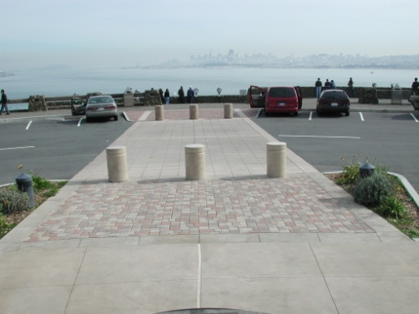 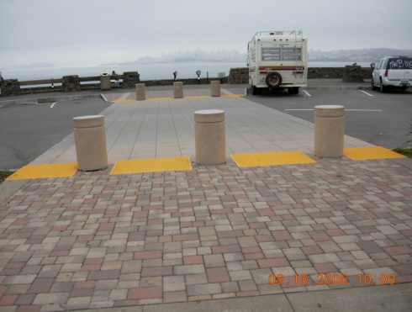

**Before After**

All curb ramps on the site are receiving truncated domes. The construction is in

progress and anticipated to be finished by the end of fiscal year.

* **Platform landing at top of ramp adjacent to the XXXXX parking lot where the wheelchair ramp leads to the XXXXXXXXX sidewalk is not 4 feet deep/wide, as required, and creates a dangerous condition with multiple cross-slopes.**

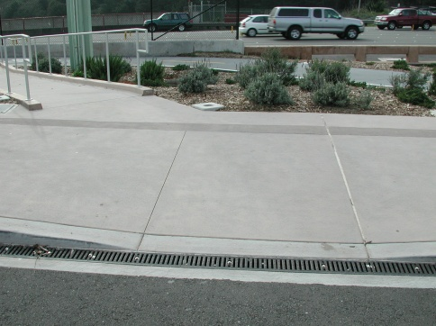 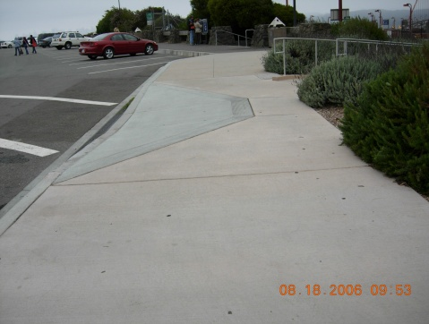

**Before After**

**(truncated domes will be added)**

The Curb ramp was moved to give 4’ landing for ramp and 4’ landing for curb ramp.

* **Pedestrians and bicycles should have separate pathways. Detectable warning surface (truncated domes) should be considered to define the separation between the bicycle trail and the pedestrian pathway**.

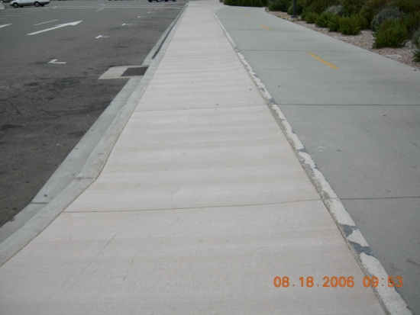

**White Stripe to be repainted under current construction contract**

STA will make no changes to the sidewalk. There is now a 4” stripe between the bike path and the sidewalk. While fixing the cross slope on the sidewalk, a small barrier was created between the sidewalk and the bike path. The 4” stripe remains at the edge of the bike path. The white stripe will be repainted under the current construction contract.

* **Van accessible signs need to be installed. There appear to be no Title 24 Department of Motor Vehicle “tow-away” signs at either the entrance to the parking area or at each accessible parking space as required by Title 24.**

At all 4 of the van accessible parking stalls, signs have been installed and a

“tow-away” sign was also installed at the entrance/exit of the site.

* **“No Parking” – sign needs to be installed at hatched areas next to disabled parking stalls.**

A “No Parking” sign was added to hatch areas indicating the aisle adjacent to the accessible space.

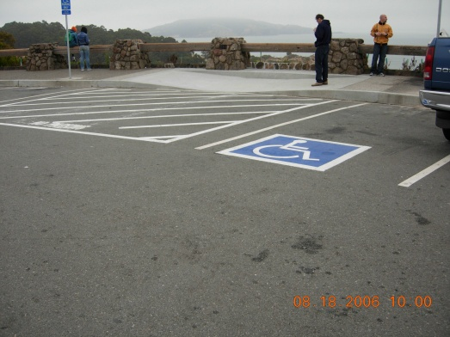

**“No Parking” sign and “Van Accessible” sign.**

**After**

* **Need Contrasting color on the noses of the tread of stairs throughout the site.**

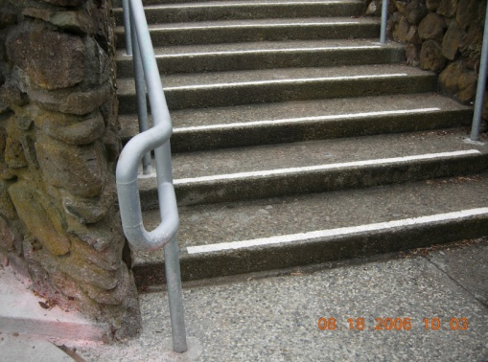

**2” non-slip and contrasting color**

All stair threads on the site have 2” non-slip and contrasting color at the edge of stair

nosing.

* **There is a problem with bottom of the gutter down spouts protruding out away from the building exterior wall and door stop installed in paving several inches from the wall.**

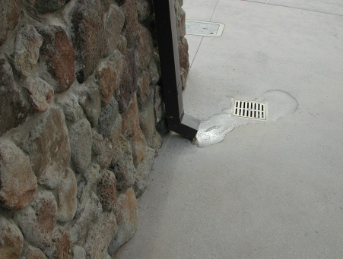 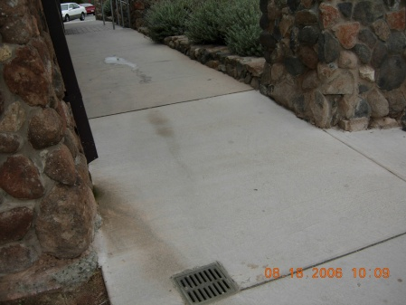

**Before After**

All protruding down spouts have been removed. The protruding down spouts in the area of the pavers has not been removed because water on pavers will cause the ground to sink.

* **Handrails need to be installed at the south-facing stairway adjacent to the XXXXXXXXXX. Railings are more than 8’ apart and there are no railings adjacent to the low walls.**

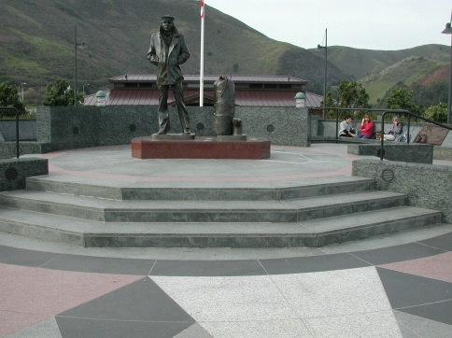 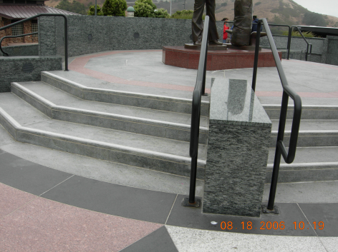

**Before After**

Handrails have been installed on both sides of the three sets of stairs leading to the XXXXXXXXX. At the top plaza where the statue is located, this area is not large enough to require handrails every 8’. Handrails were installed on both sides of all existing stairs on the site.

* **STA should provide a vibration free zone of smooth paving 36” wide.**

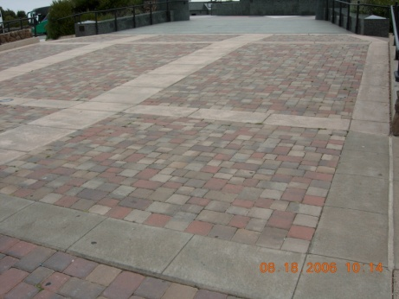

3’ wide

The plaza/ramp between the restrooms and the XXXXXXXX had a landing with a cross slope greater than 2%. This required the pavers to be reset between the granite and the flagpole. The concrete edging was expanded from 18” to 36” in two locations.

* **The ramp to the maintenance staff break room needs to have paving repaired and ramp at door improved to be compliant. Missing hand rail segments need to be replaced and compliant.**

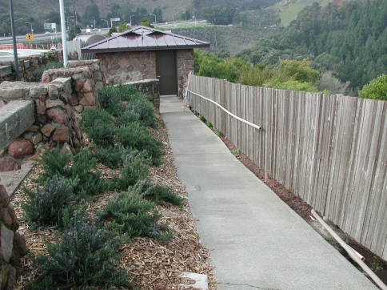 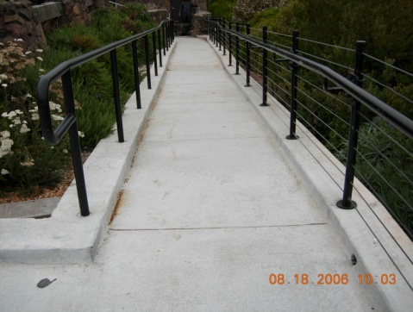

**Before After**

The ramp to the maintenance break room was removed, replaced and new handrails were installed. The ramp and handrails are now ADA compliant.

* **Drinking fountains need to be in an alcove. They are protruding from a wall in the new rest room breezeway and could be an obstacle for blind people. The bottom horizontal member on the steel rail around the drinking fountain has been omitted during construction and should be installed.**

Per the ADAAG a drinking fountain can be installed in a recessed alcove or flush mounted to a wall face with grab bar wing walls, not both. The grab bar wing wall has been replaced with a horizontal member.

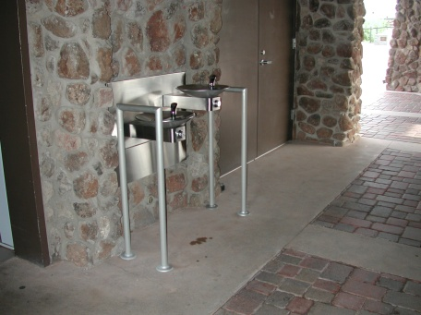

**Location of cross bar**

* **Pay telephone enclosures protrude 12” from the wall. The bottom of the telephone platform needs to be 27” above grade. The platforms are**

**28 ½” above the paving. No signage is provided to define the telephones as accessible and having volume control as required.**

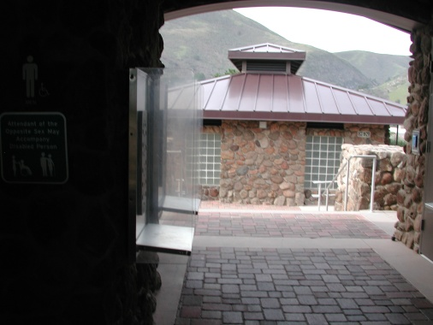

**Telephone enclosures**

**lowered to 27” above grade**

The telephone enclosures were lowered to 27” above grade. Three telephones have been installed and one is a TTY telephone with appropriate signage.

* **Recommendation -Entry gates on the restrooms must have 10” high kick plate at the bottom of each door to enable wheel chair foot petal bumpers to push the door open. The plates must be installed to be flush with the edge of door.**

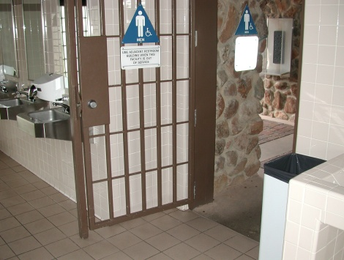

**The doors are locked in the closed position or the open position. There is no instance where a person in a wheelchair would need to push the door. Since this is a recommendation and not a code violation no action is required.**

* **Exterior doors on all the facilities should be tested for 5 pounds of closure force as required for compliance.**

All doors have been tested and adjusted to the 5 pounds of closure force as required.

* **Signage for rest rooms designating gender need to be located on the doors.**

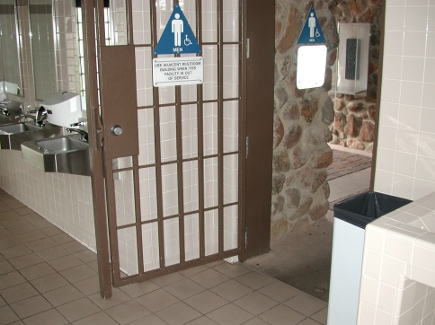

Accessible signage has been installed on the restrooms doors.

* **Gender designation sign on restroom door/gate needs to be ¼” thick.**

New signs have been installed with the ¼” thickness**.**

* **Dispensing equipment and mirror in restroom need to be 40” from floor.**

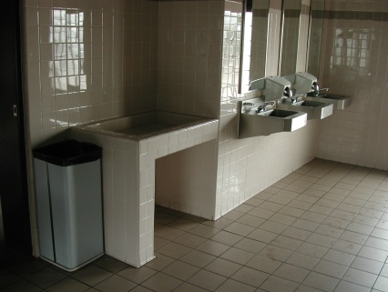

The restroom accessories are installed according to ADA requirements.

* **Recommendation – Faucets need to stay on 10 seconds.**

Faucets are electronically activated by hand movement; therefore, are exempt from the Title 24 requirements.

* **Recommendation - Push button for toilet flushing should be located on the wide side of stall wall to be ergonomically convenient.**

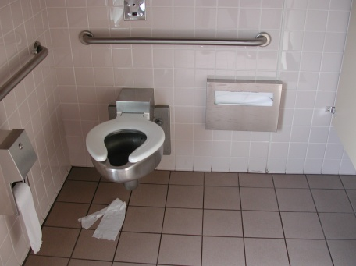

Sensor flush valves operate when an individual moves away from the toilet, placing it adjacent to the toilet may not trigger the sensor to flush. Since this is a recommendation and not a code violation no action was taken.

* **Recommendation – Wall area next to disabled toilet needs to be clear of faucets and accessories because users need to back motorized wheelchairs up next to the wall and may damage battery packs.**

The contract plans indicated that the toilet seat dispenser was located within the widened area next to the toilet for ease of accessing the seat covers. If the dispenser is mounted too low it can be relocated a maximum of 40”above the floor within the widened area. Since this is a recommendation and not a code violation no action was taken.

* **Need to have self-closing door mechanism on disabled rest room stall.**

The doors are self-closing and have required periodic adjustment by maintenance forces.

* **The lower urinal is installed too low to the floor of the restroom.**

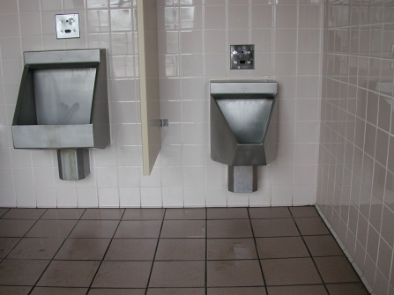

The accessible urinal has a maximum installation height of 17” at the lip of the bowl. There is no minimum requirement; the recommended range is 13” to 17” above the floor surface.

* **Fire alarms – The project require a finger pull action to activate and should be replaced with a push activated mechanism. Ergonomics may not allow a disabled person to activate the pull alarm.**

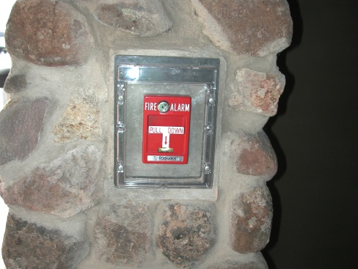

An inquiry regarding accessible requirements for fire alarm pull boxes was directed to the State Fire Marshall’s office. The State Fire Marshall’s office reported that there are no push-button, fire alarm pull boxes approved by the State Fire Marshall.

**2. Second location –**

The XXXXXXXXXX was originally built in XXXX. Accessibility improvements were performed in **year** under STA project xxxxx. An ADA Compliance Assessment for the XXXXXXXXXX was performed in **month, year** by the Respondent. The Respondent has developed short term and long term solutions. The short term solutions have been instigated. A project must be initiated for the long term solution. A request for the initiation has been made. Listed below are the Respondent’s short and long term solutions.

**Accessible Parking**

**Short Term Solutions**

* Re-assign accessible parking spaces 1 and 7 to level location;
* Request ADA exception for spaces 2, 3, 4, and 5;
* Install signage at level location for spaces 1 and 7; and,
* Patch asphalt concrete (AC) at space 5.

**Long Term Solutions**

* Re-grading accessible parking spaces;
* Excavate existing AC and base material;
* Re-grade site;
* Install AC base and cover;
* Re-stripe; and,
* Address resulting drainage issues as necessary.

**Site Accessibility**

**Short Term Solutions**

* Remedy broken drinking fountain;
* Adjust height of public phone;
* Clean landscape debris from sidewalk and build wooden wall to divert flow;
* Provide handrail at walkway;
* Replace concrete section where cracks exist in tow locations;
* Install concrete pad to transition from walkway to emergency call box; and,
* Install concrete walkway and ramp to provide access from city sidewalk to park and ride lot.

**Long Term Solutions**

* Re-construct the sidewalk;
* Re-construct bus shelter concrete pad; and,
* Raise bench to make level with replaced sidewalk.

The on-site conducted on **month, date, year** of the XXXXXXXXXX by the FHWA’s Investigator, also revealed that the pedestrian signal button is inaccessible (too high) and curb ramps at the corner are inaccessible.

1. **Third location-**

The XXXXXXXXX is located under Highway XXXX in **City, State**.

* **Inaccessible handicapped parking spaces because structural horizontal beams are lower than the 8 feet 2 inch height requirement.**

The Respondent stated that the XXXXXXXXX belongs to the **City, State**.

The Respondent has an airspace lease from the **City, State** dating back to **month, date, year**.

The Respondent will have STA’s Representatives work with the City to resolve

the issue.

The on-site conducted on **month, date, year** of the XXXXXXXXXX Facility by the FHWA’s Investigator and STA’ revealed that the parking spaces are inaccessible. The STA’ Representatives stated that as a solution to the issue they could move the inaccessible handicapped parking spaces from the beam areas and install handrails for assisting persons with disabilities to get in/out of their cars.

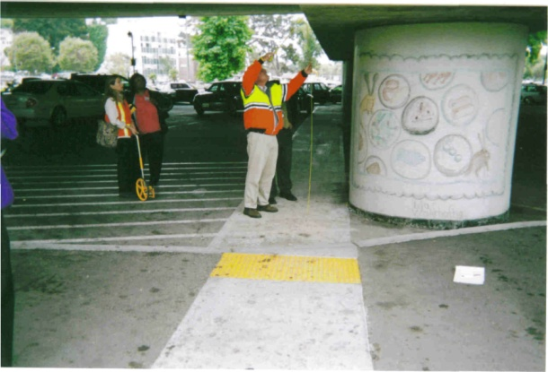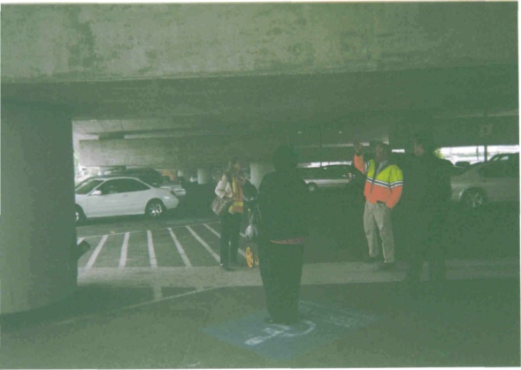

**Photo show structural horizontal beam being measured.**

**Photo show structural horizontal beams located above handicapped parking space.**

1. **Fourth location –**

The XXXXXXX Bus Shelter is located on XXXXXXXXXX in the Town of XXXXX, in XXXXX County at the North/East side of the XXXXXXX. The Bus Shelter was originally built in 1957.

* **Inaccessible for persons using wheelchairs to reach Bus Shelter/Stop**

The Respondent stated an assessment of the accessibility of the Bus Shelter was performed in

**year**. Intermediate improvements were developed and implemented in **month, year**, and

an accessible handicapped access ramp was installed at the pathway leading to the Bus Shelter/Stop, and at this time there are no further plans for improvements.

The on-site conducted on **month, date, year** of the XXXXXX Bus Shelter, revealed that an

accessible handicapped access ramp was installed at the pathway leading to the Bus

Shelter/Stop.

**Allegation #2**

**Whether ADA/Section 504 violations exist on the following projects:**

**STA’s new curb ramp standard plan**

The Respondent provided FHWA with a copy of its New Curb Ramp Standard Plan (the plan). The plan is currently being reviewed by FHWA’s Division office. The Respondent also provided FHWA with a copy of its Transition Plan dated 1997.

**Access to the STA’s’ Building in XXXXXXXX**

The Respondent stated that it planned to update both of the entrances to the Headquarters building, located at XXXXX (XXX front entrance and XXXX back entrance) in fiscal year XXX. The plan was to install a ramp at the XXXX entrance (front entrance), and to remove and replace the existing ramp at the XXXX entrance (back entrance), to bring the building into compliance with the Uniform Federal Access Standards, and Title 24 XXXX Code of Regulations. The plan to install the ramp at the XXX Street entrance was approved but the State Historic Preservation Office would not allow the ramp to be installed. An alternate plan to install a lift was developed. The lift project has been reviewed and approved by the State Fire Marshal’s Office and the Division of the State Architect, Office of Universal Design. The lift project is completed.

Funding for the new ramp project (XXX Street back entrance/existing ramp) has been received from the Department of General Services (DGS). A project number, project manager and design staff have been assigned to the project. Preliminary plans and a project estimate have been completed. Work drawings shall be completed and the bid opening is scheduled for the spring of **year**. The construction phase is scheduled for **month** through **month, year**.

The on-site conducted on **month, date, year** of the STA’s XXXXXXXX Headquarters Building, revealed, the front entrance (XXX Street entrance) is inaccessible to persons with disabilities. There is a sign posted that reads: “*Disabled Visitors Enter at XXXXX Street”* (back entrances). There is an access ramp located at the back entrance of the building (XXX Street) for persons with disabilities to enter into the building. The ramp is inaccessible for persons with disabilities because the slope is too high (exceed the 2% grade required). Photos below show both entrances to the building.

**Front entrances to building**

**Back entrance access ramp for disabled visitors**

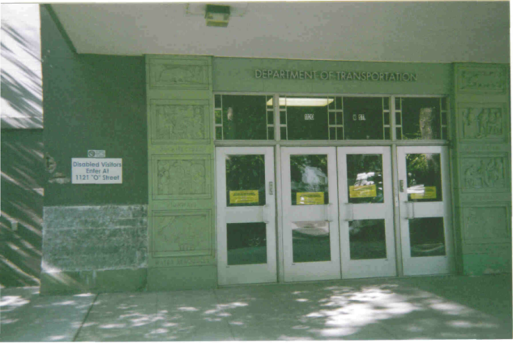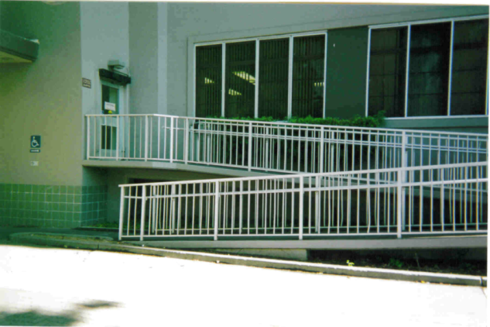

**Posted sign for disabled visitors**

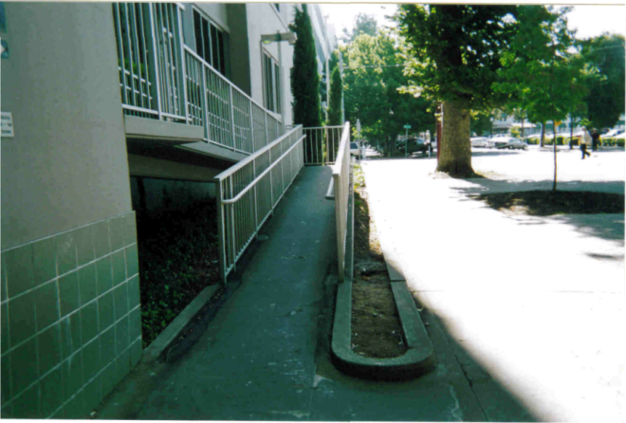**STA Signal Project**

**Slope too high (exceed 2 % grade required).**

The respondent does not have a signal project. The respondent has provided the FHWA with a copy of its “*Manual on Uniform Traffic Control Devices (MUTCD) Year XXXXX Supplement Charter 4E. Pedestrian Control Signals*.*”*

**VI. ADA Requirements**

* 28 Code of Federal Regulations (CFR) Part 35.150(a) states: *“a public entity shall operate each service, program, or activity so that the service, program, or activity, when* *viewed in its* *entirety, is readily accessible to and usable by individuals with disabilities.”*
* 28 CFR Part 35.150(2) states*: “if a public entity has responsibility or authority over*

*streets, roads, or walkways, its transition plan shall include a schedule for providing curb ramps or other sloped areas where pedestrian walks cross curbs, giving priority to walkways serving entities covered by the Act, including State and local government offices and facilities, transportation, places of public accommodation, and employers, followed by walkways serving other areas.”*

**VII.****Conclusion**

Based on the information reviewed during the investigation, the FHWA finds that the STA is in violation of the ADA with regard to the locations and the items outlined below:

1. **XXXXXXXXXXXXXXXXXXX**

* Inaccessible parking spaces;
* Inaccessible sidewalk;
* Inaccessible bus shelter;
* Lack of required signage;
* Inaccessible pedestrian signal button;
* Inaccessible curb ramps at corners;
* Inaccessible drinking fountain;
* Inaccessible public phone;
* No handrail at walkway;
* Cracks in tow locations;
* Inaccessible walkway to emergency call box; and,
* No access from city sidewalk to park and ride lot.

2. **XXXXXXXXXXXXXXXXXXXXXXXXX**

* Inaccessible parking spaces.

3**. XXXXXXXXXXXXXXXXXXXXX**

* Inaccessible access ramp located at back entrance of building.

**VIII.** **Recommendations**

The FHWA recommends that STA update its Transition Plan within the next six months to include the New Curb Ramp Standard Plan, and the Manual on Uniform Traffic Control Devices (MUTCD) Year XXXXXX XXXXXXXXXXXXXXX. The Transition Plan should include a schedule and timetable for completion of all work.

The FHWA will request STA address the issues outlined above within the next six months.

U.S. Department of Transportation

Federal Highway Administration

Headquarters, Office of Civil Rights,

Investigations and Adjudication Unit

Southeast Federal Center

1200 New Jersey Avenue, SE

HCR-40, Room E81-101

Washington, DC 20590

202/366-0693 or Fax: 202/366-1599

TTY: 202/366-5751

Visit us on the Web:

<http://www.fhwa.dot.gov/civilrights/index.htm>