SHRP2 Implementation Assistance Program
Round 4 Application Form - Application period closes June 27, 2014.

Economic Analysis Tools (C03/C11)
C11 Lead Adopter Incentive Application

FHWA Product Lead Name: Stefan Natzke, Stefan.Natzke@dot.gov, 202-366-5010

This SHRP2 Solution is part of Round 4 of the Implementation Assistance Program. For more information about this product or about applying for implementation assistance, visit the Implementation Assistance Program page (http://www.fhwa.dot.gov/GoSHRP2/ImplementationAssistance) or this product’s application page (where this form originated) on the GoSHRP2 website.

Point of Contact:
The SHRP2 Implementation Assistance Program is designed to foster peer learning, and as a result, applicants are encouraged to share their experience implementing SHRP2 products with others. By submitting this application, your organization grants permission to FHWA to publish and distribute the name and business email address of a staff member from the applying organization who is familiar with the project. Please provide:
POC Name: Provide your response here.
POC Business Email Address: Provide your response here.

Questions:
- Describe your organization’s interest and goals for adopting economic analysis tools within transportation planning and project development?

Provide your response here.

- Briefly describe your agency’s current use of economic analysis in transportation planning and project development (note: this information will only be used for benchmarking and does not automatically exclude your application or give it greater priority).

Provide your response here.

- Briefly describe your agency’s past efforts to apply economic analysis within transportation planning and project development (e.g., at what stages and using what tools).

Provide your response here.

- Describe the specific planning/project development problem you are trying to address with the application of these economic analysis tools. At which stage(s) do you intend to utilize the tools? What do you hope to gain?

Provide your response here.

- Identify which stage of the planning process depicted in the graphic below you intend to use the C11 spreadsheet tools. Explain how better understanding the reliability, connectivity, and accessibility impacts of different types of transportation investments will be useful at that stage.
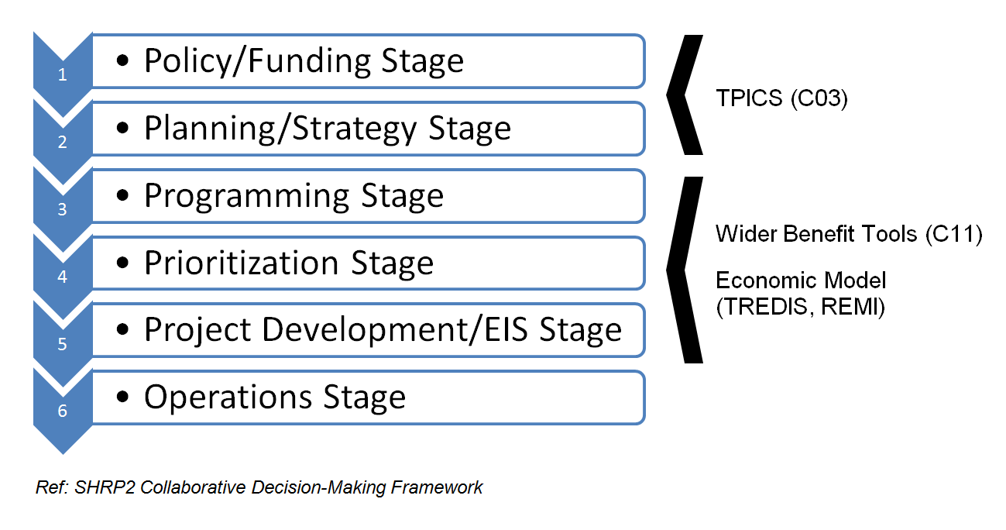

Provide your response here.

- Briefly describe your work plan (tasks, deliverables and approximate dates; no more than 1 page total) for your use of the implementation assistance.

Provide your response here.

- To what extent, if any, will methods from other SHRP2 products (e.g., L02/L05/L07/L08/C11 bundle) be integrated into this work plan?

Provide your response here.

- Describe who your agency will partner with during implementation of this product. What partnerships, if any, are planned with other agencies, and what expertise will they bring?

Provide your response here.

- What is your expected level of agency staff, consultant and university involvement? What cost / labor match, if any, is being provided?

Provide your response here.

- How do you plan to use the information that will result from use of these economic analysis tools? Specifically, how will they be used to inform the agency’s decision-making process?

Provide your response here.

- Describe challenges / risks you expect to encounter in implementation, and how you plan to address them.

Provide your response here.

As a reminder:
- Review all background information located on this product’s application page.
- Once you have completed this form and secured the required Leadership Endorsement Letter, return to application page and complete the contact information fields.
- Upload this form and the Leadership Endorsement Letter to the page. Be sure you are attaching the form to the correct application page.
- Click “Submit;” you will receive an email confirmation that includes the uploaded endorsement letter and application form.
- Application period will close June 27, 2014.
For more information or to find this product’s application page, visit the Implementation Assistance Program page (http://www.fhwa.dot.gov/GoSHRP2/ImplementationAssistance) on the GoSHRP2 website.

