2009 LaDOTD Bridge Move

I-49 over LA 526 (Bert Kouns Expressway)

An LaDOTD three-span continuous composite steel box girder bridge had a damaged segment moved with SPMTs in July 2009. The 86-ft long by 21-ft wide steel-box-girder-and-deck segment was removed and replaced by Barnhart under contract with Gibson and Associates. The bridge is the southbound I-49 structure over LA 526 (Bert Kouns Industrial Loop/Expressway).

LaDOTD contract documents encouraged SPMTs explicitly in the General Notes and in the provided contract time and closure constraints, but had no specific requirements for the use of SPMTs. The Contractor elected to use SPMTs (see photos, page 2) to remove the damaged segment, and a crane to place the new girder.

A presentation on this project will be given at the January 2011 Louisiana Transportation Conference in Baton Rouge.

For more information, contact:
Kelly M. Kemp, P.E.
LA DOTD Bridge and Structural Design Section
Phone: 225-379-1809
Email: Kelly.Kemp@la.gov

SPMT Bridge Move Photos
2009 Louisiana DOTD I-49 over LA 526 (Bert Kouns Industrial Loop/Expressway)

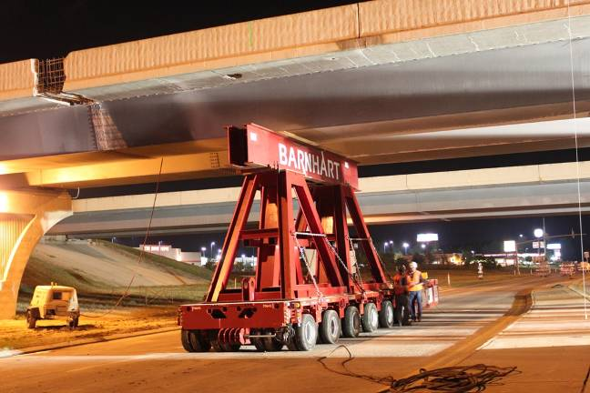 | 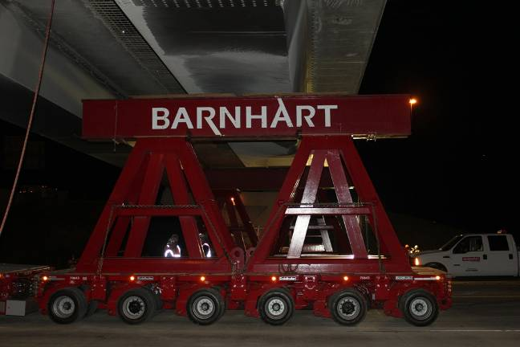
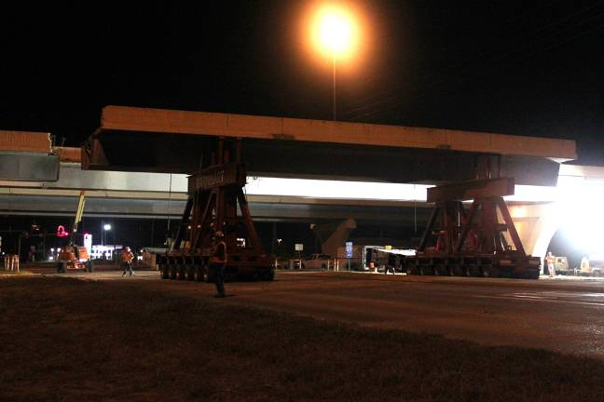 | 