Chapter IV

Universe and Sample Data Requirements

Universe Data
Certain basic inventory information is required to be reported for all open-to-traffic, public road systems in the universe portion of the HPMS data set (Items 1-46). The total length reported for all open-to-traffic records should agree with the Certified Public Road Mileage. Limited universe data for facilities on planned National Highway System (NHS) roadways that are not yet built or open to traffic also are to be reported. Universe data must be reported on a section-by-section basis for all rural arterials, urban principal arterials, the NHS and all standard sample and donut area supplemental sample sections; universe data may be reported for the remaining functional systems on a grouped length basis.

Standard Sample Data
Additional detailed information is required for a statistically chosen sample of roadways on major functional systems. The sampled functional systems include all but the rural minor collector, rural local, and urban local systems. The additional detailed data are reported for the standard sample portion of the HPMS data set (Items 47-98). The standard sample is intended to represent all applicable systems both on and off the State highway system. The standard sample is used for a variety of purposes including performance measurement, investment requirements modeling in support of Condition and Performance Reports to Congress, policy, other analyses, and in various publication media.

Donut Area Sample Data
An additional sample is required for the donut area portions of NAAQS nonattainment and maintenance areas that use the HPMS as the basis of VMT estimates for air quality travel tracking and conformity purposes. The donut area supplementary sample consists of sections in the rural and small urban minor arterial, rural major collector, and small urban collector functional systems that are located outside of urbanized area(s), but within the nonattainment or maintenance area boundary. The donut area supplementary sample is used to enhance the existing standard sample to achieve higher confidence levels for travel estimates. The purpose of the donut area supplementary sample is limited to the development of travel estimates. The combination of existing standard samples in the donut area plus the donut area supplementary samples makes up the donut area sample.

In addition to the universe data items, donut area supplementary sample sections need only have sample data Items 47 and 48 coded.

Coding Nonuniform Roadways
The HPMS is an inventory system that requires reported data to represent both directions of roadway condition and operation. As a result, conflicts in data item coding may arise for specific data items under certain reporting conditions. The following provides some guidance in addressing conflicts.

Data items that involve widths, types, condition, etc., may differ in shape or dimension on each side of a roadway. To resolve this, choose one side of the facility for inventory purposes and code only the applicable data items for the chosen side of the highway. This should be done for all roadways, whether divided or undivided with common or independent alignments. The “inventory direction” should be chosen on a statewide basis (i.e., always South to North, East to West, or vice versa) and once selected never changed.

Some data items such as AADT, number of through lanes, median width, etc., reflect the complete two-way facility. Exercise extra care when reporting through lane counts and AADT because these data are used for apportionment purposes.

Appendix E requires IRI to be reported for the same direction and lane all of the time. The “inventory direction” of a facility should be used as the side where IRI is measured and reported. IRI should not be reported or averaged for both sides of a roadway.

Averages can be used for some dimensioned items that change back and forth over a section length (i.e., median width, shoulder width). In situations where a condition changes back and forth between two or more possible types over the section length, the predominant condition can be reported (i.e., shoulder type, surface type). In both cases, the lesser or worse measurement or condition for the roadway section can be reported instead.

If one part of an existing section becomes very different from the other due to a change, for instance, in the number of lanes, urban/rural break, new construction, etc., the predominant condition cannot be reported and the existing section may need to be split. A full discussion of this topic and a list of the changes that require sample splitting can be found in Chapter VII.

Structure Treatment
The total length of all public roads, including structures, must be represented in the HPMS; note that a ferryboat is not a public road and should not be reported in HPMS. Where structures are a part of a universe or standard sample section, the reported data items should reflect the off-structure roadway conditions. However, since the HPMS standard sample is intended to represent the off-structure roadway and its conditions, standard sample sections that exist entirely on structures should be avoided if at all possible. Structures should be used as standard samples only when a volume group sample size requirement cannot be satisfied without inclusion of a structure-only section and the section cannot be combined with a roadway section.

Existing standard sample sections totally on structures should be eliminated in favor of standard sample sections on off-structure roadways where possible. Alternately, on-structure standard samples can be combined with adjacent roadway sections and the roadway characteristics reported in HPMS. When choosing new standard samples, delete any sections that are totally on structures from the list of candidates.

When a section is entirely on a structure, only the following data items need be reported, as applicable:

Universe data items: 1-34; 37-46
Sample data items: 47-49; 54; 56; 57; 80-84; 97; 98

Code all other data items “0” or “0.0” as appropriate. Supplementary donut area sample sections that are totally on structures are permitted.

Planned Unbuilt Facility
Limited data for unbuilt facilities are included in HPMS for NHS routes only. Unbuilt facilities should only be included if there are plans for the route to be built. For unbuilt sections, only universe data items 1-19 and 30 are required.

General Reporting Requirements
The HPMS data are used for a variety of purposes ranging from apportionment of highway funds to public information; therefore, the use of a data item governs the HPMS required coding. Although reporting agencies may have a need for highway inventory data coded differently from the HPMS, the State's highway inventory data system must nevertheless be capable of providing the HPMS data according to the coding requirements contained in this Manual. If there is not a one-for-one relationship between the State data inventory system and the HPMS coding requirements, the State may need to obtain additional data, revise its inventory data coding to match the HPMS, or provide means to aggregate, disaggregate, or convert State inventory data into data that meets HPMS coding requirements. Where the State has a need for a data item or some physical attribute that is not needed for HPMS, the data can be retained in the State's inventory system.

Data Item Summary Table
In the following data item summary tables (Tables IV-1 and IV-2), an “A” indicates that the item is required for all universe, standard sample, and supplementary donut area sample sections; an “S” indicates that the item is required only if the section is a standard sample; and a “D” indicates that the item is required only if the section is a supplementary donut area sample. A blank indicates that the data item is not coded for the functional system. The following abbreviations are used in the column headings.

PAS/  NHS | Principal arterial system (PAS) includes rural and urban Interstate, urban other freeways and expressways, and rural and urban other principal arterial functional systems; National Highway System (NHS) is made up primarily of these same systems, plus a minor amount of roadways on other functional systems.
Int | Interstate
OFE | Other Freeways and Expressways
OPA | Other Principal Arterial
MA | Minor Arterial
MaC | Major Collector
MiC | Minor Collector
Col | Collector
Loc | Local

Do not rely solely on the data item summary table for data coding requirements. A number of data items require additional discussion regarding the type of section to which the data coding applies. For example, although the summary table indicates that Percent Passing Sight Distance (Item 78) is required for the rural standard sample sections, it is required only for rural paved, two-lane facilities.

Table IV-1. Universe Data Summary

Item  No. | Required Universe Items |  |  |  |  |  |  |  | Data Item | Data Type
Item  No. | Rural |  |  |  | Urban |  |  |  | Data Item | Data Type
Item  No. | PAS/ NHS | MA | MaC | MiC &  Loc | PAS/ NHS | MA | Col | Loc | Data Item | Data Type
IDENTIFICATION
1 | A | A | A | A | A | A | A | A | Year of Data | Numeric; Integer
2 | A | A | A | A | A | A | A | A | State Code | Numeric; Codes
3 | A | A | A | A | A | A | A | A | Reporting Units- Metric or English | Numeric; Codes
4 | A | A | A | A | A | A | A | A | County Code | Numeric; Codes
5 | A | A | A | A | A | A | A | A | Section Identification | Character Field
6 |  |  |  |  |  |  |  |  | Is Standard Sample | Numeric; Codes
7 |  |  |  |  |  |  |  |  | Is Donut Sample | Numeric; Codes
8 |  |  |  |  |  |  |  |  | State Control Field | Character Field
9 | A | A | A | A | A | A | A | A | Is Section Grouped? | Numeric; Codes
10 | A | A |  |  | A |  |  |  | LRS Identification* | Character Field
11 | A | A |  |  | A |  |  |  | LRS Beginning Point* | Numeric; Decimal
12 | A | A |  |  | A |  |  |  | LRS Ending Point* | Numeric; Decimal
13 | A | A | A | A | A | A | A | A | Rural/Urban Designation | Numeric; Codes
14 |  |  |  |  | A | A | A |  | Urbanized Area Sampling Technique | Numeric; Integer
15 |  |  |  |  | A | A | A | A | Urbanized Area Code | Numeric; Codes
16 | A | A | A | A | A | A | A | A | NAAQS Nonattainment Area Code | Numeric; Codes

SYSTEM
17 | A | A | A | A | A | A | A | A | Functional System Code | Numeric; Codes
18 | A | A | A | A | A | A | A | A | Generated Functional System Code | Software Calculated
19 | A | A | A | A | A | A | A | A | National Highway System (NHS) | Numeric; Codes
20 | A |  |  |  | A |  |  |  | Planned Unbuilt Facility | Numeric; Codes
21 | A |  |  |  | A |  |  |  | Official Interstate Route Number | Character Field
22 | A | A |  |  | A |  |  |  | Route Signing* | Numeric; Codes
23 | A | A |  |  | A |  |  |  | Route Signing Qualifier* | Numeric; Codes
24 | A | A |  |  | A |  |  |  | Signed Route Number* | Character Field

JURISDICTION
25 | A | A | A | A | A | A | A | A | Governmental Ownership | Numeric; Codes
26 | A | A | A | A | A | A | A | A | Special Systems | Numeric; Codes

OPERATION
27 | A | A | A | A | A | A | A | A | Type of Facility | Numeric; Codes
28 | A | A | A | A | A | A | A | A | Designated Truck Route | Numeric; Codes
29 | A | A | A | A | A | A | A | A | Toll | Numeric; Codes

OTHER
30 | A | A | A | A | A | A | A | A | Section Length | Numeric; Decimal
31 |  | A | A |  |  | A | A |  | Donut Area Sample AADT Volume Group Identifier | Numeric; Integer
32 | A | A | A |  | A | A | A |  | Standard Sample AADT Volume Group Identifier | Numeric; Integer
33 | A | S&D | S&D |  | A | S&D | S&D |  | AADT* | Numeric; Integer
34 | A | A | A |  | A | A | A |  | Number of Through Lanes | Numeric; Integer
35 | A | S |  |  | A |  |  |  | Measured Pavement Roughness (IRI)* | Numeric; Decimal
36 |  |  | S |  |  | S | S |  | Present Serviceability Rating (PSR) | Numeric; Decimal
37 | A | A | A | A | A | A | A | A | High Occupancy Vehicle (HOV) Operations | Numeric; Codes
38 | A | A | A | A | A | A | A | A | Electronic Surveillance | Numeric; Codes
39 | A | A | A | A | A | A | A | A | Metered Ramps | Numeric; Codes
40 | A | A | A | A | A | A | A | A | Variable Message Signs | Numeric; Codes
41 | A | A | A | A | A | A | A | A | Highway Advisory Radio | Numeric; Codes
42 | A | A | A | A | A | A | A | A | Surveillance Cameras | Numeric; Codes
43 | A | A | A | A | A | A | A | A | Incident Detection | Numeric; Codes
44 | A | A | A | A | A | A | A | A | Free Cell Phone | Numeric; Codes
45 | A | A | A | A | A | A | A | A | On-Call Service Patrol | Numeric; Codes
46 | A | A | A | A | A | A | A | A | In-Vehicle Signing | Numeric; Codes
End of universe data items.

Key: A = Code for "All" universe, standard sample, and supplementary donut area sample sections.
S = Code for all "Standard" sample sections.
D = Code for all "Donut" area supplementary sample sections.
* = See individual data item for exceptions.

Table IV-2 Sample Data Summary
Item  No. | Required Sample Items |  |  |  |  |  |  |  |  | Data Item | Data Type
Item  No. | Rural |  |  |  | Urban |  |  |  |  | Data Item | Data Type
Item  No. | Int | OPA | MA | MAC | Int | OFE | OPA | MA | Col | Data Item | Data Type
IDENTIFICATION
47 | S | S | S&D | S&D | S | S | S | S&D | S&D | Sample Identifier | Character Field

COMPUTATIONAL
48 |  |  | D | D |  |  |  | D | D | Donut Area Sample Expansion Factor | Software Calculated
49 | S | S | S | S | S | S | S | S | S | Standard Sample Expansion Factor | Software Calculated
PAVEMENT
50 | S | S | S | S | S | S | S | S | S | Surface/Pavement Type | Numeric; Codes
51 | S | S | S | S | S | S | S | S | S | SN or D | Numeric; Decimal
52 | S | S | S | S | S | S | S | S | S | General Climate Zone | Software Set
53 | S | S | S | S | S | S | S | S | S | Year of Surface Improvement | Numeric; Integer
GEOMETRICS
54 | S | S | S | S | S | S | S | S | S | Lane Width | Numeric; Decimal
55 | S | S | S | S | S | S | S | S | S | Access Control | Numeric; Codes
56 | S | S | S | S | S | S | S | S | S | Median Type | Numeric; Codes
57 | S | S | S | S | S | S | S | S | S | Median Width | Numeric; Decimal
58 | S | S | S | S | S | S | S | S | S | Shoulder Type | Numeric; Codes
59 | S | S | S | S | S | S | S | S | S | Shoulder Width -Right | Numeric; Decimal
60 | S | S | S | S | S | S | S | S | S | Shoulder Width - Left | Numeric; Decimal
61 |  |  |  |  | S | S | S | S | S | Peak Parking | Numeric; Codes
62 | S | S | S | S | S | S | S | S | S | Widening Feasibility | Numeric; Codes
63 | S | S | S |  | S | S | S |  |  | Length Class A Curves | Numeric; Decimal
64 | S | S | S |  | S | S | S |  |  | Length Class B Curves | Numeric; Decimal
65 | S | S | S |  | S | S | S |  |  | Length Class C Curves | Numeric; Decimal
66 | S | S | S |  | S | S | S |  |  | Length Class D Curves | Numeric; Decimal
67 | S | S | S |  | S | S | S |  |  | Length Class E Curves | Numeric; Decimal
68 | S | S | S |  | S | S | S |  |  | Length Class F Curves | Numeric; Decimal
69 |  |  |  | S |  |  |  |  |  | Horizontal Alignment Adequacy* | Software Calculated
70 | S | S | S | S |  |  |  |  |  | Type of Terrain | Numeric; Codes
71 |  |  |  | S |  |  |  |  |  | Vertical Alignment Adequacy* | Software Calculated
72 | S | S | S |  | S | S | S |  |  | Length Class A Grades | Numeric; Decimal
73 | S | S | S |  | S | S | S |  |  | Length Class B Grades | Numeric; Decimal
74 | S | S | S |  | S | S | S |  |  | Length Class C Grades | Numeric; Decimal
75 | S | S | S |  | S | S | S |  |  | Length Class D Grades | Numeric; Decimal
76 | S | S | S |  | S | S | S |  |  | Length Class E Grades | Numeric; Decimal
77 | S | S | S |  | S | S | S |  |  | Length Class F Grades | Numeric; Decimal
78 | S | S | S | S |  |  |  |  |  | Percent Passing Sight Distance* | Numeric; Integer
TRAFFIC/CAPACITY
79 |  |  |  |  |  |  |  |  |  | Weighted Design Speed | Software Calculated
80 | S | S | S | S | S | S | S | S | S | Speed Limit | Numeric; Integer
81 | S | S | S | S | S | S | S | S | S | Percent Single Unit Trucks - Peak | Numeric; Integer
82 | S | S | S | S | S | S | S | S | S | Percent Single Unit Trucks - Average Daily | Numeric; Integer
83 | S | S | S | S | S | S | S | S | S | Percent Combination Trucks - Peak | Numeric; Integer
84 | S | S | S | S | S | S | S | S | S | Percent Combination Trucks -Average Daily | Numeric; Integer
85 | S | S | S | S | S | S | S | S | S | K-Factor | Numeric; Integer
86 | S | S | S | S | S | S | S | S | S | Directional Factor | Numeric; Integer
87 | S | S | S | S | S | S | S | S | S | Number of Peak Lanes | Numeric; Integer
88 |  |  |  |  | S | S | S | S | S | Left Turning Lanes | Numeric; Codes
89 |  |  |  |  | S | S | S | S | S | Right Turning Lanes | Numeric; Codes
90 |  |  |  |  | S | S | S | S | S | Prevailing Type of Signalization | Numeric; Codes
91 |  |  |  |  | S | S | S | S | S | Typical Peak Percent Green Time* | Numeric; Integer
92 | S | S | S | S | S | S | S | S | S | Number At-Grade Intersections - Signals | Numeric; Integer
93 | S | S | S | S | S | S | S | S | S | Number At-Grade Intersections - Stop Sign | Numeric; Integer
94 | S | S | S | S | S | S | S | S | S | Number At-Grade Intersections - Other/No Control | Numeric; Integer
95 | S | S | S | S | S | S | S | S | S | Peak Capacity | Software Calculated
96 | S | S | S | S | S | S | S | S | S | Volume/Service Flow Ratio (V/SF) | Software Calculated
97 | S | S | S | S | S | S | S | S | S | Future AADT | Numeric; Integer
98 | S | S | S | S | S | S | S | S | S | Year of Future AADT | Numeric; Integer
End of sample data items.
Key: A = Code for "All" universe, standard sample, and supplementary donut area sample sections.
S = Code for all "Standard" sample sections.
D = Code for all "Donut" area supplementary sample sections.
* = See individual data item for exceptions.

General Coding Instructions
Data items in the summary table are denoted in the Data Type column as having either “numeric” or “character” reporting specifications.
For numeric data items:
- leading zero must be coded in decimal value when the value is less than an integer (length = 0.21); otherwise, leading zeros are not required
- decimal points are required for all data items labeled “Numeric; Decimal,” i.e., those reported in tenths, hundredths, or thousandths (PSR = 2.2; length = 10.252, etc.)
- one digit must be coded after a decimal point for all data items labeled “Numeric; Decimal”
- (PSR = 3 must be coded 3.0); additional trailing zeros are not required for the decimal portion
- when data is not available, code “0” or “0.0” as appropriate
For character data items:
- any alphanumeric character (A through Z; 0 through 9; space) may be coded
- do NOT use double quotes (“) within the character string
For data items with assigned values (codes):
- select the appropriate value from the table
- the value must be coded precisely as listed in the table

Data Coding Instructions
Item 1 — Year of Data (Numeric; Integer)
Enter the four digits of the calendar year for which the data apply. The HPMS software is “year 2000” compliant.

If adding a section while working in the HPMS software, the year will automatically be set based on the year in which the user is working. The year is displayed on top of the screen.

Item 2 — State Code (Numeric; Codes)
The State FIPS code is used in the HPMS database to identify the reporting State. Enter the State FIPS code as listed in Appendix A.

If adding a section while working in the HPMS software, the State code will automatically be coded based on the State selected. The State name is displayed on top of the screen.

Item 3 — Reporting Units - Metric or English (Numeric; Codes)
Code for all sections to indicate the units used to report measured and other measurement related data items. All data submitted to FHWA must be in metric units; the HPMS software will automatically convert all data to metric during the FHWA submit process. The same reporting unit must be used for all applicable data items for the entire data set. There can be no mixing of units within the data set.

Code | Description
0 | Section data is coded using the English system of unit measurement (miles, feet, inches, etc.).
1 | Section data is coded using the modernized metric system of unit measurement known as the SI (kilometers, meters, millimeters, etc.).

Most used soft conversions:
1 mile = 1.609344 kilometers 1 foot = 0.3048 meters = 304.8 millimeters
1 square mile = 2.59 square kilometers 1 inch = 0.0254 meters = 25.4 millimeters

Most used hard conversions:
11 foot lane = 3.3 meters 10 foot lane or shoulder = 3.0 meters
12 foot lane = 3.6 meters 55 mph = 90 km/h
8 foot shoulder = 2.4 meters 65 mph = 105 km/h

Reference: American Association of State Highway Transportation Officials (AASHTO) Guide To
Metric Conversion, 1993

Hard conversion of data Items 54 (Lane Width); 59 and 60 (Shoulder Width); 79 (Weighted Design Speed); and 80 (Speed Limit) is preferred. A soft conversion for data Item 35, Measured Pavement Roughness, is provided in Appendix E as 63.36 inches/mile = 1.0 meter/kilometer.

HPMS conversion software is discussed in Appendix L; the software will perform the appropriate conversions of all of the applicable data items from English to Metric.

Item 4 — County Code (Numeric; Codes)
The FIPS county code permits analysis and mapping of information at a sub-State level. Enter the three-digit FIPS county code from FIPS Publication 6-4, Counties and Equivalent Entities of the United States, Its Possessions, and Associated Areas. Use county equivalents in HPMS for the following:
State | County Equivalent
Alaska | Highway Districts
Louisiana | Parishes
Puerto Rico | Municipio Districts

In the HPMS software, the County Names table must be kept current. To add a county, modify a county name, or delete a county code, select “Tools/County Names.” When adding a section, the county code must be in the County Names table or the system will not allow the section to be added.

Item 5 — Section Identification (Character Field)
This item permits locating specific roadway section data within the HPMS database. This item must contain a 12-character countywide unique identifier. It provides flexibility to identify sections in accordance with a State's needs independent of the unique identifier that must be maintained for sample sections. This item may be defined to suit the needs of the State and may contain any right-justified alphanumeric character.

- For all individually reported sections (code “0” in item 9), supply a countywide unique section identifier. This may be a location specific identifier such as route kilometerpoint (milepoint), A-node/B-node, or a unique number.
- For highways reported as grouped sections (code “1” in Item 9), provide a countywide, unique group identifier. REMINDER: Only nonsample urban minor arterial, collector and local, and nonsample rural major and minor collector and local data can be grouped; NHS routes cannot be grouped regardless of functional system.

Examples:

1. Section Identifier (Item 9 = 0)
Use any countywide unique identifier with no more than 12 “right justified” characters. An example using a location specific identifier:

Interstate Inventory Route 56, Kilometerpoint 4.321
Code | 0 | 0 | 0 | I | 5 | 6 | 0 | 0 | 4 | 3 | 2 | 1

2. Grouped Length (Item 9 = 1)
Use any countywide unique identifier - no limit on number of digits. An example using a unique number:

Grouped Length Record 98365
Code | 0 | 0 | 0 | 0 | 0 | 0 | 0 | 9 | 8 | 3 | 6 | 5

Item 6 — Is Standard Sample (Numeric; Codes)
This data item is used by the software to indicate if a section is a standard sample.

Code | Description
0 | Section is not a standard sample.
1 | Section is a standard sample.

Item 7 — Is Donut Sample (Numeric; Codes)
This data item is used by the software to indicate if the section is a donut sample.

Code | Description
0 | Section is not a donut sample.
1 | Section is a donut sample.

If a section is:
- a universe section only, code “0” for both Items 6 and 7;
- both a standard sample and a donut sample, code “1” for both Items 6 and 7;
- a donut sample, code “0” for Item 6 and code “1” for Item 7;
- a standard sample, code “1” for Item 6 and code “0” for Item 7.

Item 8 — State Control Field (Character Field)
This is a data item of up to 100 alphanumeric characters for State use for identification or any other purpose. It may contain any keyboard characters; however, do not use binary zeros or double quotes. FHWA does not use this data item.

Item 9 — Is Section Grouped? (Numeric; Codes)
This item is used by the software to indicate whether the data reported are for a single section or for a group of sections.

Code | Description
0 | Individual Section Data
1 | Grouped Section Data

Use code “0” for all sections, including universe, standard sample, and supplementary donut area sample sections that are being reported on an individual section basis. Code “0” must be used for all principal arterial system (PAS), rural Minor Arterial, and NHS sections - grouping within these systems is not permitted.

Use the grouped length code “1” only when grouping homogeneous sections for reporting purposes; contiguous sections should not be reported as grouped sections. Only nonsample rural major collector, rural minor collector, rural local, nonsample urban minor arterial, nonsample urban collector, and urban local system sections not on the NHS can be grouped. Grouping may only be done when the data for Items 4; 13-17; 25-29; and 31-32 are homogeneous across all sections being grouped.

Item 10 — LRS Identification (Character Field)
This item, along with Items 11 and 12, permits users to reference HPMS information to the map location of road sections. Code for all PAS, NHS, and rural minor arterial system sections, in conjunction with LRS beginning and ending points (Items 11 and 12). More information concerning the LRS may be found in Chapter V, Linear Referencing System Requirements.

Inventory Route and Subroute Numbers for LRS Use:
The inventory route and subroute numbers reported in this item must be consistent with the inventory route and subroute numbers identified on the Inventory Route and Node Maps and in the Inventory Route Link Data File discussed in Chapter V, Linear Referencing System Requirements.

The inventory route number is a 10-character, right justified value. The LRS inventory route number can be alphanumeric, but must not contain blanks; leading zeros must be coded. The inventory route number is not necessarily the same as that posted along the roadway, but is a number used to uniquely identify a route within at least a county or, alternately, throughout the State. The inventory route number is followed by a 2-character numeric subroute number that uniquely identifies the AHEAD and BACK portions of an inventory route section where duplicate kilometerpoints (KMPTs) [milepoints (MPTs)] occur.

Example: Inventory Route 63951, Subroute Number 2
Code | 0 | 0 | 0 | 0 | 0 | 6 | 3 | 9 | 5 | 1 | 0 | 2

Item 11 — LRS Beginning Point (Numeric; Decimal)
This item, along with Items 10 and 12, permits users to reference HPMS information to the map location of road sections. Code this item for all PAS, NHS, and rural minor arterial system section records for the purpose of establishing an LRS. This numeric item must be coded with the beginning KMPT (MPT) for the section on the inventory route and for the subroute number coded in the LRS Identification (Item 10).

The KMPT (MPT) for the section must be consistent with the LRS information found on the Inventory Route and Node Maps and in the Inventory Route Link Data File for a particular route and subroute. In order to be consistent, section breaks must adhere to the conditions listed in Chapter V, particularly under the section titled “Effects of LRS on HPMS Sections.” See Chapter V for a full discussion on coding of the Linear Referencing System.

Code “0.0” for this item if LRS information is not provided. Code the beginning KMPT (MPT) to three decimal points. The KMPT (MPT) represents the distance in kilometers (miles) from a set reference point to the beginning of the highway segment and is the lowest KMPT (MPT) of the section.

The KMPT (MPT) numbering format should be such that the combination of county, inventory route number, subroute number, and KMPT (MPT) information will define a unique location.
Example: Beginning kilometerpoint 98.252 for the inventory route and subroute number coded in Item 10:
Code | 9 | 8 | . | 2 | 5 | 2

Item 12 — LRS Ending Point (Numeric; Decimal)
This item, along with Items 10 and 11, permits users to reference HPMS information to the map location of road sections. Code this item for all PAS, NHS, and rural minor arterial system section records for the purpose of establishing an LRS. This numeric item must be coded with the ending KMPT (MPT) for the section on the inventory route and for the subroute number coded in the LRS Identification (Item 10).

The KMPT (MPT) for the section must be consistent with the LRS information found on the Inventory Route and Node Maps and in the Inventory Route Link Data File for a particular route and subroute. In order to be consistent, section breaks must adhere to the conditions listed in Chapter V, particularly under the section titled “Effects of LRS on HPMS Sections.” See Chapter V for a full discussion on coding of the Linear Referencing System.

Code “0.0” for this item if LRS information is not provided. Code the ending KMPT (MPT) to three decimal points. The KMPT (MPT) represents the distance in kilometers (miles) from a set reference point to the end of the highway segment and is the highest KMPT (MPT) of the section.

The KMPT (MPT) numbering format should be such that the combination of county, inventory route number, subroute number, and KMPT (MPT) information will define a unique location.

Example: Ending kilometerpoint 101.206 for the inventory route and subroute number coded in Item 10:

Code | 1 | 0 | 1 | . | 2 | 0 | 6

Item 13 — Rural/Urban Designation (Numeric; Codes)
This item permits analysis and mapping of information at a sub-State level. Code the value best describing the area.

Code | Description
1 | Rural Area
2 | Small Urban Area (5,000 to 49,999)
3 | Small Urbanized Area (Population 50,000 to 199,999)
4 | Large Urbanized Area (Population 200,000 or More)

The decennial or special census urban boundary, including portions that cross State boundaries, is used to establish population criteria for coding this data item. County level estimates are available by the end of each calendar year on the Internet at www.census.gov.

Item 14 — Urbanized Area Sampling Technique (Numeric; Integer)
This item is used by the software to calculate expansion factors. All urbanized areas that contain a population of 200,000 persons or more, or smaller urbanized areas that are within an NAAQS nonattainment area boundary, or smaller urbanized areas that are NAAQS nonattainment areas on their own must be individually sampled. This includes any portion of a nonattainment urbanized area that crosses a State boundary, and individual State portions of an urbanized area that, in the aggregate (all States), contain more than 200,000 persons, even if the State's portion does not reach that population by itself.
Code “0” for rural universe and standard sample sections and urban universe and standard sample sections that are located in urbanized areas, which are being individually sampled. For grouped urbanized areas within one Federal-aid urbanized area, a State may code universe and standard sample roadway sections as follows:

If two or more areas are being grouped (assuming each urbanized area is maintained as a separate area), one number, starting with “1,” should be used to identify the sections in each group. For example, if a State has consolidated all qualifying urbanized areas (<200,000 population and not an NAAQS nonattainment area) into one group, “1” should be coded for all sections in the group. If qualifying areas have been consolidated into two groups, sections in the first group of qualifying areas should be coded “1”, and those in the second group coded “2.” Sections in remaining individually sampled urbanized areas should be coded “0.”

Item 15 — Urbanized Area Code (Numeric; Codes)
This item permits analysis and mapping of information at the urbanized area level. Enter the numeric urbanized area code for sections within an urbanized area boundary when the Rural/Urban Designation (Item 13) is coded “3” or “4”. Otherwise, code “0.” Codes are included in Appendix B. Code for universe and standard sample sections only. Leading zeros are not required. If the State chooses to combine two or more urbanized areas into one Federal-aid urbanized area as approved by FHWA, use the code of the most populous urbanized area. In the HPMS software, the Urbanized Area Names table must be kept current.

Item 16 — NAAQS Nonattainment Area Code (Numeric; Codes)
This item permits analysis and mapping of information for EPA designated nonattainment and maintenance areas. Enter the numeric urbanized area code for the EPA-named NAAQS nonattainment or maintenance area for all rural, small urban, and urbanized area universe, standard sample, and supplemental sample sections within the NAAQS nonattainment or maintenance area boundary. When more than one urbanized area is within the nonattainment or maintenance area boundary, enter the code for the most populous urbanized area. Leading zeros are not required.
Code “0” for sections that are not within a nonattainment or maintenance area boundary, or if an NAAQS nonattainment area contains only partial or split urbanized areas. Because the HPMS sample can represent only whole urbanized areas, expanded results are not legitimate for partial urbanized areas and HPMS cannot be used for travel tracking or other air quality purposes in these areas.
Urbanized area codes are included in Appendix B; assignment of NAAQS nonattainment area codes is discussed in Appendix G including in areas that are nonattainment or maintenance for multiple pollutants. The Houston nonattainment area coding example in Appendix G provides more explanation for coding this data item.

Item 17 — Functional System Code (Numeric; Codes)
This item permits analysis and mapping of information by highway functional system. Code the value that represents the functional system upon which the section is located.

Code | Description | Code | Description
RURAL |  | URBAN
1 | Principal Arterial - Interstate | 11 | Principal Arterial - Interstate
2 | Principal Arterial - Other | 12 | Principal Arterial-Other Freeways & Expressways
6 | Minor Arterial | 14 | Principal Arterial - Other
7 | Major Collector | 16 | Minor Arterial
8 | Minor Collector | 17 | Collector
9 | Local | 19 | Local
Definitions of the highway functional systems can be found in Highway Functional Classification, Concepts, Criteria and Procedures, FHWA, March 1989.

Item 18 — Generated Functional System Code (Software Calculated)
This item is encoded by the HPMS software based on the Functional System (Item 17), and is used as a software aid. If Item 17 is changed, the standard calculations in the HPMS software package must be run to obtain the proper code in this field. The codes are as follows:

Code | Description
RURAL |  | URBAN
1 | Interstate | Interstate
2 | Other Principal Arterial | Other Freeways and Expressways
3 | Minor Arterial | Other Principal Arterial
4 | Major Collector | Minor Arterial
5 | Minor Collector | Collector
6 | Local | Local
Item 19 — National Highway System (NHS) (Numeric; Codes)
This item, along with item 20, is used to track changes to the approved NHS, including intermodal connectors. Code this item for all sections to indicate whether the section is on the NHS or is an NHS connector to an intermodal facility. See the definition of NHS in Chapter II. Enter one of the following codes:

Code | Description
0 | This section is not on the NHS
1 | This section is on the NHS but is not an NHS intermodal connector
2 - 9 | This section is an NHS intermodal connector. Type of connector:
2 - 9 | 2 | Major Airport
2 - 9 | 3 | Major Port Facility
2 - 9 | 4 | Major Amtrak Station
2 - 9 | 5 | Major Rail/Truck Terminal
2 - 9 | 6 | Major Intercity Bus Terminal
2 - 9 | 7 | Major Public Transit or Multi-Modal Passenger Terminal
2 - 9 | 8 | Major Pipeline Terminal
2 - 9 | 9 | Major Ferry Terminal
2 - 9 | If more than one connector type is involved, use the predominant type.

Item 20 — Planned Unbuilt Facility (Numeric; Codes)
This item, along with item 19, is used to track changes to the approved NHS, including intermodal connectors. Code the status of the section being reported.

Code | Description
0 | This roadway section is not on the NHS.
1 | This roadway section is on the NHS and is open to public travel.
2 | This roadway section is on the NHS but is not yet built.

For sections coded “0” or “1”, code all applicable data items. For sections coded “2”, report at least items 1-19 and 30, as applicable.
Item 21 — Official Interstate Route Number (Character Field)
This item, along with Items 22, 23, and 24, is used to track HPMS information by specific route. Code for all Interstate System sections using the officially approved AASHTO/FHWA Interstate route number. Enter a 5-character, right justified, alphanumeric value for the Interstate System route number. If two or more Interstate routes occupy the same roadway, code the lowest official route number. If the route is not an official Interstate route, leave blank or zero-fill, regardless of signing.
Alaska, Hawaii, and Puerto Rico may use alpha characters in the Interstate route number field as part of the official AASHTO/FHWA route number. Other exceptions include coding for Interstate routes with parallel or diverging branches having cardinal direction letters in the official route number; for example, Interstate Route 35 in Minnesota splits with 35E going through St. Paul and 35W through Minneapolis.
Item 22 — Route Signing (Numeric; Codes)
This item, along with Items 21, 23, and 24, is used to track HPMS information by specific route. Code for all PAS, NHS, and rural minor arterial system sections. Reporting for other systems is optional. Code the value which best represents the manner in which the highway segment is signed with route markers. If the roadway is unsigned, use code “0.”

Code | Description | Code | Description
0 | Not Signed or Not Applicable | 5 | County
1 | Interstate | 6 | Township
2 | U.S. | 7 | Municipal
3 | State | 8 | Parkway Marker or Forest Route Marker
4 | Off-Interstate Business Marker | 9 | None of the Above

When a section is signed with two or more identifiers (i.e., Interstate 83 and U.S. 32), code the highest class of route (Interstate in this example). Follow the hierarchy as ordered above.
Item 23 — Route Signing Qualifier (Numeric; Codes)
This item, along with Items 21, 22, and 24, is used to track HPMS information by specific route. Code for all PAS, NHS, and rural minor arterial system sections. Reporting for other systems is optional. Code the value which best represents the manner in which the highway segment is signed on the route marker described in Item 22. Where more than one code is applicable, use the lower code. If the roadway is unsigned, use code “0.”

Code | Description | Code | Description
0 | No Qualifier or Not Signed or Not Applicable | 5 | Loop
1 | Alternate | 6 | Proposed
2 | Business Route | 7 | Temporary
3 | Bypass | 8 | Truck Route
4 | Spur | 9 | None of the Above

Item 24 — Signed Route Number (Character Field)
This item, along with Items 21, 22, and 23, is used to track HPMS information by specific route. Code for all PAS, NHS, and rural minor arterial system sections. Reporting for other systems is optional. Enter an 8-character, right-justified, alphanumeric value for the signed route number shown on the marker described in Items 22 and 23. If two or more routes of the same class in the hierarchy are signed along a roadway section (i.e., Interstate 64 and Interstate 81), code the lowest route number (Interstate 64 in this example). If Items 22 or 23 are coded “9,” code other descriptive alphabetic character prefixes or suffixes abbreviated to 8 characters if available. If Item 22 is coded “0,” leave blank or zero-fill.

Item 25 — Governmental Ownership (Numeric; Codes)
This item identifies the road owner and is used in cost allocation studies, to track historic data, and in the national highway database. Code the level of government that best represents the highway owner irrespective of whether agreements exist for maintenance or other purposes. The purpose of this item is to identify the owner of public roads; do not include privately owned roads in HPMS. If more than one code applies, code the lowest numerical value.

Code | Description | Code | Description
1 | State Highway Agency | 5 | Other State Agency
2 | County Highway Agency | 6 | Other Local Agency
3 | Town or Township Highway Agency | 7 | Federal Agency
4 | Municipal Highway Agency | 8 | Other

For purposes of this data item:
“State” means owned by one of the 50 States, the District of Columbia, or the Commonwealth of Puerto Rico including quasi-official State commissions or organizations;
“County, local, municipal, town, or township” means owned by one of the officially recognized governments established under State authority;
“Federal” means owned by one of the branches of the U.S. Government or independent establishments, government corporations, quasi-official agencies, organizations, or instrumentalities;
“Other” means owned by tribal Nations, or nongovernmental organizations with the authority to build, operate, or maintain toll or free highway facilities.

Item 26 — Special Systems (Numeric; Codes)
This item is used to track changes to the STRAHNET and is used by the Department of Defense (DOD) to identify strategic deployment routes. Code whether an open-to-traffic section is on the STRAHNET or a STRAHNET connector (see definition in Chapter 2). Code all open-to-traffic Interstate System sections “1.”

Code | Description
0 | Section is not on STRAHNET or a STRAHNET connector
1 | Section is on STRAHNET or a STRAHNET connector

Item 27 — Type of Facility (Numeric; Codes)
This item is used to determine whether a roadway or structure is a one- or two-way operation. It is used in investment requirements modeling to calculate capacity and estimate roadway deficiencies and improvement needs, in the cost allocation pavement model, and in the national highway database.

Code | Description
1 | One-Way Roadway
2 | Two-Way Roadway
3 | One-Way Structure (Bridge, Tunnel, Causeway, etc.)
4 | Two-Way Structure (Bridge, Tunnel, Causeway, etc.)

Use code “1” or “2” as applicable except when the section being reported is entirely on a structure.
One-Way: A roadway or structure section with traffic moving in only one direction during non-peak period hours. When part of a one-way couplet, report each roadway/structure section independently.

Two-Way: A roadway or structure with traffic moving in both directions during non-peak period hours.

Item 28 — Designated Truck Route (Numeric; Codes)
This item is used in truck size and weight studies as an administrative identifier to determine whether a section is on or off a truck route designated under Federal regulatory authority. Code this item for all applicable sections described below.

Code | Description
0 | Not on a designated truck route
1 | Designated truck route under Federal authority in 23 CFR 658.

Data Item 28 requires the identification of nationally designated truck routes. These are the routes designated for use by dimensioned commercial vehicles under the Surface Transportation Assistance Act (STAA) of 1982 as identified in 23 CFR 658, Appendix A. Nationally designated truck routes include the Interstate System (a few sections are exempted by Federal law in Minnesota and Virginia), non-Interstate routes specifically listed in 23 CFR 658, Appendix A, as amended, and the other non-Interstate existing Federal-aid Primary (FAP) routes as defined in 1991 that STAA-dimensioned commercial vehicles may legally operate on. These routes are to be coded as “1” in HPMS Item 28.

Some States have allowed STAA-dimensioned commercial vehicles to operate on other State routes. These and other non-national truck network roads used between the STAA national network and terminals and facilities for food, fuel, repairs, and rest under the reasonable access rule are not nationally designated truck routes. These routes are to be coded as “0” in HPMS data Item 28.

Item 29 — Toll (Numeric; Codes)
This item is used as an administrative identifier to determine whether a section is on or off a toll road. Toll data are also used for historic trends, policy analysis, and legislation development purposes. Code this item for all sections.

Code | Description
0 | Section is non-Toll
1 | Section is Toll

In general, code a section as toll if a fee is charged for its use. If portions of a contiguous facility can be traversed without the payment of a toll, but a toll is charged on other portions, code the entire contiguous facility as toll. This applies even if some vehicles can enter and exit from the main through route without payment of a toll. If a toll is charged in only one direction, the “free” direction is also considered to be toll. Code a facility operated by a toll authority upon which no toll is charged as non-toll.

Item 30 — Section Length (Numeric; Decimal)
This item provides basic inventory information on the amount of public roads. It is extensively used for apportionment, administrative, legislative, analytical, and national highway database purposes. Code this numeric data item for all sections. Report length, in kilometers (miles), as measured along the centerline of the roadway. If the state has chosen an inventory direction for data reporting on divided facilities, the length is as measured along the centerline of the inventory direction. On independently aligned, divided highways, centerline length also may be reported as the average of the lengths of the directional roadways, measured along their center lines. Report the length of the two roadways of a one-way couplet independently; do not average.

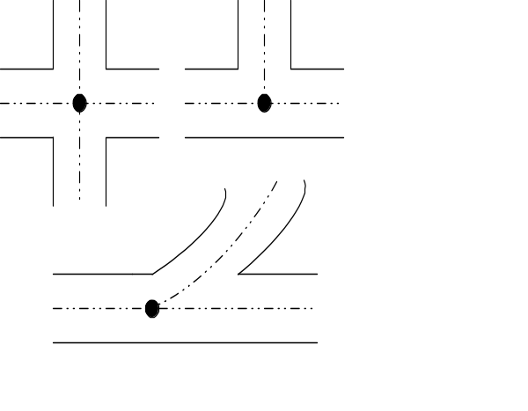When measuring length between at-grade route intersections, use the actual center of the intersection as the point of measurement (Figure IV-1). If grade separated, measure to the theoretical center of the intersecting roadways. When a route terminates at a tee interchange, measure the length as the average of the four directional, connecting ramp lengths to the first point of intersection with the other mainline route (Figure IV-2). In all other situations, ramps are considered part of the mainline routes and their length is not reported for HPMS purposes.
At-Grade Intersections

When grouping homogeneous nonsample roadways (see Items 5 and 9), code the total combined length of the grouped sections. Code length to the nearest thousandth, although measurements may reflect the precision normally utilized by the State. Minimal measurement precision to at least the nearest tenth kilometer (mile) is requested. Length cannot be zero-coded.

Figure IV-1. Two-Way At-Grade
Intersections.
Length is measured to the midpoint of the roadways.

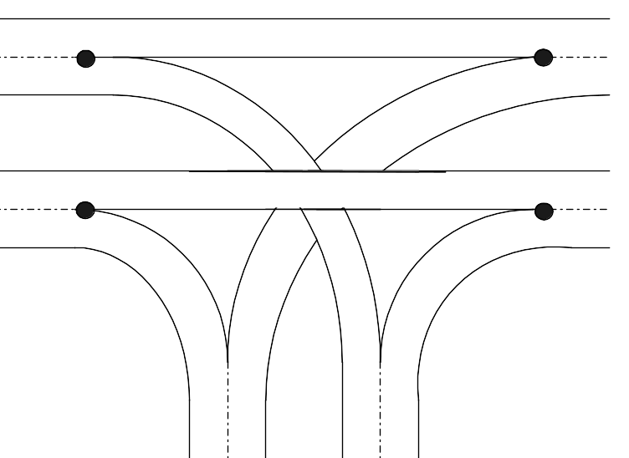
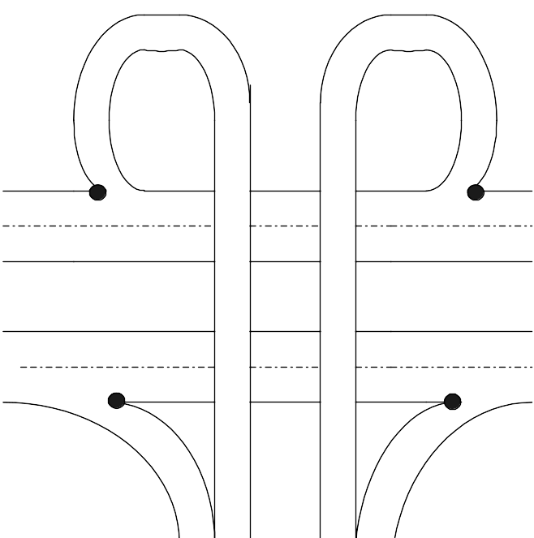
Freeway Connections

Figure IV-2. Freeway Tee Intersection.
Length is an average of the four connectors (Ramps) measured to the gore points.

Item 31 — Donut Area Sample AADT Volume Group Identifier (Numeric; Integer)
This item is used to identify the AADT volume group for a section when an actual AADT is not reported in Item 33. Code a donut area sample volume group number (valid codes 1-5) for the section when an AADT is not coded in Item 33; when an AADT is coded, the HPMS software will assign the volume group number if the State is using the FHWA volume group ranges. The AADT or volume group must be coded for applicable universe, standard sample, and donut area supplementary sample sections for the rural minor arterial and major collector, and the small urban minor arterial and collector functional systems that are within the donut area portion of a nonattainment area. Code “0” for all other sections. The AADT ranges for each volume group number are shown in Appendix C, Table C-5.

When AADT is not known, use traffic flow maps, count data obtained from local governments, and other available data to make reasonable volume group assignments.

A discussion of NAAQS nonattainment and donut areas and a description of the donut area sampling scheme is contained in Appendix G.

Item 32 — Standard Sample AADT Volume Group Identifier (Numeric; Integer)
This item is used to identify the AADT volume group for a section when an actual AADT is not reported in Item 33. Code a standard sample volume group number (valid codes 1-13) for the section when an AADT is not coded in Item 33; when an AADT is coded, the HPMS software will assign the volume group number if the State is using the FHWA volume group ranges. An AADT or the volume group must be coded for applicable universe, standard sample, and donut area supplementary sample sections for all except the rural minor collector and the rural and urban local functional systems. Code “0” for all other sections. The AADT ranges for each volume group number are shown in Appendix C, Tables C-1 to C-4.

When AADT is not known, use traffic flow maps, count data obtained from local governments, and other available data to make reasonable volume group assignments.

A description of the standard sampling scheme is contained in Chapter VII.

Item 33 — Annual Average Daily Traffic (AADT) (Numeric; Integer)
This item provides basic existing traffic inventory information for selected sections. It is extensively used for apportionment, administrative, legislative, analytical, and national highway database purposes. Code this numeric data item for all PAS, NHS, standard sample, and donut area supplementary sample sections; leading zeros are not required. Coding is optional for remaining sections. Code “0” when AADT is not coded.

Enter the section AADT for the data year. This is either a count AADT or factored AADT value to represent the current data year. For two-way facilities, provide the AADT for both directions; provide the directional AADT if part of a one-way couplet or for one-way streets. Since many applications, including travel estimates, are based on section AADTs, States should provide AADT values that are count-based (actual counts adjusted to represent AADT) rather than estimated values.
Update reported AADT values annually. All counts must reflect application of day of week, seasonal, and axle correction factors, as necessary. Growth factors must be applied if the AADT is not derived from current year counts. Specific guidance for the frequency and size of traffic data collection programs, factor development, age of data, and other applications is contained in Appendix F and the Traffic Monitoring Guide.

REMINDER: Metropolitan planning organizations and other local governmental agencies may use an average weekday traffic volume for local purposes. The HPMS requires reported AADT to be an average daily value that represents all days of the reporting year.

Item 34 — Number of Through Lanes (Numeric; Integer)
This item provides basic inventory information on the amount of public road supply. It is extensively used for apportionment, administrative, legislative, analytical, and national highway database purposes. Code this numeric data item for all HPMS sections except those non-NHS sections on the rural minor collector and the rural and urban local functional systems; leading zeros are not required. Number of through lanes is required for all NHS sections regardless of functional system. Code “0” when the data are not provided.

Code the number of through lanes according to the striping, if present, on multilane facilities, or according to traffic use or State/local design guidelines if no striping or only centerline striping is present.

Enter the prevailing number of through lanes in both directions carrying through traffic in the off-peak period. Exclude what are defined as auxiliary lanes, such as collector-distributor lanes, weaving lanes, frontage road lanes, parking and turning lanes, acceleration/deceleration lanes, toll collection lanes and truck climbing lanes. See the AASHTO Design Guide for additional information on auxiliary lanes.

Item 35 — Measured Pavement Roughness (IRI) (Numeric; Decimal)
This item provides information on pavement surface roughness on selected roadway sections. It is used in investment requirements modeling to estimate pavement deterioration, section deficiencies, and needed improvements, in cost allocation studies, in pavement condition trends, and for other analysis purposes including NHS performance. Code the International Roughness Index (IRI) for paved sections in accordance with minimum reporting specifications contained in Table IV-3; IRI is required for all NHS sections regardless of functional system. IRI should be remeasured in the field on a two-year cycle; however, retain existing IRI values for sections until they are replaced by new measured values.

Table IV-3. Roughness Reporting Requirements

Functional System | Section Type | Roughness
RURAL
Interstate  Other Principal Arterial  Minor Arterial  Major Collector | All Sections  All Sections  Standard Sample  Standard Sample | Required  Required  Required  Recommended
URBAN
Interstate  Other Freeways & Expressways  Other Principal Arterial  Minor Arterial  Collector | All Sections  All Sections  All Sections  Standard Sample  Standard Sample | Required  Required  Required  Recommended  Recommended

Enter the measured IRI value to the nearest unit per length measurement, hundredths of meters/kilometer (x.xx) for the Metric system or whole inches/mile (x.0) for the English system. The entry must be in accordance with the reporting units chosen for Metric (or English) Reporting Units (Item 3). Code “0.0” for unpaved facilities and for sections for which IRI data are not provided.

Default values or values obtained by other means or conversions that are not directly obtained from measured road profiles are not to be used. However, when a pavement improvement is made on an applicable section, a temporary value for the improved section reflecting a reasonable average value for new pavement may be provided until replaced by a measured value. States are encouraged to use data from State or local pavement management systems when they are available, are current, and when they meet HPMS reporting requirements.

A PSR value is required for those standard sample sections where an IRI value is not reported. If a measured IRI value is reported for a section, a PSR value for that section is not required. A standard sample section must have either PSR or IRI reported.

FHWA has adopted AASHTO Provisional Standard Practice PP37-02 as the preferred method of providing IRI data for the HPMS. Appendix E contains the AASHTO Provisional Standard Practice along with recommended additional good practice guidelines and data collection procedures.

Item 36 — Present Serviceability Rating (PSR) (Numeric; Decimal)
This item provides information on pavement condition on selected roadway sections. It is used in investment requirements modeling to estimate pavement deterioration, section deficiencies, and needed improvements, in the cost allocation pavement model, and for national highway database purposes. Code a PSR or equivalent value, to the nearest tenth (x.x), for all paved standard sample sections where Item 35, Measured Pavement Roughness, is not reported. Code “0.0” for unpaved facilities and for sections for which PSR data are not provided. Code PSR or the Present Serviceability Index (PSI) where available. If sufficiency ratings of pavement condition are available, they may be used after a correlation between the sufficiency rating scale and the PSR scale or other rating factors is developed.

If there are no current PSR, PSI, or sufficiency ratings that can be adapted, the section can be rated using values in Table IV-4. Estimates to the nearest tenth within the applicable range should be made, e.g., 2.3. Where different lanes have different pavement condition ratings, code the worst condition.

If IRI is reported for a section, then PSR for that section is not required to be reported. A standard sample section must have either PSR or IRI reported.

Table IV-4. Pavement Condition Rating (Use full range of values)

PSR | Description
4.0 - 5.0 | Only new (or nearly new) superior pavements are likely to be smooth enough and distress free (sufficiently free of cracks and patches) to qualify for this category. Most pavements constructed or resurfaced during the data year would normally be rated in this category.
3.0 - 4.0 | Pavements in this category, although not quite as smooth as those described above, give a first class ride and exhibit few, if any, visible signs of surface deterioration. Flexible pavements may be beginning to show evidence of rutting and fine random cracks. Rigid pavements may be beginning to show evidence of slight surface deterioration, such as minor cracks and spalling.
2.0 - 3.0 | The riding qualities of pavements in this category are noticeably inferior to those of new pavements, and may be barely tolerable for high-speed traffic. Surface defects of flexible pavements may include rutting, map cracking, and extensive patching. Rigid pavements in this group may have a few joint failures, faulting and/or cracking, and some pumping.
1.0 - 2.0 | Pavements in this category have deteriorated to such an extent that they affect the speed of free-flow traffic. Flexible pavement may have large potholes and deep cracks. Distress includes raveling, cracking, rutting and occurs over 50 percent of the surface. Rigid pavement distress includes joint spalling, patching, cracking, scaling, and may include pumping and faulting.
0.0 - 1.0 | Pavements in this category are in an extremely deteriorated condition. The facility is passable only at reduced speeds, and with considerable ride discomfort. Large potholes and deep cracks exist. Distress occurs over 75 percent or more of the surface.

Item 37 — High Occupancy Vehicle (HOV) Operations (Numeric; Codes)
This item is used to identify those roadway sections with HOV operations. Code this data item for all sections to best reflect the nature of existing HOV operations.

Code | Description
0 | Section does not have HOV lanes
1 | Section has exclusive HOV lanes (HOV use only; no other uses permitted)
2 | Normal through lane(s) used for exclusive HOV in specified time periods
3 | Shoulder/parking lane(s) used for exclusive HOV in specified time periods

Items 38-46 — Highway Surveillance Systems (Numeric; Codes)
These items are used to track the deployment of ITS surveillance technologies. Code these data items to best describe the nature of existing surveillance systems. Enter the appropriate code for “yes” or “no” to describe the surveillance systems. If the surveillance system affects the operation of the roadway, code this data item even if the system does not actually exist on the section (i.e., variable message signs may be mounted every few miles, but the whole roadway is affected from the first such sign to the last; all sections in between should contain the “yes” code).

Item | No | Yes | Description
38 | 0 | 1 | Section is under electronic surveillance to collect real time traffic data to monitor traffic flow.
39 | 0 | 1 | Section has metered entrance ramps.
40 | 0 | 1 | Section is covered by permanent variable message signs.
41 | 0 | 1 | Section is covered by highway advisory radio.
42 | 0 | 1 | Section is covered by surveillance cameras.
43 | 0 | 1 | Section is covered by incident detection technology algorithms.
44 | 0 | 1 | Section is covered by free cell phone to dedicated number other than 911, statewide DUI, etc.
45 | 0 | 1 | Section is covered by publicly sponsored on-call service patrol or towing service.
46 | 0 | 1 | Section has hardware needed to provide in-vehicle signing information to equipped vehicles.

Item 47 — Sample Identifier (Character Field)
The sample identifier is a statewide or countywide unique 12-character alphanumeric code that cannot change once it has been assigned. It is used to track standard and supplementary sample sections over time, and must never change for any reason. For existing sections, carry over the sample identifier from year to year. For a new sample section, assign a new, unique sample identifier. When an existing sample is split, assign the existing sample identifier to the section retained as the HPMS sample; see Chapter VII for a further discussion of sample splitting.

The State may change the Section Identification (Item 5) if necessary; the State Control Field (Item 8) should be used for additional State required identifiers.

Item 48 — Donut Area Sample Expansion Factor (Software Calculated)
Expansion factors are used to expand sampled data to represent the universe from which the sample is drawn. This value is calculated and coded to the donut area sample section by the HPMS software using the volume group information in Item 31. By definition, the expansion factor is the ratio of the total length in a volume group to the total sampled volume group length:

Expansion Factor = Total length in the Volume Group
Sampled length in the Volume Group

If the expansion factor for a volume group exceeds 100.000, select additional sample sections from the universe volume group until the expansion factor is reduced to a maximum of 100.000. If there are fewer than three samples in a volume group and additional universe sections are available, select additional samples from the universe volume group.

Appendix G contains a discussion of travel estimate requirements for the donut area portion of NAAQS nonattainment and maintenance areas and describes the donut area sample selection and maintenance scheme.

Item 49 — Standard Sample Expansion Factor (Software Calculated)
Expansion factors are used to expand sampled data to represent the universe from which the sample is drawn. This value item is calculated and coded to the standard sample section by the HPMS software using the volume group information in Item 32. By definition, the expansion factor is the ratio of the total length in a volume group to the total sampled volume group length:

Expansion Factor = Total length in the Volume Group
Sampled length in the Volume Group

If the expansion factor for a volume group exceeds 100.000, select additional sample sections from the universe volume group until the expansion factor is reduced to a maximum of 100.000. If there are fewer than three samples in a volume group and additional universe sections are available, select additional samples from the universe volume group.

Chapter VII contains a description of the standard sample selection and maintenance scheme.

Item 50 — Surface/Pavement Type (Numeric; Codes)
This item details the type of pavement surface on sample roadway sections. It is used in investment requirements modeling to estimate pavement deterioration and loading history, for the cost allocation pavement model, and for the national highway database. Enter the code which best represents the type of surface on the section.

Code | Description
1 | Road is unpaved.
2 | Low type bituminous surface-treated—a bituminous surface course with or without a seal coat, the total compacted thickness of which is less than 25 millimeters (1 inch). Seal coats include those known as chip seals, drag seals, plant-mix seals, and rock asphalt seals.
3 | Intermediate type mixed bituminous or bituminous penetration surface—a surface course 25 millimeters (1 inch) or greater and less than 178 millimeters (7 inches) in compacted thickness composed of gravel, stone, sand or similar material, and mixed with bituminous material under partial control as to grading and proportions or bound with bituminous penetration material.
4 | High type flexible—mixed bituminous or bituminous penetration road on a flexible base with a combined surface and base thickness of 178 millimeters (7 inches) or more. Includes any bituminous concrete, sheet asphalt, or rock asphalt having a high load-bearing capacity. Includes any brick, stone, wood, or steel block pavement with or without a wearing surface of less than 25 millimeters (1 inch).
5 | High type rigid—Portland cement concrete (PCC) pavement with or without joints; with or without mesh or similar reinforcement. Includes continuously reinforced PCC pavement, PCC pavement over a PCC pavement, either bonded, unbonded, or partially bonded, and PCC pavement over a bituminous pavement, either mixed or penetration.
6 | High type composite—mixed bituminous or bituminous penetration road on a rigid pavement with a combined surface and base thickness of 178 millimeters (7 inches) or more. Includes any bituminous concrete, sheet asphalt or rock asphalt overlay of rigid pavement that is greater than 25 millimeters (1 inch) of compacted bituminous material; otherwise use code “5.”

Item 51 — SN or D (Numeric; Decimal)
This item provides specific information about the pavement section in terms of structural number [SN] for flexible pavement or thickness (depth) [D] for rigid pavement on sample roadway sections. It is used in investment requirements modeling to estimate pavement deterioration and loading history and in the cost allocation pavement model. Code this numeric item for all standard sample sections. Enter SN to the nearest tenth (xx.x) and D to the nearest whole millimeter or inch (xx.0). When known, enter the actual value; otherwise code a typical value for the functional system and pavement type based upon historic data or State practice. The SN or D value should reflect the last improvement on the section. That is, when an improvement is made, take all new or redesigned base and pavement materials into consideration when determining the appropriate value.
Code SN or D consistent with the reporting units chosen for Metric (or English) Reporting Units (Item 3). Calculate SN (a unitless number) such that the layer coefficients [value per millimeter (inch)] and the layer thicknesses [millimeters (inches)] are in the appropriate reporting unit system.
Item 52 — General Climate Zone (Software Set)
This item is a calculated value locating the sample section in one of nine climate zones. It is used in the cost allocation pavement model. This numeric item is coded by the HPMS software from county/climate zone equivalency tables. It should be checked and may be changed if found not to be representative of the area in question. If the county code is changed, the climate zone should be updated using the HPMS calculation software. The definitions for the nine climate zones are included in Appendix I.
Item 53 — Year of Surface Improvement (Numeric; Integer)
This item is used to identify the year in which the sample section roadway surface was last improved. It is used in the cost allocation pavement model to deteriorate pavement condition. Enter the 4-digit year when the last surface improvement was completed on the section. Retain the coded improvement year in this data item until another improvement affecting the surface is completed. Code “0” if the section has not been improved since the initial reporting year (1988). Include post 1987 improvements on newly selected sample sections. Twenty-five millimeters (one inch) or more of compacted pavement material must be put in place for it to be considered a surface improvement for HPMS purposes.
Item 54 — Lane Width (Numeric; Decimal)
This item is a measure of existing lane width on sample roadway sections. It is used in investment requirements modeling to calculate capacity, estimate needed improvements, and compute a safety index, for cost allocation pavement models, and for other policy analysis and national highway data base purposes. Enter the prevailing through lane width to the nearest tenth of a meter (x.x) or whole foot (x.0). Code according to the reporting units chosen for Metric (or English) Reporting Units (Item 3).
Lane width should be coded according to where the pavement/shoulder surface changes, or to the pavement lane striping if the shoulder and pavement surface are the same, or according to traffic use or State/local design guidelines if no striping or only centerline striping is present. For example, the number of through lanes in Figure IV-4 would probably be 2; deducting 3 meters (10 feet) for parking on each side would leave width for two 5.5 meter (18 foot) lanes. Number of through lanes (Item 34) and lane width would be coded accordingly.
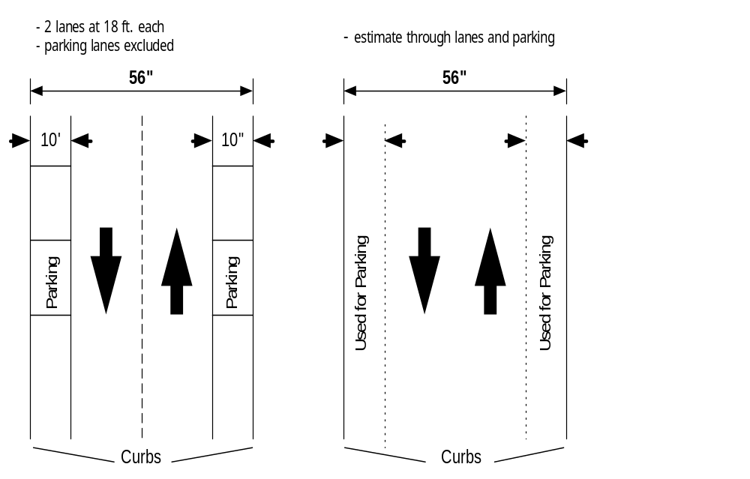Where there is no delineation between the through traffic lane and the shoulder or parking lane, or where there is no centerline, estimate a reasonable split between the actual width used by traffic and the shoulder or parking lane based on State/local design guides.
Figure IV-3. Lane Width

Item 55 — Access Control (Numeric; Codes)
This item is a measure of the degree of access control on sample roadway sections. It is used in investment requirements modeling to calculate capacity and estimate type of design, in truck size and weight studies, and for national highway data base purposes. Code the type of access control for all standard sample sections.

Code | Description
1 | Full Access Control: Preference given to through traffic movements by providing interchanges with selected public roads and by prohibiting crossing at grade and direct driveway connections.
2 | Partial Access Control: Preference given to through traffic movement. In addition to interchanges, there may be some crossings at-grade with public roads, but direct private driveway connections have been minimized through the use of frontage roads or other local access restrictions. Control of curb cuts is not access control.
3 | No Access Control: Include all sections that do not meet the criteria above.

Item 56 — Median Type (Numeric; Codes)
This item is a characterization of the type of median on sample roadway sections. It is used in investment requirements modeling to calculate capacity and estimate type of design and for national highway data base purposes. Code the type of median for all standard sample sections.

Code | Description
1 | Curbed
2 | Positive Barrier
3 | Unprotected
4 | None

A positive barrier normally consists of a guardrail or concrete barrier, but could consist of thick, impenetrable vegetation. Turning lanes or bays are not considered medians unless the turning lanes/bays are cut into an existing median at intersections, entrance drives, etc; a continuous turning lane is not a median. Use code “3” if an unprotected median is at least 1.2 meters (4 feet) wide; otherwise, use code “4”, None.
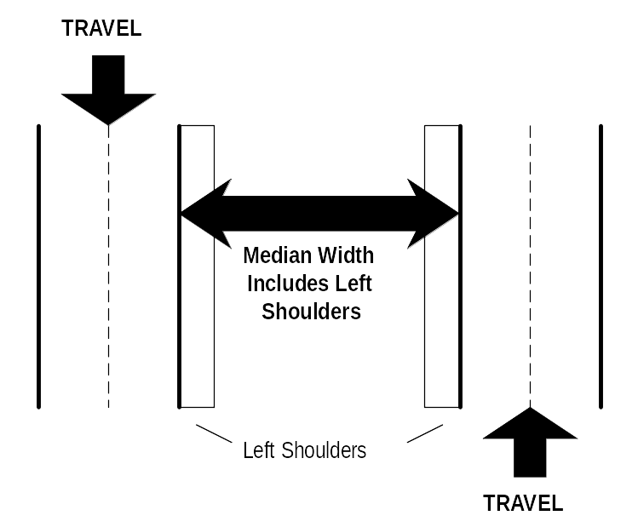
Figure IV-4. Median Measurement.
Item 57 — Median Width (Numeric; Decimal)
This item is a measure of existing median width on sample roadway sections. It is used in investment requirements modeling to calculate capacity and estimate type of design and for national highway data base purposes. Code the median width for all standard sample sections. Code according to the reporting units chosen for Metric (or English) Reporting Units (Item 3).

Enter the predominant median width including left shoulders, if any, measured between the inside edges of the through lanes, to a tenth of a meter (x.x) or the nearest foot (x.0). Enter “0.0” where Item 56 is coded “4.” Enter “999.9” where the median width is 30 meters or 100 feet or greater. Ignore turning bays cut into the median. See Figure IV-4.

Item 58 — Shoulder Type (Numeric; Codes)
This item provides information on the type of existing shoulders on sample roadway sections. It is used in investment requirements modeling to estimate needed improvements. Enter the code for the type of shoulder on the section. If the shoulder type changes back and forth along the length of the section, code the predominant type. If left and right shoulder types differ on a divided facility, code the right shoulder type as the predominant type. If there is a shoulder in front of a barrier curb, code the shoulder type and width, but do not code as a shoulder the area behind a barrier curb. Ignore mountable curbs for reporting purposes; if there is a shoulder either in front of or behind a mountable curb, code the shoulder type and width. If the section has parking abutting the through lane, there cannot be a shoulder; if a bike lane abuts the through lane, there cannot be a shoulder unless it is a combined shoulder/bike lane. If there is parking on one side of a divided roadway and a shoulder or a curb on the other side, code both parking and shoulder type and width accordingly. A shoulder cannot exist between a traffic lane and a parking lane. If a bike lane or parking is completely separated from the roadway, it should not be considered.
Code | Description
1 | None: No shoulders or curbs exist.
2 | Surfaced shoulder exists (bituminous concrete or Portland cement concrete surface).
3 | Stabilized shoulder exists (stabilized gravel or other granular material with or without admixture).
4 | Combination shoulder exists (shoulder width has two or more surface types; for instance, part of the shoulder width is surfaced and a part of the width is earth, etc.).
5 | Earth shoulder exists.
6 | Barrier curb exists; no shoulders in front of curb.

Item 59 — Right Shoulder Width (Numeric; Decimal)
This item measures the existing shoulder width on sample roadway sections. It is used in investment requirements modeling to calculate capacity and estimate needed improvements. Enter the width of the right shoulder to the nearest tenth of a meter (x.x) or whole foot (x.0). Code “0.0” if no right shoulder exists. Refer to Item 58 and Figures IV-5A-C for additional coding details. Do not include parking or bicycle lanes in the shoulder width measurement; code the predominant width where it changes back and forth along a roadway section; ensure that the total width of combination shoulders is reported. Include
rumble strips and gutter pans in shoulder width.

Figure IV-5A. Shoulder Type/Width

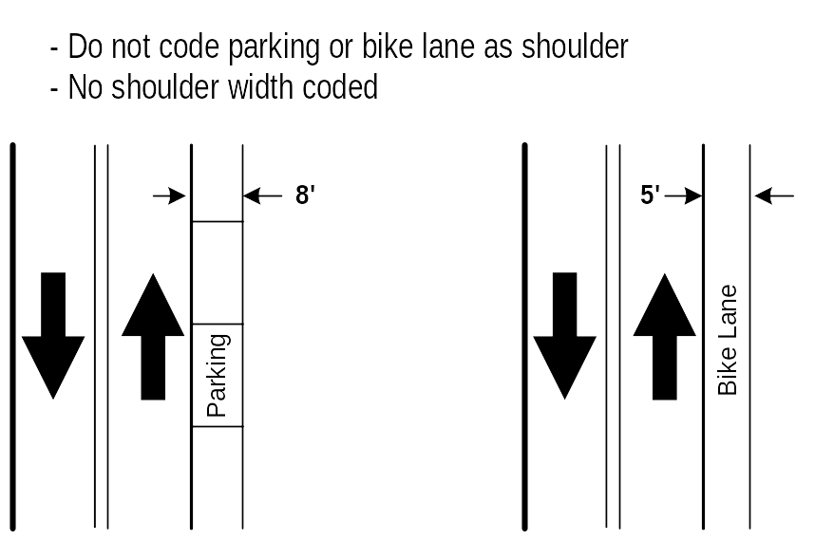
Item 60 — Left Shoulder Width (Numeric; Decimal)
This item measures the existing shoulder width on sample roadway sections. It is used in investment requirements modeling to calculate capacity and estimate needed improvements. On divided highways, enter the width of the left (median) shoulder to the nearest tenth of a meter (x.x) or whole foot (x.0). Code “0.0” where no left shoulder exists or if the section is undivided. Refer to Item 58 and Figures IV-5A-C for additional coding details. Do not include parking or bicycle lanes in the shoulder width measurement; code the predominant width where it changes back and forth along a roadway section; ensure that the total width of combination shoulders is reported. Include rumble strips and gutter pans in shoulder width.
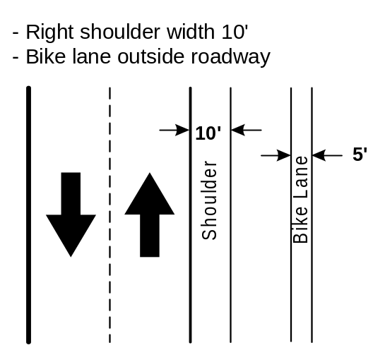
Item 61 — Peak Parking (Urban Data Item) (Numeric; Codes)
This item provides specific information about the presence of peak parking on urban sample roadway sections. It is used in investment requirements modeling to calculate capacity on sections with signals. Enter the code that best reflects the type of peak parking that exists on the section. Code to reflect permitted use; code permitted parking even if the section is not formally signed or striped for parking. If parking is actually beyond the shoulder or the pavement edge where there is no shoulder, use code “3” for no parking. If parking lanes are legally used for through traffic or turning lanes during the peak-hour, code the appropriate in-use condition.
Figure IV-5B. Shoulder Type/Width

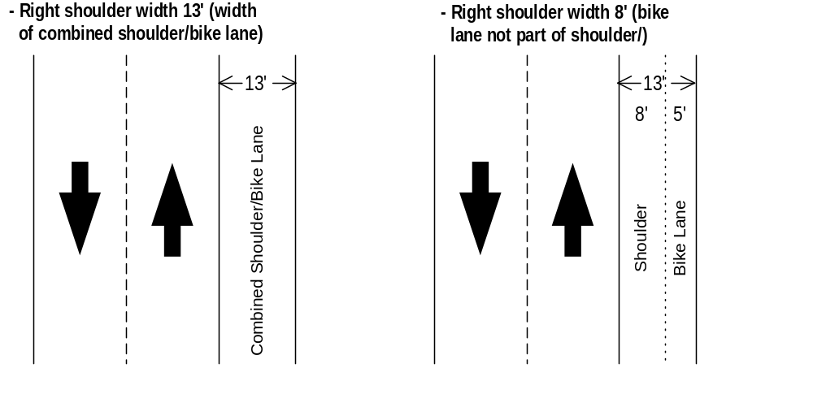
Code | Description
0 | Not Applicable; Section is Rural
1 | Parking Allowed One Side
2 | Parking Allowed Both Sides
3 | No Parking Allowed or None Available

Figure IV-5C. Shoulder Type/Width

Item 62 — Widening Feasibility (Numeric; Codes)
This item provides a measure of whether it is feasible to widen an existing sample section. It is used in investment requirements modeling to estimate needed capacity improvements. Enter the code which best represents the extent to which it is feasible to widen the existing road. Consider mainly the physical features along the roadway section, such as large single family residences or office buildings, shopping centers and other large enterprises, severe terrain, cemeteries, wet lands, and park land, as well as where widening would be otherwise cost or environmentally prohibitive. Do not consider restrictions because of current right-of-way width, State practices concerning widening, politics, or projected traffic.
The code is to represent the lanes that could be added in both directions; e.g., if a lane could be added for each direction of the roadway, then use code “4”; if one full lane only can be added, use code “3”; if only minor widening or widening narrow lanes can occur, use code “2”. Restriping to narrower lanes, resulting in an additional lane on a multilane facility, does not constitute widening feasibility. When coding this item, also consider medians and other areas already within the right-of-way to be available for widening.

Code | Description
1 | No Widening is Feasible
2 | Yes, Partial Lane
3 | Yes, One Lane
4 | Yes, Two Lanes
5 | Yes, Three Lanes or More

Items 63-68 — Curves by Class (Numeric; Decimal)
These items provide specific information regarding the length of horizontal curves by degree of curvature for sample sections. They are used in investment requirements modeling to calculate horizontal alignment adequacy and estimate running speed and operating costs. Code for paved rural arterials and urban principal arterials in accordance with Table IV-5. Curves by class may be coded for other functional systems if the data are available; code “0.0” when curve data are not reported. When this item is not reported for the required rural systems, code Horizontal Alignment Adequacy (Item 69).

Table IV-5. Coding Guide for Curves and Grade by Class.
(Items 63-69 & 71-77)
Highway  Category | Items 63-68 | Item 69 | Items 71 | Item 72-77
Highway  Category | Curves  by  Class | Horizontal  Alignment  Adequacy | Vertical  Alignment  Adequacy | Grades  by  Class

PAVED - RURAL
Principal Arterial  Minor Arterial  Major Collector | Required  Required  Not Required | Software Coded  Software Coded  Required | Software Coded  Software Coded  Required | Required  Required  Not Required

PAVED - URBAN
Principal Arterial  Minor Arterial  Collector | Required  Not Required  Not Required | Not Required  Not Required  Not Required | Not Required  Not Required  Not Required | Required  Not Required  Not Required

Each curve and tangent segment is coded as a separate curve; segments are summed by curve class to obtain the total length in each class. Report the sum of the class lengths for each of the six curve classes in kilometers (miles); the sum of all curve lengths must equal the section length. Code according to the reporting units chosen for Metric (or English) Reporting Units (Item 3); when reporting in Metric units, curve classes are identified by the radius length in meters. They are approximately equivalent to the English unit degree of curvature classes shown below:

Item | Curve Classes |  |  | Length of  Curves in Class  (to 3 decimals) xx.xxx
Item | Curve  Class | Radius Length  (Metric) | Degree of Curvature  (English) | Length of  Curves in Class  (to 3 decimals) xx.xxx
63 | A | 506+ | 0.0- 3.4 | ——
64 | B | 321- 505 | 3.5-5.4 | ——
65 | C | 206- 320 | 5.5- 8.4 | ——
66 | D | 126- 205 | 8.5-13.9 | ——
67 | E | 61- 125 | 14.0-27.9 | ——
68 | F | <61 | 28+ | ——

Item 69 — Horizontal Alignment Adequacy (Rural Data Item)(Software Calculated)
This item provides information about the adequacy of horizontal alignment when curve data are not reported. It is used in investment requirements modeling to estimate horizontal alignment deficiencies and in the truck size and weight analyses. Code for all paved sample sections unless Curves by Class (Items 63 - 68) are coded for the section. (See Table IV-5.) If curves by class are coded, horizontal alignment adequacy will be calculated for paved sections from the curve data. Use the following codes:

Code | Description
0 | Curve data are reported or this item is not required for the section.
1 | All curves meet appropriate design standards for the type of roadway. Reduction of curvature would be unnecessary even if reconstruction were required to meet other deficiencies (i.e., capacity, vertical alignment, etc.).
2 | Although some curves are below appropriate design standards for new construction, all curves can be safely and comfortably negotiated at the prevailing speed limit on the section. The speed limit was not established by the design speed of curves.
3 | Infrequent curves with design speeds less than the prevailing speed limit on the section. Infrequent curves may have reduced speed limits for safety purposes.
4 | Several curves uncomfortable or unsafe when traveled at the prevailing speed limit on the section, or the speed limit on the section is severely restricted due to the design speed of curves.

Item 70 — Type of Terrain (Rural Data Item)(Numeric; Codes)
This item provides information on the type of terrain through which the sampled roadway passes. It is used in investment requirements modeling to calculate capacity and estimate needed capacity improvements and in the truck size and weight analysis process. For all rural sample sections, enter the code that best characterizes the terrain classification for the sampled roadway. In coding this item, consider the terrain of an extended length of the roadway upon which the sample is located rather than the grade on the specific sample section by itself. The extended roadway section may be several miles long and contain a number of upgrades, downgrades, and level sections; for long sample sections, such as rural freeway samples extending between interchanges, the extended roadway section and the sample section may be the same. Code according to the following table:

Code | Terrain Type
0 | Not Applicable; this is an Urban Section.
1 | Level: Any combination of grades and horizontal or vertical alignment that permits heavy vehicles to maintain the same speed as passenger cars; this generally includes short grades of no more than 2 percent.
2 | Rolling: Any combination of grades and horizontal or vertical alignment that causes heavy vehicles to reduce their speeds substantially below those of passenger cars but that does not cause heavy vehicles to operate at crawl speeds for any significant length of time.
3 | Mountainous: Any combination of grades and horizontal or vertical alignment that causes heavy vehicles to operate at crawl speeds for significant distances or at frequent intervals.

Item 71 — Vertical Alignment Adequacy (Rural Data Item)(Software Calculated)
This item provides information about the adequacy of vertical alignment when grade data are not reported. It is used in investment requirements modeling to estimate vertical alignment deficiencies. Code for all paved sample sections unless Grades by Class (Items 72 - 77) are coded for the section. (See Table IV-5.) If grades by class are coded, vertical alignment adequacy will be calculated for all paved sections from the grade data. Use the following codes:

Code | Description
0 | Grade data are reported or this item is not required for the section.
1 | All grades (rate and length) and vertical curves meet minimum design standards appropriate for the terrain. Reduction in rate or length of grade would be unnecessary even if reconstruction were required to meet other deficiencies (i.e., capacity, horizontal alignment, etc.).
2 | Although some grades (rate and/or length) and vertical curves are below appropriate design standards for new construction, all grades and vertical curves provide sufficient sight distance for safe travel and do not substantially affect the speed of trucks.
3 | Infrequent grades and vertical curves that impair sight distance or affect the speed of trucks (when truck climbing lanes are not provided).
4 | Frequent grades and vertical curves that impair sight distance or severely affect the speed of trucks; truck climbing lanes are not provided.

Items 72-77 — Grades by Class (Numeric; Decimal)
These items provide specific information regarding the length of vertical grades by percent gradient for sample sections. It is used in investment requirements modeling to calculate vertical alignment adequacy and estimate running speed and operating costs and in the truck size and weight analysis process. Code for paved rural arterials and urban principal arterials in accordance with Table IV-5. Grades by class may be coded for other functional systems if the data are available; code “0.0” when grade data are not reported. When this item is not reported for the required rural systems, code Vertical Alignment Adequacy (Item 71).
Each grade and flat segment is coded as a separate segment; segments are typically measured between vertical points of intersection (VPI) and summed by grade class to obtain the total length in each class. Report the sum of the class lengths for each of the six grade classes in kilometers (miles); the sum of all grade lengths must equal the section length. Code according to the reporting units chosen for Metric (or English) Reporting Units (Item 3). Report the following data:

Item | Grade  Class | Grade Classes  by Gradient  (Percent) | Length of Grades  in Class  (to 3 decimals)  xx.xxx
72 | A | 0.0-0.4 | ——
73 | B | 0.5-2.4 | ——
74 | C | 2.5-4.4 | ——
75 | D | 4.5-6.4 | ——
76 | E | 6.5-8.4 | ——
77 | F | 8.5+ | ——

Item 78 — Percent Passing Sight Distance (Rural Data Item)(Numeric; Integer)
This item provides specific information on the percent of the sample section meeting the sight distance requirement for passing. It is used in investment requirements modeling to calculate capacity and estimate running speed and for truck size and weight analysis purposes. Code this numeric item for all rural, paved two-lane sample sections. Enter the percent of the section length that is striped for passing. Where there is a discernable directional difference, code for the more restrictive direction. Code “0” for nonapplicable sections as well as for very curved or very hilly sections without passing zones.
Item 79 — Weighted Design Speed (Software Calculated)
This item is a calculated value that provides a design speed weighted by the length of individual horizontal curves and tangents in a sample section. It is used in investment requirements modeling to calculate capacity and estimate needed capacity improvements. This item is calculated by the HPMS software from curve data; when curve data are not provided, a default value based upon functional system and facility type is used as shown in the following table.
Facility Type | Functional Class
Facility Type | 1 | 2 | 6 | 7 | 11 | 12 | 14 | 16 | 17
Multilane Divided | 70 | 70 | 70 | 65 | 70 | 70 | 70 | 60 | 55
Multilane Undivided | 70 | 70 | 70 | 60 | 70 | 70 | 70 | 55 | 45
2/3 Lane | 70 | 70 | 65 | 60 | 70 | 65 | 65 | 55 | 45

Item 80 — Speed Limit (Numeric; Integer)
This item provides information on the posted speed limit on sample sections. It is used in investment requirements modeling to estimate running speed and for other analysis purposes, including delay estimation. Enter the daytime speed limit for automobiles posted or legally mandated on the greater part of the section. Code according to the reporting units chosen for Metric (or English) Reporting Units (Item 3). If there is no legally mandated maximum daytime speed limit for automobiles, code “999”.
Item 81 — Percent Peak Single Unit Trucks (Numeric; Integer)
This item provides information on truck use on a sample section. It is used in investment requirements modeling to calculate capacity and design volumes. Code this item with the percent from Item 82 unless the State has determined that the percent of trucks in the peak period is different from the average daily percent trucks. Some routes, such as urban commuter or recreational routes, may exhibit significant differences in truck percentages between peak period and average daily operation; these differences may have a significant impact on route capacity. In cases where the State determines that differing peak period operations have a significant bearing on route capacity, code a separate peak usage value for the section, even if it is an estimated value.

Item 82 — Percent Average Daily Single Unit Trucks (Numeric; Integer)
This item provides information on truck use on a sample section. It is used in investment requirements modeling to estimate pavement deterioration and operating speeds, in the cost allocation pavement model, and in the truck size and weight analysis process. Code single unit truck traffic as a percentage of section AADT to the nearest whole percent. This value should be representative of all single unit truck activity over all days of the week and seasons of the year as a percent of total annual traffic. Single unit trucks include vehicle classes 4 through 7 (buses through four-or-more axle, single-unit trucks). Further information on vehicle classes is included in Chapter III. Section specific measured values are requested. If not available, use values derived from classification station data on the same route or on a similar route with similar traffic in the same area. Avoid using a single statewide value or statewide values by functional system.

Item 83 — Percent Peak Combination Trucks (Numeric; Integer)
This item provides information on truck use on a sample section. It is used in investment requirements modeling to calculate capacity and design volumes. Code this item with the percent from Item 84 unless the State has determined that the percent of trucks in the peak period is different from the average daily percent trucks. Some routes, such as urban commuter or recreational routes, may exhibit significant differences in truck percentages between peak period and average daily operation; these differences may have a significant impact on route capacity. In cases where the State determines that differing peak period operations have a significant bearing on route capacity, code a separate peak usage value for the section, even if it is an estimated value.
Item 84 — Percent Average Daily Combination Trucks (Numeric; Integer)
This item provides information on truck use on a sample section. It is used in investment requirements modeling to estimate pavement deterioration and operating speeds, in the cost allocation pavement model, and in the truck size and weight analysis process. Code combination truck traffic as a percentage of section AADT to the nearest whole percent. This numeric value should be representative of all combination truck activity over all days of the week and seasons of the year as a percent of total annual traffic. Combination trucks include vehicle classes 8 through 13 (four-or-less axle, single-trailer trucks through seven-or-more axle, multi-trailer trucks). Further information on vehicle classes is included in Chapter III. Section specific measured values are requested. If not available, use values derived from classification station data on the same route or on a similar route with similar traffic in the same area. Avoid using a single statewide value or statewide values by functional system.
Item 85 — K-Factor (Numeric; Integer)
This item provides the design hour volume as a percent of AADT for a sample section. It is used in investment requirements modeling to calculate capacity and estimate needed capacity improvements, in the cost allocation pavement model, and for other analysis purposes, including delay estimation. Code the K-factor for the section to the nearest percent. The K-factor is the design hour volume (30th highest hour) as a percentage of the annual average daily traffic. Section specific values are requested. If not available, use values derived from continuous count station data on the same route or on a similar route with similar traffic in the same area. Avoid using a single statewide value or statewide values by functional system. The K-Factor normally ranges from 6 to 18 percent.
Item 86 — Directional Factor (Numeric; Integer)
This item provides the percent of design hour volume flowing in the peak direction on a sample section. It is used in investment requirements modeling to calculate capacity and estimate needed capacity improvements, in congestion, delay, and other analyses, and in the cost allocation pavement model. Enter the percentage of the design hour volume (30th highest hour) flowing in the peak direction. Code “100” for one-way facilities. Section specific values are requested. If not available, use values derived from continuous count station data on the same route or on a similar route with similar traffic in the same area. Avoid using a single statewide value or statewide values by functional system. The directional factor normally ranges from 50 to 70 percent.
Item 87 — Number of Peak Lanes (Numeric; Integer)
This data item is used to provide information on the number of lanes used in the peak hour direction of flow on a sample section. It is used in investment requirements modeling to calculate capacity, and in congestion analyses, including estimates of delay. Code the number of through lanes used in the peak period in the peak direction. Include reversible lanes, parking lanes, or shoulders that legally are used for through traffic whether for SOV or HOV operation. For rural 2- or 3-lane sections, code the number of through lanes in both directions in the peak period. The number of peak lanes is used in the HCM-based capacity calculation procedure (see Appendix N).
Items 88-89 — Left/Right Turning Lanes (Urban Data Items)(Numeric; Codes)
These items provide information on the presence of turning lanes at a typical intersection on a sample section. They are used in investment requirements modeling to calculate capacity and in congestion analyses, including estimates of delay. Enter the code from the following tables that best describes the peak-period turning lane operation on the inventory section. Where peak capacity for a section is governed by a particular intersection that is on the section, code the turning lane operation at that location; otherwise code for a typical intersection. Code turning lanes and the percent green time for the same intersection. Include turning lanes that are located at entrances to shopping centers, industrial parks, and other large traffic generating enterprises as well as public cross streets.
Code a continuous turning lane with painted turn bays as a continuous turning lane. Code a through lane that becomes an exclusive turning lane at an intersection as a turning lane (see Figure IV-7); however, if through and turning movements can be made from a lane at an intersection, it is not a turning lane.

Examples:
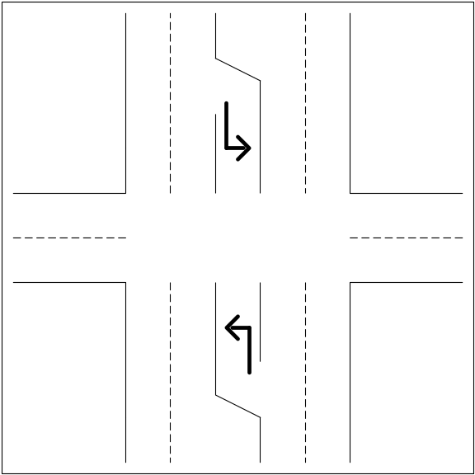Figure IV-6 contains a section that has a single left turn lane, and nothing for the right turns; both left and right turns are permitted in the peak period. Code “3” for Item 88 (turns permitted; a single left turning lane exists) and “4” for Item 89 (turns permitted; no right turning lanes exist). There are four through lanes (Item 34) and two peak period through lanes (Item 87).
Figure IV-7 contains what appears to be four through lanes, but one in each direction becomes an exclusive right turn lane at the intersection; both left and right turns are permitted in the peak period. The correct codes would be “4” for Item 88 (turns permitted; no left turning lanes exist) and “3” for Item 89 (a single right turning lane exists). The number of through lanes is 2 (Item 34) and the number of peak period through lanes is 1 (Item 87).
Figure IV-6. Left Turn Lanes

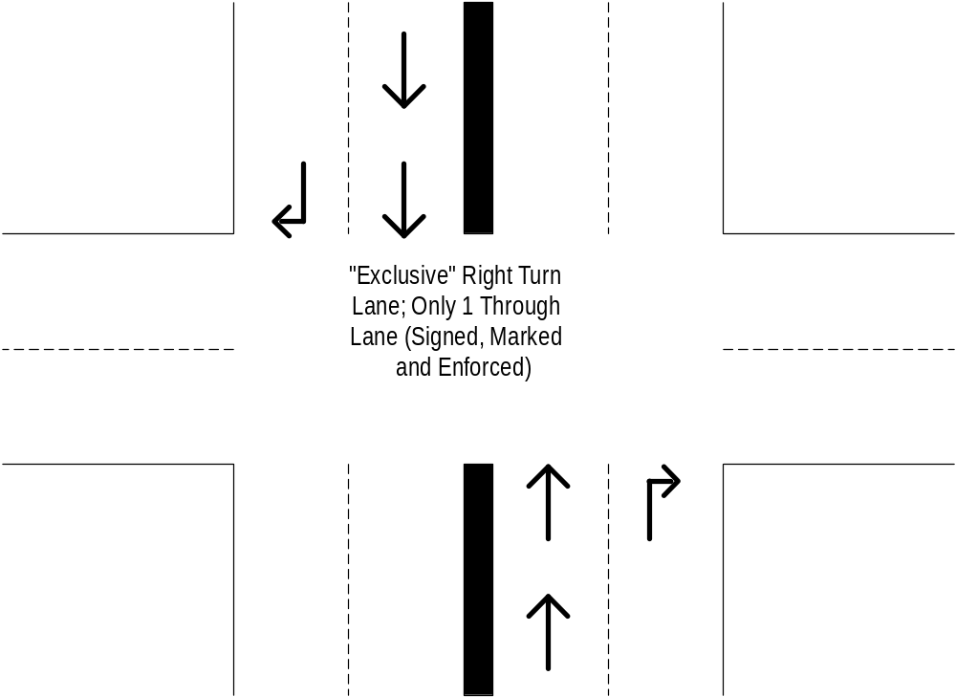

Figure IV-7. Exclusive Right Turn Lane

Item 88 — Left Turn Lane Codes (Numeric; Codes)
Code | Description
0 | Not applicable; this is a rural section or no intersections exist on the section.
1 | Turns permitted; multiple exclusive left turning lanes exist. Through movements are prohibited in these lanes. Multiple turning lanes allow for simultaneous turns from all turning lanes.
2 | Turns permitted; a continuous exclusive left turning lane exists from intersection to intersection. Through movements are prohibited in this lane.
3 | Turns permitted; a single exclusive left turning lane exists.
4 | Turns permitted; no exclusive left turning lanes exist.
5 | No left turns are permitted during the peak period.

Item 89 — Right Turn Lane Codes (Numeric; Codes)
Code | Description
0 | Not applicable; this is a rural section or no intersections exist on the section.
1 | Turns permitted; multiple exclusive right turning lanes exist. Through movements are prohibited in these lanes. Multiple turning lanes allow for simultaneous turns from all turning lanes.
2 | Turns permitted; a continuous exclusive right turning lane exists from intersection to intersection. Through movements are prohibited in this lane.
3 | Turns permitted; a single exclusive right turning lane exists.
4 | Turns permitted; no exclusive right turning lanes exist.
5 | No right turns are permitted during the peak period.

Item 90 — Prevailing Type of Signalization (Urban Data Item)(Numeric; Codes)
This item describes the predominant type of signal system on a sample section. It is used in the investment requirements modeling process to calculate capacity and estimate delay. Enter the code that best describes the predominant type of signal system for the direction of travel on the inventory section. Signal information may be coded for rural sections on an optional basis.

Code | Description
0 | Not applicable; this is a rural section.
1 | Uncoordinated Fixed Time (may include pre-programmed changes for peak or other time periods).
2 | Traffic Actuated.
3 | Progressive (coordinated signals through several intersections).
4 | No signal systems exist.

Item 91 — Typical Peak Percent Green Time (Urban Data Item)(Numeric; Integer)
This item provides information on the typical through lane percent green time in effect at intersections on a sample section. It is used in investment requirements modeling to calculate capacity and in congestion analyses, including estimates of delay. Enter the percent green time in effect during the peak period for through traffic at signalized intersections for the direction of travel on the inventory section; percent green time may be coded for rural sections on an optional basis. Where peak capacity for a section is governed by a particular intersection that is on the section, code the percent green time at that location; otherwise code for a typical intersection. Code the percent green time for the same intersection where Items 88 and 89 are coded. Code “0” if no signalized intersections exist or if the section is rural. Use results of a field check of several peak period light cycles to determine a “typical” green time for traffic actuated/demand responsive traffic signals. Ignore separate green-arrow time for turning movements.

Items 92-94 — Number of At-Grade Intersections (Numeric; Integer)
These items provide a count of the number of intersections and traffic controls on the sample section. They are used in investment requirements modeling to calculate capacity and estimate delay. Code the number of intersections on the inventory route according to the following table. Include at-grade intersections at entrances to shopping centers, industrial parks, and other large traffic generating enterprises.

Item | Description
92 | Signals: Enter the number of at-grade intersections with a signal controlling traffic on the inventory route. A signal that cycles through red, yellow, and green for all or a portion of the day should be counted as a signalized intersection. If none, enter “0.”
93 | Stop Signs: Enter the number of at-grade intersections with a stop sign controlling traffic on the inventory route. A continuously operating, flashing red signal should be counted as a stop sign control. If none, enter "0".
94 | Other or No Controls: Enter the number of at-grade intersections where traffic on the inventory route is not controlled by either a signal or a stop sign; or is controlled by other types of signing; or has no controls. A continuously operating, flashing yellow signal should be considered as "other or no control.” If none, enter “0.”
Care needs to be taken to prevent over counting. Special treatment is required when a sample section begins and/or ends with a counted data item. This is accomplished by doing the following:
- Choose a statewide direction for inventory (South to North, West to East, etc.)
- Choose a statewide rule to always count the beginning only or the ending only, but never both
- Count and report accordingly
In the upper portion of Figure IV-8, the intersection count is the same (2) using either the beginning only or ending only rule. In the lower portion of Figure IV-8, a count of two results using the bottom to top inventory direction and the beginning only rule. If the inventory direction remains bottom to top, but the ending only rule is followed, the count is only one.
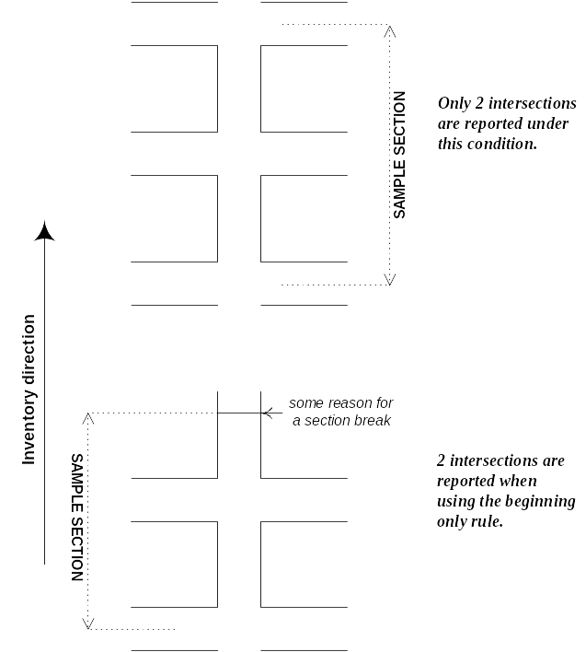
Figure IV-8. Count Items
Item 95 — Peak Capacity (Software Calculated)
This item provides existing peak hour capacity for a sample section. It is used in investment requirements modeling to calculate capacity, in the cost allocation pavement model, and in congestion, delay, and other analyses.
The rural and urban peak capacity values are calculated by procedures in the HPMS software provided to the States. The procedures used in the software for determining highway capacity conform to the Highway Capacity Manual (HCM). The capacity calculations are based on service flow rates for level of service E. Capacity calculation procedures are described in Appendix N.
All urban capacity is for the peak direction as is rural capacity for freeways and other multi-lane facilities. If a rural facility has 2 or 3 lanes with one-way operation, it is considered to be a multi-lane facility for determining capacity. The capacity for rural facilities with 2 or 3 lanes and two-way operation is for both directions.
The state may override the calculated capacity if it determines that the capacity is too low or too high because of operational conditions that are not appropriately reflected in the HPMS data items used in the calculation.

Figure IV-9, Count Items

Item 96 — Volume/Service Flow Ratio (V/SF) (Software Calculated)
This item is a computed value reflecting peak hour congestion for a sample section. It is used in investment requirements modeling to estimate needed capacity improvements, in the national highway database, and for congestion, delay, and other data analyses. This value is generated by the HPMS software from HPMS data; procedures are described in Appendix N.

Item 97 — Future AADT (Numeric; Integer)
This item provides forecast AADT information for a sample section. It is used in investment requirements modeling to estimate deficiencies and future improvement needs, in the cost allocation pavement model and in other analytical studies. Code the forecasted two-way AADT for the year coded in Item 98, Year of Future AADT. The intent is to include a 20-year forecast in the HPMS but the estimate may be for some other period of time within an 18 to 25 year time span. This item may be updated at any time but must be updated when the forecast falls below 18 years.

Future AADT should come from a technically supportable State procedure or data from MPOs or other local sources. HPMS forecasts for urbanized areas should be consistent with those developed by the MPO at the functional system and urbanized area level.

For example, the expanded HPMS sample value of travel for the urban OF&E functional system in an urbanized area should be consistent with the MPO travel forecast for that functional system. Total travel from the expanded HPMS sample for all functional systems in an urbanized area should also be consistent with total travel estimates produced by MPO models.

Link-by-link comparisons may not be possible to attain due to differences in the MPO network and the on-the-ground road system covered by the HPMS.

Item 98 — Year of Future AADT (Numeric; Integer)
This item provides the year for which the AADT has been forecast. It is used to normalize the forecast AADT to a consistent 20-year horizon. Enter the four-digit year for which Future AADT (Item 97) has been forecasted. This cannot be for less than 18 years nor more than 25 years from the data year (Item 1).

? The "A" in the summary table cells for the Donut Area Volume Group (Item 31) is meant to indicate that all data records (universe only and sample) for the noted functional systems in a donut area are to include these data.

