
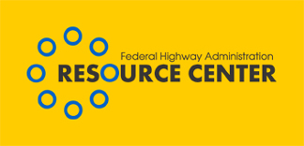

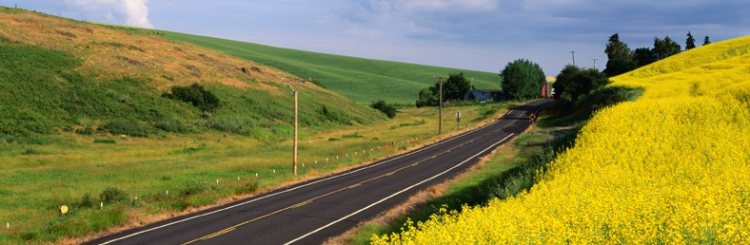

Volume 1, Issue 3 October 2005

A Primitive Fish with Modern Transportation Issues

LETTER FROM THE EDITOR

Dear Environmental Colleague,

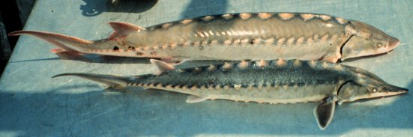
Although this newsletter greets you later than expected, we hope you find valuable information within. As always, your feedback and requests are always welcome. If you have comments about a story or story ideas you’d like to see, please let us know.

Sincerely, Don Cote
Environment Technical Service Team (TST) Leader &
Editor–in-Chief
The above picture features a juvenile Atlantic Sturgeon in the foreground and a juvenile shortnose sturgeon in the background. (NOAA Fisheries)

Phone: (720) 963-3210
E-mail: Don.Cote@fhwa.dot.gov
From the Woodrow Wilson Bridge on the Potomac on the east coast to bridges crossing the Sacramento River (San Francisco Bay) on the west coast and on projects in between, sturgeon are becoming a significant issue in project development.

Sturgeon are large primitive fish; they are virtually unchanged since they coexisted with the dinosaurs. They are typically found in large northern hemisphere river systems, and migrate between marine and upstream spawning grounds in fresh water.

Sturgeon are included in the family Acipenseridae and consists of four genera and 24 species of Sturgeon. All sturgeons have a cartilaginous skeleton, and protractile, tube-like mouth and sensory barbels on the snout. Eight species of sturgeon occur in North America (4 are listed as T&E one is proposed for listing).

Sturgeon are long lived and take up to 15 years to reach sexual maturity.

Sturgeon’s requirements for large stretches of river, a slow reproductive rate and high value as a source of meat and caviar make them vulnerable to extinction. The main threats to their existence are dams blocking migration routes, over-fishing and river pollution.

Sturgeon occur in the larger river systems of most of the 50 US states (excluding Hawaii, Nevada, Arizona).

While the life history of sturgeon can vary somewhat based upon the specific species and the geographic region and temperature regime they inhabit, adult sturgeon generally migrate from the ocean to upstream sand and gravel spawning areas in moderate currents, off the main stems of rivers. Males apparently form into groups near the spawning areas. Females lay large numbers of sticky eggs that adhere to the bottom of the river, stones and vegetation. Fertilization is external. Recent studies have found that vocalization may be involved during or prior to spawning (If this proves to be the case, underwater noise may have “masking” impacts at levels lower than those causing physical damage). Eggs hatch in about a week and after about 20 days the hatchlings have changed into miniature adults that live in the river feeding first on plankton then on benthic invertebrates. They leave the river for the ocean after approximately 5 years. They seem to stay in the ocean littoral area until they reach adulthood. At sexual maturity (approximately

15 years) adults return to the river to spawn (late spring to summer). From then on, they typically spawn once every 2-3 years for the rest of their lifespan, which may exceed 50 years. They return to the oceans after spawning to feed and grow. Adult sturgeons do not seem to feed much during migration. Some of the larger species (white sturgeon) can weigh over 1000 lbs.

Because of their late maturity, long life and migration requirements, sturgeon are especially susceptible to changes in their migration routes. Dams are particularly problematic as they cut off populations from their spawning grounds. Over-fishing has also damaged once robust populations. To a lesser extent, water pollution and other changes in their habitat may be reducing their populations.

Sturgeon are becoming an increasingly important environmental issue for bridge projects.
While Sturgeon may never raise the level of concern that Salmonids (salmon and salmon-like fish) generate during NEPA scoping (sturgeon are not as widespread, nor as commercially valuable) the trend shows that more projects will need to address potential effects on the fish. There are several reasons for this; the most obvious is that more sturgeon populations are being considered for listing under the Endangered Species Act. Another reason is that resource agencies are becoming more concerned in general with non-lethal effects on fish, especially the non-lethal effects of underwater noise.

The effects of construction noise from the use of explosives, pile driving, and other forms of underwater noise have become a sensitive issue for the resource agencies. Measures of non-lethal underwater noise (i.e., temporary hearing threshold shifts (TTS), hormonal changes, stress and behavioral effects) are becoming common in discussions setting project noise restrictions.

The effects of pile driving on fish were highlighted in a special session at the International Conference on Ecology and Transportation in San Diego, CA. A CALTRANS funded study by Mardi C. Hastings and Arthur N. Popper, Effects of Sound on Fish was recently made available on the Web: www.dot.ca.gov/hq/env/bio/files/Effects_of_Sound_on_Fish23Aug05.pdf.
The study reviews what is known to date about the effects and mechanisms involved in noise impacts on fish.

A pending Transportation Pooled Fund Program study will further research the effects of pile driving on fish. The new study is slated to provide an analysis of how piles transmit sound into the water, develop models for sound transmission and attenuation and identify needed research to address regulatory issues.

The point is, for a variety of reasons, the effects of underwater construction noise on fish in general, and on sturgeon in particular, are becoming more prominent in planning for potential project impacts.

This is an increasingly critical issue because as environmental professionals, we have a duty to preserve and enhance fish resources as part of our stewardship responsibilities. In addition, by law, impacts to threatened or endangered species (ESA Section 7) must be avoided. Recent and future listings of species and populations of sturgeon require awareness of potential highway project impacts and avoidance of any impacts to these populations.

Types of impacts to be aware of, if sturgeons (or other aquatic resources) are in your project area include:

- Project changes to streambed morphology (obstructions) or capacity;
- Changes in discharge volume, speed, seasonality;
- In-water construction or demolition;
- Pollutants from road surface runoff;
- Pollutant disturbance and redistribution during construction;
- Turbidity increase during spawning season and in spawning areas;
- Noise from construction during Sturgeon migration and spawning (i.e., effects of pile driving, use of explosives, boat operations, normal underwater operations such as grinding and cutting).

All of these potential impacts must be addressed in project planning and coordinated with the appropriate resource agencies (typically FWS, NMFS, COE, tribal entities). If there is any potential to affect (“may affect”) a listed federal species, the project must consult with FWS/NMFS under the Endangered Species Act. Failure to plan early and reach an agreement with the agencies may result in delays or stoppage of a project. An actual violation of the Endangered Species Act could result in personal fines or criminal penalties.

Species currently listed as Threatened or Endangered:
Eight species of sturgeon occur in North America, and four species as well as one population of the white sturgeon are listed as endangered or threatened. Shortnose sturgeon (Acipenser brevirostrum), gulf sturgeon, (Acipenser oxyrhynchus desdotoi) pallid sturgeon (Scaphirhynchus albus), Alabama sturgeon (Scaphirhynchus suttkusi) and the Kootenai River population of the white sturgeon (Acipenser transmontanus, subpop. Kootenai) are all on the Endangered Species list, while one population of the green sturgeon (Acipenser medirostris) has been proposed for listing and is currently in the process of being listed. Populations of Sturgeon not on federal lists may be on state lists as either T&E or have some other protected status. If you have sturgeon in your project area you should talk to state and federal (NMFS, FWS) resource managers and the Corps of Engineers early to identify and resolve any potential issues.

If you have sturgeon issues and need help, please contact William VanPeeters at the FHWA Environmental Technical Service Team at (415)744-0116 or at william.vanpeeters@fhwa.dot.gov.
We will help at any stage of the process, but it is much easier if these types of issues are resolved early in the planning process.

TST Editorial Board Members:
David Grachen, Dan Harris,
Brian Smith, and David Sullivan
FHWA Resource Center
Aung Gye, Office of Project Development & Environmental Review, FHWA HQ

INSIDE
- Project planning impacts on Sturgeon… p. 1
- Update on Southwest CIA Workshop…p. 4
- Tribal consultation report published…p. 5
- Improving the Quality of Environmental Documents…p. 6
- Environmental Calendar…p. 7

Continued on page 2.

Sturgeon continued from page 1


Continued on p. 3

Sturgeon, continued from p. 2

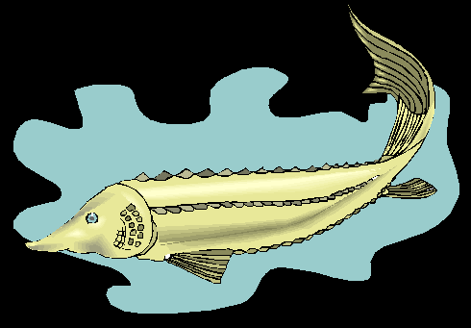
Continued on p. 4

This past June marked a first for the CIA. No, not that CIA. We’re talking about FHWA’s CIA -- Community Impact Assessment.

The first Southwest Community Impact Assessment (CIA) Workshop took place at the Scottsdale Hilton Resort and Villas in Scottsdale, Arizona, on June 6 - 9, 2005. The workshop was hosted by Rick Duarte, the Environmental Manager of ADOT, and Steve Thomas, The Arizona Division Environmental Manager, along with HDR Consultants. This well organized four day conference included a variety of current CIA issues, site reviews, exhibits, and local highlights.
The theme of the workshop was the Community Impact Assessment: Tools of the Trade. Each participant received information packages and a “toolbox” they could take home with them. Some focus areas were defining impact areas, surveying, and working with diverse populations and cultures.

Over 150 people from highway development disciplines as varied as design engineers, planning practitioners, and technical specialists attended the Workshop.

Some notable highlights were:
- Discussions on different types of outreach techniques and using the internet to reduce project cost and enhance public involvement by Robert Puentes, from the Metropolitan Policy Program, Brookings Institute;
- Techniques on communicating with the low literacy and English proficiency requirement;
- Tips on working with the media; and
- Guest speaker, Richard Strange, who made a slide show presentation on his personal photography of national parks.

Participant Brenda Kragh, from the Office of Planning, FHWA Headquarters, praised this regional workshop as one of the best or the best she has ever attended, adding that she has attended or participated at almost every single one since 1995.

For more information, see www.dot.state.az.us/highways/EEG.

A First for the CIA?
Sturgeon, continued from p. 3

Tribal Consultation Best Practices Report Published
The National Association of Tribal Historic Preservation Officers (NATHPO) recently published a report entitled, Tribal Consultation: Best Practices in Historic Preservation.

The report documents the results of a project that was conceived by NATHPO, the Advisory Council on Historic Preservation, and the National Park Service, and begun in January 2004. The goal of the project was to identify a best practice model for consultation between Federal Agencies and Tribes. A survey was developed and sent to all Federal Preservation Officers and federally-recognized Tribes asking them to identify successful consultations, the participants, and the factors they felt contributed to a successful result.

Survey responses were collected through November 2004. Sixty six (66) responses were received and sixty one (61) projects were identified by the thirteen (13) Tribes and twenty four (24) Agencies that responded to the survey. Some respondents identified more than one project and some projects were identified by more than one respondent. Survey responses from the transportation community included responses from seven FHWA Division Offices - AR, GA, ME, NC, PA, NY and TN; and six State DOT’s - AK, AR, GA, IA, NC and PA.
Some of the findings identified in the report include:
- Successful consultation begins early in the planning stages, and is predicated on each party being
Knowledgeable about the project and the priorities, and the desires of the

other parties involved in the consultation.
- Mutual respect must be the basis upon which successful consultation builds
- Consultation builds relationships, and the funds and time spent in consultation reap ongoing benefits and efficiencies for future projects.
- Good processes last beyond individual personal relationships, even though the latter may have initially opened the door to effective communication.
- Neither the Tribes nor the Agencies have time and money to spare. Both look for efficiencies in working relationships.
- Though not without cost, successful consultation results in better and lasting final agreements and project decisions.

Federal Agencies have an obligation to consult with Tribes on a government-to-government basis for all Federal undertakings in order to comply with the Section 106 process of the National Historic Preservation Act. The results of this study will assist consulting parties arrive at successful results by identifying and promoting effective consultation practices.

Both Paul Tufts and David Grachen from the Resource Center Environmental Team offer technical assistance and training on tribal consultation matters. If you would like to pursue this assistance, please contact Don Cote, Environmental Team Leader at 720-963-3210.

The entire report can be downloaded from the NATHPO website at: www.nathpo.org

Improving the Quality of Environmental Documents
In 2004, an AASHTO - ACEC - FHWA Taskforce was formed to address needed improvements in the overall quality of transportation environmental documents prepared by State Departments of Transportation and engineering consultants for the Federal Highway Administration. Three Task Teams were formed to focus on different issues important to improving the quality of environmental documents:
- Legal Sufficiency, chaired by Lamar Smith from FHWA–HEPE
- Quality and Clarity of Environmental Documents, chaired by Carol Lee Roalkvam from Washington DOT
- Education and Training, chaired by Tim Hill from Ohio DOT.
On April 18, 2005, the three Task Teams met in Chicago. Representatives from FHWA Headquarters and the Environmental Team of the Resource Center also participated in the meeting.
The Quality and Clarity of Environmental Documents Task Team began its meeting with a review of the 2004 AASHTO Practitioner’s Survey and the NCHRP 25-25-1 Research Product: Synthesis of Data Needs for EA and EIS Documentation – A Blueprint for NEPA Document Content. These items, as well as other initiatives underway across the nation, like the Washington DOT's Reader-Friendly Document Toolkit and the California DOT’s Formatting Guide, are indicative of ongoing efforts to improve the quality of NEPA documents.
Based on discussions of all of these NEPA document improvement efforts, the group concluded that there is agreement on the basic components that should be part of every quality NEPA document. The Task Team was able to identify the action items that would unite the findings and best practices of these various components into one document. A draft document will be prepared during the fall of 2005 in anticipation of having a final document ready in 2006.
The Task Team on Legal Sufficiency agreed that areas for improvement exist with the current legal sufficiency review process as related to the following issues:
- Consistency among FHWA reviewers, State DOT and FHWA Division project development and review practices;
- The amount of time required to respond to comments from FHWA reviewers some of which are related to other than legal issues (i.e. grammar); and
- Confusion among the States DOT's, Division Offices and consultant practitioners concerning the level of analytical detail that should be included in NEPA documents.
The Legal Sufficiency Task Team agreed on several possible courses of action including establishing parameters for special focus in legal review issues such as when legal counsel should be involved, preparation of Administrative Records, EIS formats and highlighting best practices (such as the Office of the Chief Counsel – Midwestern Field Legal Service best practice approach to attorney involvement and legal sufficiency review).
The Task Team on Education and Training is focusing on competency in the NEPA process and in preparing environmental documents that lead to successful project decision-making. The group agreed that education and training would benefit those tasked with preparing such documents including state DOT staffs, consultants, and cooperating agencies. The Task Team is working to identify the basic competency and skill sets needed to fulfill NEPA responsibilities and to succeed in high quality project development and project outcomes. The Task Team is presently compiling information about what kind of training is currently available and what might be missing. The Task Team will develop recommendations for parameters and opportunities for training and education to support competency in the NEPA process.
For additional information please contact Lamar S. Smith, lamar.smith@fhwa.dot.gov or 202-366-8994.

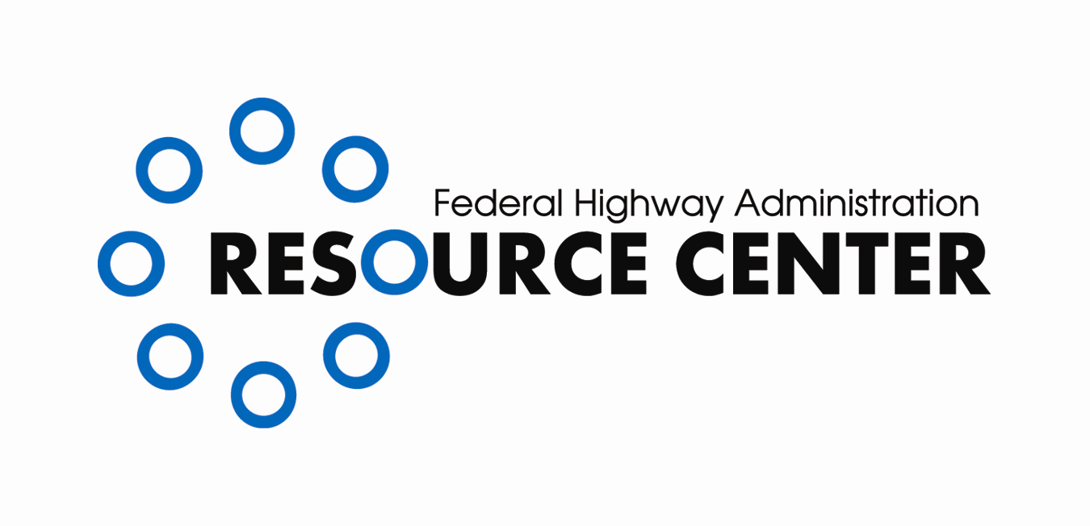
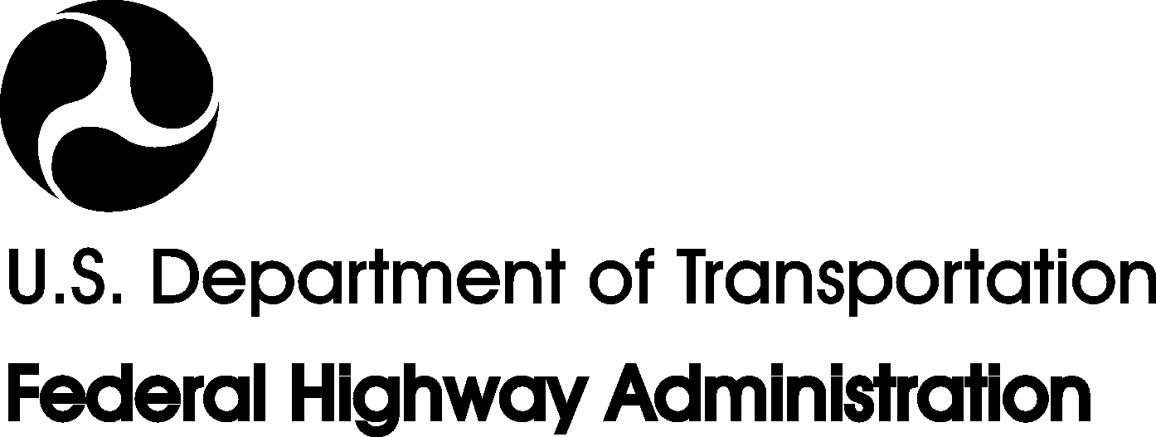
CONTACT INFORMATION:

Editor–in-Chief
Don Cote
Environment Technical Service Team (TST)
Team Leader
Phone: (720) 963-3210
don.cote@fhwa.dot.gov

TST Editorial Board Members:
David Grachen, Dan Harris,
Brian Smith, and David Sullivan
FHWA Resource Center
Aung Gye
Office of Project Development &
Environmental Review, FHWA HQ

Managing Editor:
Marie Roybal,
FHWA Resource Center
(720) 963-3241
marie.roybal@fhwa.dot.gov

Due to Quarterly publication schedule, all article submissions for future issues are due to the Editor-In-Chief by the 15th of March, June, September, and/or December

*If you would like to receive this newsletter electronically, please send your email address to:
marie.roybal@fhwa.dot.gov
Here are a few of the upcoming events of interest to the environmental community:
October 2005
October 16-19
National Scenic Byways Conference
Rock and Road 2005
Cleveland, Ohio

October 18-19
Wetland and Riparian Area Legal Workshop: Identifying “Waters of the U.S.” After SWANCC
Albuquerque Marriott Pyramid North, Albuquerque, New Mexico

October 24-26
It's So Easy Funding Green: The First National Green Building Conference for Funders
The Funders' Network
Cleveland, Ohio

November 2005
November 8-10
Green Highways Forum
University of Maryland
College Park, MD
Contact: Frank Reilly, Wetlands Working Group,
540-286-0072

November 2-4
2005 WSEAS Int. Conf on Environment, Ecosystems, and Development (EED 05)
Venice, Italy

January 2006
January 22-26
TRB 84th Annual Meeting
Washington D.C.

April 2006
April 23-26
National Association of Environmental Professionals (NAEP) 31st Annual Conference Albuquerque, NM

March 2007
Mar 17 - Mar 18
National OHV Program Managers Workshop
Ontario, CA
Co-sponsored by: National Off-Highway Vehicle Conservation Council and FHWA's Recreational Trails Program Contact: Bob Walker (406) 444-4584
Contact Donna Carter, conference@naep.org

May 2007
May 13 - May 17
Coastal Sediments 2007
New Orleans, LA

